Created By: Peggy Thomas Subject: ELA/Science Grade: Kindergarten
Unit Title: By the Sea
Unit Context:
This unit was prepared for a full-day kindergarten focusing on ELA instruction overlapping into science, math, and science standards for four (4) weeks at the end of the 4th quarter. The listed materials include an Open Court Kindergarten (2005) series Teacher’s manual, Open Court sounds and letters (S & L) workbook, Open Court big book (By the Sea), multiple trade books, ocean realia, and art supplies. This unit includes activities focused towards 5- and 6-year-old students with varied abilities. Many of these young students may be included in a low socioeconomic status and have limited interaction with the world.

This unit will focus on Idaho Core Key shifts 1, 2, and 4:
- Students will build knowledge and academic language through a balance of content rich, complex nonfiction and literary texts.
- Students will participate in Reading/Writing/Speaking that is grounded in evidence from the text, across the curriculum.
4. Students will collaborate effectively for a variety of purposes while also building independent literacy skills.
Unit Rationale:
Oceans occupy the majority of the surface on earth. Most kindergarten children are only vaguely aware of the plants and animals that live in and around the ocean. They do not have much understanding about how oceans affect their lives. The purpose of this unit is to investigate ocean life and the life that surrounds them. This unit will use primarily informational texts that will assist students as they discover facts about the ocean, delve into marine life, and investigate the plants that grow in and around the oceans. Students will also discover the properties of ocean water and investigate how it differs from the water that they drink. Students will investigate the ocean using the scientific process and create individual scientific journals that delineate their learning through writing, illustrations, and lists.
Focus Standards being Explicitly Taught and Assessed
CCSS.ELA-Literacy.RL.K.1
With prompting and support, ask and answer questions about key details in a text.
CCSS.ELA-Literacy.RL.K.3
With prompting and support, identify characters, settings, and major events in a story.
CCSS.ELA-Literacy.RL.K.7
With prompting and support, describe the relationship between illustrations and the story in which they appear (e.g., what moment in a story an illustration depicts).
CCSS.ELA-Literacy.W.K.1
Use a combination of drawing, dictating, and writing to compose opinion pieces in which they tell a reader the topic or the name of the book they are writing about and state an opinion or preference about the topic or book (e.g., My favorite book is...).
CCSS.ELA-Literacy.SL.K.1
Participate in collaborative conversations with diverse partners about kindergarten topics and texts with peers and adults in small and larger groups.

CCSS.ELA-Literacy.SL.K.1.a
Follow agreed-upon rules for discussions (e.g., listening to others and taking turns speaking about the topics and texts under discussion).
CCSS.ELA-Literacy.L.K.1
Demonstrate command of the conventions of standard English grammar and usage when writing or speaking. CCSS.ELA-Literacy.L.K.1.a
Print many upper- and lowercase letters.
Supporting CCSS Kindergarten Standards
CCSS.ELA-Literacy.RL.K.2
With prompting and support, retell familiar stories, including key details. CCSS.ELA-Literacy.RL.K.10
Actively engage in group reading activities with purpose and understanding.
CCSS.ELA-Literacy.RI.K.2
With prompting and support, identify the main topic and retell key details of a text. CCSS.ELA-Literacy.RI.K.3
With prompting and support, describe the connection between two individuals, events, ideas, or pieces of information in a text.
CCSS.ELA-Literacy.RI.K.7
With prompting and support, describe the relationship between illustrations and the text in which they appear (e.g., what person, place, thing, or idea in the text an illustration depicts).
CCSS.ELA-Literacy.RI.K.10
Actively engage in group reading activities with purpose and understanding.
CCSS.ELA-Literacy.W.K.2
Use a combination of drawing, dictating, and writing to compose informative/explanatory texts in which they name what they are writing about and supply some information about the topic.
CCSS.ELA-Literacy.W.K.3
Use a combination of drawing, dictating, and writing to narrate a single event or several loosely linked events, tell about the events in the order in which they occurred, and provide a reaction to what happened.
CCSS.ELA-Literacy.W.K.8
With guidance and support from adults, recall information from experiences or gather information from provided sources to answer a question.
CCSS.ELA-Literacy.SL.K.1
Participate in collaborative conversations with diverse partners about kindergarten topics and texts with peers and adults in small and larger groups.
CCSS.ELA-Literacy.SL.K.1.b
Continue a conversation through multiple exchanges. CCSS.ELA-Literacy.SL.K.2
Confirm understanding of a text read aloud or information presented orally or through other media by asking and answering questions about key details and requesting clarification if something is not understood.
CCSS.ELA-Literacy.SL.K.6
Speak audibly and express thoughts, feelings, and ideas clearly.
CCSS.ELA-Literacy.L.K.1
Demonstrate command of the conventions of standard English grammar and usage when writing or speaking.

CCSS.ELA-Literacy.L.K.1.f
Produce and expand complete sentences in shared language activities. CCSS.ELA-Literacy.L.K.5
With guidance and support from adults, explore word relationships and nuances in word meanings. CCSS.ELA-Literacy.L.K.5.a
Sort common objects into categories (e.g., shapes, foods) to gain a sense of the concepts the categories represent.
CCSS.ELA-Literacy.L.K.5.b
Demonstrate understanding of frequently occurring verbs and adjectives by relating them to their opposites (antonyms).
Idaho Social Studies Content Standards
K.SS.4.1.1
Name some rules and the reasons for them. K.SS.2.1.4
Recognize a map of the United States of America and know that it is the country in which we live. K.SS.4.1.2
Discuss how groups make decisions and solve problems. K.SS.3.1.2
Recognize that people have limited resources. K.SS.2.1.2
Distinguish between landmasses and water on a globe or map.
Idaho Science Content Standards
K.S.1.8.1
Follow instructions.
K.S.1.2.1
Make observations and collect data. K.S.1.6.1
Use cooperation and interaction skills. K.S.3.1.1
Observe and describe the characteristics of plants and animals. K.S.2.1.1
Use senses to describe matter. K.S.3.2.1
Describe the difference between living and non-living things.

Measurable Objectives:
Learning Goals:
- Students will recognize different sea animals and confirm their understanding through peer group discussions. (SL.K.2)
- Students will identify the main idea in an ocean text. (RL.K.1, RL.K3)
- Students will cite evidence and develop an argument for a favorite sea creature. (W.K.1)
- Students will distinguish relevant information about salt water and fresh water plants and animals from illustrations and text. (RL.K.7)
- Students will apply simple sentence structure when writing. (L.K.1f)
- Students will interpret information obtained through texts, illustrations and activities and will participate in collaborative discussions using class rules. (SL.K.1a)

Student-Friendly Learning Targets:
- I can talk about different sea animals with my classmates. (SL.K.1a)
- I can tell what the story is about. (RL.K.1, 3)
- I can tell the difference between fresh water and saltwater plants and animals. (RL.K.7)
- I can tell why I like a sea animal and give proof for my feelings. (W.K.1)
- I can write a complete sentence. (L.K.1f)
- I can share what I learn with my classmates. (SL.K.1a)

Success Criteria:
- Students will confirm understanding of the ocean as they complete a scientific journal. The journal will include drawings of plants and animals, and correct labeling of illustrations, descriptive lists of scientific experiments of fresh water and salt water, correctly formatted sentences, and using the rules of public speaking while presenting information from journal or experiments. The journal will engage students as they express their knowledge with text and illustrations, be evident in the knowledge as they acquire different and interesting ocean facts, and will require all the modalities of English Language Arts including listening, speaking, reading, and writing.

Summative Assessment:
- All students will create a scientific journal where they will draw and label pictures of animals that live in the ocean, participate in and write notes about scientific experiments about the difference between fresh and salt water, and present science experiments to peers. This assessment will occur through the entire 4-week unit. Additionally, students will complete formative and summative unit assessments.
- Rubric and Assessment Guidelines: Student writing journal rubric, teacher writing assessment rubric, and checklist of scientific journal are in appendices A, B, and C.

Depth of Knowledge (DOK) Explanation:
- Level 2 (skills and concepts)
A Level 2 “describe or explain” assessment would require students to go beyond a description or explanation of recalled information to describe or explain a result or “how” or “why.” The learner should make use of information in a context different from the one in which it was learned. All students will work individually, in small groups, or with the teacher to complete the scientific journal, participate in speaking and listening, and practice listening skills during group time.

Unit Essential Questions Addressed:
- How do humans connect with and interact with the ocean?
- Why is it so important that people take care of the ocean?
- Is the ocean important to people like you and me, who live far away from it?
Unit Enduring Understandings Addressed:
- The ocean is filled with salt water.
- Some animals that live in the ocean can also live in freshwater.
- There are differences between fish and marine mammals.
- It is important to learn about the oceans.
- It is important to develop an understanding of the ocean even when it isn’t near us.
- People play an important role in keeping the ocean healthy.
Central Text: Hello Ocean (Pam Muñoz Ryan) Text Complexity Analysis:
- Quantitative:
This is a moderately complex text with a Lexile range of 700-730 and an associated grade band level of 3-6.

Although this book is higher in the Lexile range and associated band level, it is an appropriate book for use in the primary grade levels. It is a picture book, appropriate to be read with meaning and expression by an accomplished reader. It is a beautifully illustrated text with many opportunities to explore new vocabulary and ideas. Underlying concepts of visualizing and making connections to real life are also greatly encouraged in this text making it a good book for encouraging young imaginations.

- Qualitative:
Text Structure:
This is a moderately complex text that is occasionally hard to understand. The story is about a young child’s experience at the ocean, but the text provides learning opportunities using the five senses that is sometimes hard to grasp. The illustrations provide clues to the text, and provide many opportunities for discussion.

- Language Features:
This is a moderately complex text with spirited words. The text features beautiful language with many concrete examples illustrated in the pictures. The use of metaphors is sometimes abstract leading the instructor to introduce new vocabulary. The vocabulary allows for dense discussion opportunities for teachers and students and peer to peer.

- Meaning/Purpose:
The purpose of this story is moderately complex, ranging from a simple story of a day at the beach to an instructional usage of the five senses to describe a place. The story is charming in its use of the draw of the ocean, including lots of figurative language and illustrations. There isn’t a lot of academic language, but ensuing discussions will arise as the text is reread and underlying issues and vocabulary are pursued.

- Knowledge Demands:
This is a moderately complex text where several themes are explored. The story allows for background knowledge and offers opportunities to relive experiences or to learn of a new theme without threat. It is very concrete in some areas and also offers extension opportunities in others.

- Reader-Task:
Potential Challenges this Text Poses:
This text provides a wonderful picture of the ongoing opportunities the ocean provides for learning. However, it is a complex text that may take many re-readings and much discussion to solidify the hidden concepts in the story. The text is very figurative and metaphoric in areas and that is hard for young students to comprehend without a lot of scaffolding and explanations. Transferring knowledge of the ocean/sea will be easier with the assistance of the beautiful and accurate illustrations, but it will be difficult for young students to use the same type of figurative language in their speaking and writing attempts.

- Differentiation/Supports for Students:
  - Tier 3 Students: Teacher should provide systematic and very explicit instruction that includes many opportunities for high-quality, scientifically based instruction with additional support in the classroom and possible Title 1, ELL, or Special Education assistance. Strategies could include hands-on “play” with ocean realia, partner discussions, one-on-one with teacher or assistant, repeated oral access to materials, and opportunities to apply skills with support.

  - Tier 2 Students: Teacher should use the scientifically based research based curriculum and very explicit instruction and modeling with Tier 2 Students, but should also apply intensive intervention techniques such as increased reading and writing time, discussions in a small group setting, vocabulary development skills, and hands-on opportunities. Strategies such as pairing with partners, assistance from outside sources, and one-on-one with the teacher should also be employed.

  - Tier 1 Students: Teacher should use the scientifically based research based curriculum and very explicit instruction and modeling with Tier 1 Students, but should also provide opportunities for enrichment including more detailed assignments in reading and writing that match student extension abilities.

Scaffolds/Supports for Texts:
  - Graphic organizers
  - Leveled Readers from Open Court Reading Curriculum
  - Paired readings
  - Large and Small Group readings
  - Using context clues for unknown words and illustrations
Additional Materials Recommended:
Open Court Kindergarten (2005) ELA manual Unit 8, Open Court Sounds and Letters workbook pages, Open Court Willy the Wisher (visualization stories), Open Court decodable booklets, high-frequency words, chart paper, markers, projector and white board, sea creature and freshwater creature pictures, assorted stories with descriptive text and illustrations of sea plants and animals for read-alouds and student interest, Language!
Sounds and Letters (phoneme awareness drills) units 16-18 activities, word family practice pages, A-Z

leveled reading books for small group instruction, and realia (shells, driftwood, sand, shovels, buckets, beach balls, etc.). Additional “games” for workshop/intervention practice times should include activities which focus on rhyming, initial and final sound deletion and/or changes, sentence and sight word practice with listening, speaking, reading and writing opportunities. Assorted colors of construction paper and markers could be used for class webs. Additionally, each student will need an individual scientific journal, pencils, crayons, glue sticks, scissors, composition book, and various art supplies. Students may also use sea animal and plant stencils to complete the illustrations on their scientific journal pages.
Key Vocabulary Terms: Content and Academic
Academic Vocabulary |  | Content Vocabulary
Academic: scientist, experiments, label, author, illustrator, antonyms, illustrate, visualize, compare, contrast, attributes, symmetrical, classify and investigate.  All academic language will be taught and used during lessons. It will be defined in student friendly terms and used within the lessons as needed. (i.e., scientist: someone who is really interested in learning about something and who does experiments to find out answers to questions.) |  | Content: ocean, marine, mammal, creature, freshwater, salt water, island, rock, sand, pod, rescue, ramp, unique, coral, spine, invisible, transparent, tentacles, enormous, rafts, tasty, delicious, muffin, lonely, playmates, hue, chameleon, bubbly, roar, shushing, clang, screak, refrain, tickle, squishy, soggy, fresh, reeky, sea animal names and attributes, and 5 senses (sight, hearing, taste, smell, touch).  All content language will be integrated into whole group, small group, and individual practice during listening, speaking, reading, and writing opportunities. Further learning will occur when conducting scientific experiments, completing art activities, individual reading time, during library, and through intertwined lessons in writing, math, social studies, and science.
Unit Procedures
Frontloading/Anticipatory Set
Lesson plan or outline: Introduce the unit concept through pictures, hands on realia, discussion. Create a concept/question board where the class lists what they know, what questions they might have, and eventually answers the questions. The concept/question board also showcases student “show and tells” that accentuate the unit theme, provides visual and textual clues to the unit, and provides an area for expanding unit ideas.
Additionally, small realia pieces can be “tacked” up on the board (in this unit, for example, small beach buckets, shovels, rakes, beach umbrellas, driftwood, shells, etc.)
Week One | Introduction to the ocean, building background knowledge of plants and animals.
Day 1 | Lesson Design:  - Focus on words in print  - High-frequency word review  - Oral blending  - Segmentation  - Working with sounds  - Linking letters to sounds  - Blending –in word family

- S & L Workbook pgs. 132-133, identifying words
- Content vocabulary: island, rock, sand
- A Walk by the Seashore by Caroline Arnold
- Make a fishing pole with –in family words

Frontloading:
- Introduce the unit concept through pictures, hands on realia, discussion.
- Ask students to tell what they know about the ocean. (Activate prior knowledge)
- Begin the concept/question board including student questions and knowledge of the ocean by writing them as students share knowledge and then post them on the board.
- Generate questions about oceans. Ask students how we could investigate to find some of the answers for our questions?
- Build background knowledge for the study of oceans and water.

Lesson Development:
- Introduce pictures and realia from the ocean and post it on the concept/question board.
- Work in a large group setting to create a KWL chart focusing on the first 2 columns (What I KNOW and What I WANT to Know). Set aside for end of unit review and completion. (For use as a formative assessment.)
- Use guided modeling and practice for focusing on words (reviewing rhymes using rhyming word puzzle cards and changing the initial sounds using letter cards), reviewing high-frequency words in the room and in books, oral blending using words in context, segmentation (deleting sounds from words), identifying initial and final sounds using picture cards or objects in the room, linking letters to sounds through writing CVC words and having students identify which word is asked for, and board blending using the –in word family in a large group setting. (See appendix G).
- Students complete workbook pages 132-133 (additional materials file) at desk in large group format. Teacher should model on the white board and circulate to ensure student understanding of assignment.
- Moving back into large group, introduce the new story vocabulary (island, rock, sand). Discuss with students how it fits into our new unit. Use the teacher read aloud, A Walk by the Seashore by Caroline Arnold for shared reading and personal information modeling fluency and building excitement for the unit and to aid in answering discussion questions after reading the story. Use text-dependent questions to aid in discussion:
**Name some of the plants and animals that can be found by the seashore.
**What would you hear and smell if you were by the seashore?
**What is your favorite part of the text? Why?
**What new things have you learned about the ocean?
- Introduce the unit essential questions with the students. Write these questions on the board at the front of the room and keep them up there for the duration of the unit.
- How do humans connect with and interact with the ocean?
- Why is it so important that people take care of the ocean?
- Is the ocean important to people like you and me, who live far away from it?
- Send Home Connection pg. 91 or page 92 home for parents to review.

Guided Practice:
- During workshop/intervention time period, have the students participate in differentiated centers to reinforce lesson topics and skills.
  - Look at ocean books during center time for workshop.

- High-frequency word review using textured and trace sight words cards.
- Read leveled A-Z readers in small groups. Monitor partner reading, choral reading and repeated readings of text, following along in the text when teacher or other fluent reader is reading aloud. Reteach vocabulary during workshop intervention and preteach future vocabulary.
- Play sight word fishing using magnet fishing pole and magnet fish.
- Make an –in word family fishing pole. (spin, thin, chin, shin, win, fin, bin, din, kin, pin, sin, tin).
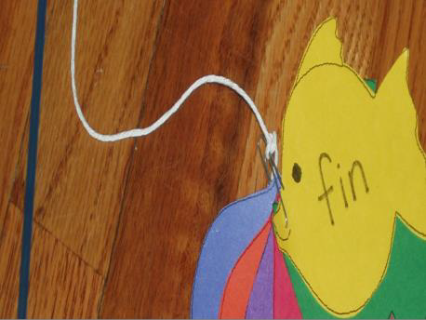
- Have fish printed on different colored pages and students can cut them out and put together on a string and “straw” fishing pole. (Pattern Appendix K)

Independent Practice:
- Review sight words and –in family words at desk.

Additional Materials File/Appendix Thumbnails:
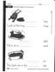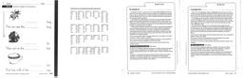
Day 2 | Lesson Design:  - Blending words in context  - Word segmentation  - Identifying initial consonant sounds  - Identifying final consonant sounds  - Sound object matching  - Blending –ap word family  - Use comprehension skills while listening to story.  - Vocabulary: seahorse, starfish, crab, octopus  - The Ocean (Alan Baker)  Frontloading:  - Review the unit concept through pictures, hands on realia, discussion.  - Review and reteach vocabulary.  Lesson Development:  - Introduce more pictures and realia from the ocean and post on the concept/question board.  - Use guided modeling and practice for blending words in context, word segmentation,

identifying initial consonant sounds using beginning sounds play and learn phonics game, and identifying final consonant sounds.
- Use small student groupings for sound object matching around the room.
- Use the white board to model board blending using the –ap word family in a large group setting. (See appendix G).
- Using large group reading strategies, the teacher will read aloud for shared reading and personal information modeling fluency and building excitement for the unit and to aid in answering discussion questions after reading the story.
- Guide the students through visualizing what will happen in the story and in predicting what might happen next. Use illustrations to help with understanding (ELL and SpEd students will benefit from repeated exposure to visual information).
- Review the unit essential questions with the students.
- How do humans connect with and interact with the ocean?
- Why is it so important that people take care of the ocean?
- Is the ocean important to people like you and me, who live far away from it?
- Work as a group to create the first ocean web (post for everyday review).

seaweed

crabs ocean sharks

dolphins

- Introduce the science journals and show an example of what they might look like when they are finished. Point out that they will look different, but that they will all contain some of the same things. Remind students that the journal will be graded based on the rubric, so everyone should be working their best to complete it. Show the rubric and discuss the different areas of assessment with the students. Post the rubric on the board.

Guided Practice:
- During workshop/intervention time period, have the students participate in differentiated centers to reinforce lesson topics and skills.
  - Look at ocean books during center time for workshop.
  - High-frequency word review using textured and trace sight words cards.
  - Read leveled A-Z readers in small groups. Monitor partner reading, choral reading and repeated readings of text, following along in the text when teacher or other fluent reader is reading aloud. Reteach vocabulary during workshop intervention and preteach future vocabulary.
  - Play sight word fishing using magnet fishing pole and magnet fish.
  - Building words using –ap word family (cut and paste into comp book) (Please see additional materials file).

Independent Practice:
- Scientific Journal: Write a sentence (teacher generated) on board about the ocean. {The ocean has many things in it.} Draw a simple picture to illustrate the sentence. Ask students to do the

same in their new scientific journal. Assist students in labeling their pictures, where necessary. Remind them to use the strategies of asking a neighbor, looking at resources in the room, and trying to do it by themselves.

Additional Materials File/Appendix Thumbnails:
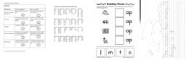
Day 3 | Lesson Design:  - Word order in sentences  - Blending words in context  - Dropping sounds from words  - Consonant riddle game  - Blending –ut word family  - Compare and contrast  - Vocabulary: whale, dolphin, seahorse, flying fish  - Make a web about a crab  - Reread The Ocean by Alan Baker  Frontloading:  - Review the unit concept through pictures, hands on realia, discussion.  - Review and reteach vocabulary.  - Review ocean web and add to it, if possible.  Lesson Development:  - Introduce more pictures and realia from the ocean and post it on the concept/question board.  - Use guided modeling and practice for word order in sentences using Cut and Paste Sight Words Sentences examples, blending words in context, dropping sounds from words, consonant riddle game, and blending -ut word family on board. (See appendix G).  - Using large group reading strategies, the teacher will reread The Ocean by Alan Baker modeling fluency and visualization strategies. Guide the students through visualizing what happened in the beginning, middle, and end of the story. Use illustrations to help with understanding. The teacher will also be focusing on story vocabulary to help students to create a compare/contrast graphic organizer listing the different attributes of sea animals. (Alike and Different).  - Review the unit essential questions with the students.  - How do humans connect with and interact with the ocean?  - Why is it so important that people take care of the ocean?  - Is the ocean important to people like you and me, who live far away from it?  - Work as a group to create a web about a crab. (Post for everyday review)  Guided Practice:  - During workshop/intervention time period, have the students participate in differentiated centers to reinforce lesson topics and skills.  - Look at ocean books during center time for workshop.

- High-frequency word review using textured and trace sight words cards.
- Read leveled A-Z readers in small groups. Monitor partner reading, choral reading and repeated readings of text, following along in the text when teacher or other fluent reader is reading aloud. Reteach vocabulary during workshop intervention and preteach future vocabulary.
- Play sight word fishing using magnet fishing pole and magnet fish.
- Word Building –ut word family (cut and paste into comp book). (Please see additional materials file).

Independent Practice:
- Scientific Journal: Sentence prompt: crab. Cultivate student interest through writing a
student-generated sentence about a crab on the board. Complete journal page individually with teacher assistance for labeling, when necessary. Draw a simple picture to illustrate the sentence. Ask students to do the same in their new scientific journal. Assist students in labeling their pictures, where necessary. Remind them to use the strategies of asking a neighbor, looking at resources in the room, and trying to do it by themselves.

Additional Materials File/Appendix Thumbnails:
Day 4 | Lesson Design:  - Blending words in context  - Dropping sounds from words  - Link letters to sounds  - Blending (-og) word family on board  - S & L Workbook pgs.134-135, identifying words  - Vocabulary: ray, eel, shark  - Make a web about a shark  - Read Wonders of the Sea by Louis Sabin  - Make an entry into scientific journal about a shark.  Frontloading:  - Review the unit concept through pictures, hands on realia, discussion.  - Review and reteach vocabulary.  - Review ocean and crab webs and add to them, if possible.  Lesson Development:  - Introduce more pictures and realia from the ocean and post on the concept/question board.  Use guided modeling and practice for blending words in context, dropping sounds from words, linking letters to sounds using stories from Phonics Tales and blending (-og) word family on board. (See appendix G).  - Move group to desk to complete workbook pages 134-135 in large group format. Teacher should model on the white board and circulate to ensure student understanding of assignment.  - Review vocabulary from story (The Ocean) and then work as a large group to create a web

about a shark and post next to other webs.
- Using large group reading strategies, the teacher will read Wonders of the Sea by Louis Sabin modeling fluency, building excitement for the unit, and to aid in answering discussion questions after reading the story. Guide the students through visualizing what happened in the beginning, middle, and end of the story. Use illustrations to help with understanding.
- Remind the students of the unit essential questions.
- How do humans connect with and interact with the ocean?
- Why is it so important that people take care of the ocean?
- Is the ocean important to people like you and me, who live far away from it?
- Send Home Connection page 93 or page 94 home for parents to review.

Building Knowledge:
- Discuss with whole class what we have learned the last few days about the ocean, its’ animals, and its’ importance to us. Use the journals to reinforce the knowledge we have already gained. Remind students that the journal will be graded based on the rubric, so everyone should be working their best to complete it. Review the rubric posted on board.
- Use some of the enduring understanding prompts to stimulate student discussions.
- The ocean is filled with salt water.
- Some animals that live in the ocean can also live in freshwater.
- There are differences between fish and marine mammals.
- It is important to learn about the oceans.
- It is important to develop an understanding of the ocean even when it isn’t near us.

Guided Practice:
- During workshop/intervention time period, have the students participate in differentiated centers to reinforce lesson topics and skills.
  - Look at ocean books during center time for workshop.
  - High-frequency word review using textured and trace sight words cards.
  - Read leveled A-Z readers in small groups. Monitor partner reading, choral reading and repeated readings of text, following along in the text when teacher or other fluent reader is reading aloud. Reteach vocabulary during workshop intervention and preteach future vocabulary.
  - Play sight word fishing using magnet fishing pole and magnet fish.
  - Word building –og word family (cut and paste into comp book). (Please see additional materials file).

Independent Practice:
- Scientific Journal: Sentence prompt: shark. Cultivate student interest through writing a student-generated sentence about a shark on the board. Complete journal page individually with teacher assistance for labeling, when necessary. Draw a simple picture to illustrate the sentence. Ask students to do the same in their scientific journal. Remind students to use the strategies of asking a neighbor, looking at resources in the room, and trying to do it by themselves. Remind students that the journal will be graded based on the rubric, so everyone should be working their best to complete it. (Point out displayed writing rubric).

Additional Materials Thumbnails:
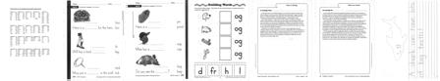
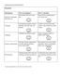
Day 5 | Lesson Design:  - Blending words in context  - Dropping sounds from words  - Blending (letter -s means more than one)  - Decodable book: A Bump  - Read Houses From the Sea by Alice E. Goudey  - Vocabulary: turtle, lobster, shell  - Make a web about shells  - Willy the Wisher, “Mr. Muddle Tells About the Circus”, pg. 89  - Make an entry into scientific journal about shells.  - Create a class book about favorite sea animals.  Frontloading:  - Review the unit concept through pictures, hands on realia, discussion.  - Review and reteach vocabulary.  - Review ocean, crab, and shark webs and add to them, if possible.  Lesson Development:  - Introduce more pictures and realia from the ocean and post it on the concept/question board. Use guided modeling and practice in large group format for blending words in context, dropping sounds from words, and blending (-s) words on board. (See appendix G).  - Using guided reading, group reading, choral reading, and partner reading, have students work their way through an Open Court decodable book, A Bump. Monitor partner reading, choral reading and repeated readings of text, following along in the text when teacher or other fluent reader is reading aloud. Focus on explicitly building students’ academic and content vocabulary skills while instructing using correct syntax with the goal of constantly advancing students towards grade-level reading.  - Browse and activate prior knowledge for the new story. Continuing to use large group reading strategies, the teacher will read Houses From the Sea by Alice E. Goudey modeling fluency and extending information for the unit and to aid in answering discussion questions after reading the story. Guide the students through visualizing what happened in the beginning, middle, and end of the story. Facilitate test-based discussions using thought-provoking questions and text illustrations to help with understanding.  - Review vocabulary from story (Houses From the Sea) and then work as a large group to create a web about shells and post next to other webs.

- Read Willy the Wisher, “Mr. Muddle Tells About the Circus”, pg. 89 to build questioning and answering skills through visualization and critical thinking strategies. Facilitate test-based discussions using thought-provoking questions to help with understanding.

Building Knowledge:
- Remind the students of the unit essential questions.
- How do humans connect with and interact with the ocean?
- Why is it so important that people take care of the ocean?
- Is the ocean important to people like you and me, who live far away from it?
- Discuss with whole class what we have learned the last few days about the ocean, its’ animals, and its’ importance to us. What new vocabulary have we learned and used in our stories and writing? Have we answered any of our questions on the concept/ question board? Do we have any to add?

Guided Practice:
- During workshop/intervention time period, have the students participate in differentiated centers to reinforce lesson topics and skills.
  - Look at ocean books during center time for workshop.
  - Reread A Bump in small group and with a partner practicing “mouth-to-ear, and knee- to-knee” strategies to contain noise levels. Monitor partner reading, choral reading and repeated readings of text, following along in the text when teacher or other fluent reader is reading aloud.
  - Read leveled A-Z readers in small groups. Monitor partner reading, choral reading and repeated readings of text, following along in the text when teacher or other fluent reader is reading aloud. Reteach vocabulary during workshop intervention and preteach future vocabulary.
  - Play sight word fishing using magnet fishing pole and magnet fish.
  - Make a picture of your favorite ocean animal and label it with help from your peers or your teacher. (Teacher will collect pictures and put together in a class book entitled, Our Favorite Ocean Animals.)

Independent Practice:
- Scientific Journal: Sentence prompt: shells. Cultivate student interest through writing a student-generated sentence about shells on the board. Complete journal page individually with teacher assistance for labeling, when necessary. Draw a simple picture to illustrate the sentence. Ask students to do the same in their scientific journal. Remind students to use the strategies of asking a neighbor, looking at resources in the room, and trying to do it by themselves. Remind students that the journal will be graded based on the rubric, so everyone should be working their best to complete it.
- Make a simple shell out of paper using a plain piece of paper, fold it fan-style, and stapling it one time on the bottom after folding it up. Have students color it according to individual preferences and then post at the base of the By the Sea bulletin board.
- Send Home Connection page 95 or page 96 home for parents to review (sea life mobile directions).

Additional Materials File/Appendix Thumbnails:
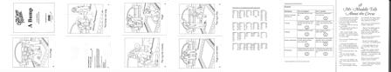
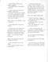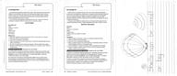
Week Two | Introduction to human and animal interaction in the ocean.
Day 6 | Lesson Design:  - Rhyme and rhythm  - Blending words in context  - Adding phonemes to make word changes  - Picture/letter sound match  - Blending -en family  - Vocabulary: pod, humpback  - Humphrey the Lost Whale by Wendy Tokuda and Richard Hall  - Use predicting and asking questions strategies during reading  - Make a web about a whale  - Make an entry into scientific journal about whales comparing its’ size to other animals.  Frontloading:  - Review the unit concept through pictures, hands on realia, discussion.  - Review and reteach vocabulary.  - Review webs and add to them, if possible.  Lesson Development:  - Review the concept/question board and look at “Show and Tell” items relating to the ocean. Use guided practice for rhyming practice including Rhyming Sounds Play and Learn Phonics game, blending in context, adding phonemes to make word changes picture sound matching, and blending -en word family on board. (See appendix G).  - Activate prior knowledge about the ocean, the animals, and plants. Use a map of the U.S. to point out where the oceans are and where California and Idaho are.  - Introduce new vocabulary and browse and activate prior knowledge for the new story. Continuing to use large group reading strategies, the teacher will read Humphrey the Lost Whale by Wendy Tokuda and Richard Hall modeling fluency and extending information for the unit and to aid in answering discussion questions after reading the story. Facilitate text- based discussions using thought-provoking questions and text illustrations to help with understanding. Guide the students in using predicting and asking questions strategies during reading.  - Use text-dependent discussion questions after reading the story:

- Where was Humphrey supposed to be going when he got lost?
- Why do you think people care about what happens to whales?
- Why is the open sea the best place for a whale?
- How did the people help Humphrey?
- Why is it strange for a whale to be in San Francisco Bay?
- How does this story help answer our essential questions?
- How do humans connect with and interact with the ocean?
- Why is it so important that people take care of the ocean?
- Is the ocean important to people like you and me, who live far away from it?
- Make a web about a whale and post.

Building Knowledge:
- Remind the students of the role the ocean plays in our lives. Ask for examples with replies expected from the texts, illustrations, etc. Ask students to show “evidence” for their examples.

Guided Practice:
- During workshop/intervention time period, have the students participate in differentiated centers to reinforce lesson topics and skills.
  - Play magic wand words in small groups. (See appendix H).
  - Complete activities in Sounds and Letters for phoneme awareness) practice in small group setting. Unit 16 activities in additional materials file (stages 1-7 daily).
  - Read leveled A-Z readers in small groups. Monitor partner reading, choral reading and repeated readings of text, following along in the text when teacher or other fluent reader is reading aloud. Reteach vocabulary during workshop intervention and preteach future vocabulary.
  - Complete the Creating Sight Words Sentences game (writing and spelling).
  - Word building –en word family (cut and paste into comp book). (Please see additional materials file).

Independent Practice:
- Scientific Journal: Sentence prompt: whales. Cultivate student interest through writing a student-generated sentence about a whale on the board. Draw a picture of Humphrey in your journal. Compare his size to another ocean animal. Remind students to use the strategies of asking a neighbor, looking at resources in the room, and trying to do it by themselves. Remind students that the journal will be graded based on the rubric, so everyone should be working their best to complete it.

Additional Materials File/Appendix Thumbnails:
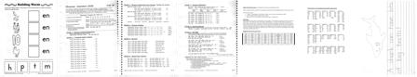
Day 7 | Lesson Design:  - Find the rhyme  - High-frequency words  - Blending words in context

- Adding phonemes to make word changes
- Blending –at word family
- S & L Workbook pgs. 136-137, identifying words
- Vocabulary: freshwater, salt water
- Make a web about an octopus
- Complete “science” project of comparing freshwater and saltwater by preparing a taste of both for each student. (See instructional notes in appendix I).
- Record steps of experiment in a list in the scientific journal (teacher modeled).
Frontloading:
- Review the unit concept through pictures, hands on realia, discussion.
- Review and reteach vocabulary.
- Review webs and add to them, if possible.

Lesson Development:
- Look at “Show and Tell” items relating to the ocean.
- Use guided practice for rhyming using as many high-frequency words from word wall as possible, high frequency words (finding in reading selections), blending in context, adding phonemes to make word changes picture sound matching, and blending -at word family on board. (See appendix G).
- Complete workbook pages 136-137 at desk in large group format. Teacher should model on the white board and circulate to ensure student understanding of assignment.
- Retell Humphrey the Lost Whale in a group setting and point out how the people and Humphrey have to work together. Invite students to use sequencing to retell the key details in the story. Use the illustrations in the story to prompt retelling in sequential order. Facilitate test-based discussions using thought-provoking questions and text illustrations to help with understanding.
- Complete “science” project of comparing freshwater and saltwater by preparing a taste of both for each student. (Prepare two glasses of water, leave one as freshwater and stir salt into the other.) Invite all students to taste the water and talk about how they are different and compare it to how Humphrey felt when he left the ocean.
- Record steps in a list in the scientific journal (teacher modeled).
- Create a web about an octopus in a group setting.

Building Knowledge:
- Continue to refer to the unit essential questions and check for enduring understanding.

Guided Practice:
- During workshop/intervention time period, have the students participate in differentiated centers to reinforce lesson topics and skills.
  - Play magic wand words in small groups. (See appendix H).
  - Complete activities in Sounds and Letters for phoneme awareness practice in small group setting. Unit 16 activities in additional materials file (stages 1-7 daily).
  - Read leveled A-Z readers in small groups. Monitor partner reading, choral reading and repeated readings of text, following along in the text when teacher or other fluent reader is reading aloud. Reteach vocabulary during workshop intervention and preteach future vocabulary.
  - Complete the creating sight words sentences game (writing and spelling).
  - Letter slide –at word family (cut and paste into comp book).

Independent Practice:
- Scientific Journal: Make a list of ingredients and the process of creating “salt” water. List on the board and have students copy the list into their scientific journals. Remind students to use the strategies of asking a neighbor, looking at resources in the room, and trying to do it by themselves. Remind students that the journal will be graded based on the rubric, so everyone should be working their best to complete it.
- Art activity: Make an octopus from a toilet paper roll (paint outside, make a smiley
face and then cut from bottom to make 8 legs).
- Send octopi home with children.

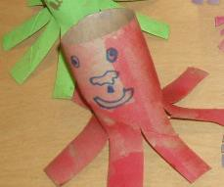

Additional Materials File/Appendix Thumbnails:
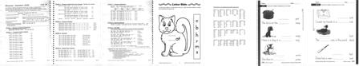
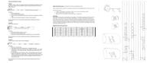
Day 8 | Lesson Design:  - Find the rhyme  - Blending words in context  - Adding phonemes to make word changes  - Identifying final sounds  - Word pairs  - Blending –et word family  - Vocabulary: rescue  - Antonyms  - Humphrey the Lost Whale by Wendy Tokuda and Richard Hall  (optional: watch the Reading Rainbow version of Humphrey on Discovery Education)  - Make a web about a turtle  - Create a symmetrical turtle during small group time  Frontloading:  - Review the unit concept through pictures, hands on realia, discussion.  - Review and reteach vocabulary.

- Review webs and add to them, if possible.
Lesson Development:
- Look at “Show and Tell” items relating to the ocean.
Use guided practice for rhyming using Rhyming Words Puzzle Cards, blending words in context (AlphaTales stories), adding phonemes to make word changes, identifying final sounds, word pairs and blending -et word family on board. (See appendix G).
- Review unit vocabulary in large group setting; refer to stories and illustrations for examples.
- Retell or watch video of Humphrey the Lost Whale in a group setting and point out how the people and Humphrey have to work together. Facilitate test-based discussions using thought- provoking questions and text illustrations to help with understanding. Invite students to use the illustrations in the story to draw attention to the antonyms (deep, shallow, narrow, and wide). Additional practice with antonyms (back, front, close, far, up, and down) would benefit most students.
- Create a web about a turtle in a group setting and post with other webs.

Building Knowledge:
- Continue to refer to the unit essential questions and check for enduring understanding. Remind the students of the role the ocean plays in our lives. Ask for examples with replies expected from the texts, illustrations, previous discussions, etc.

Guided Practice:
- During workshop/intervention time period, have the students participate in differentiated centers to reinforce lesson topics and skills.
  - Play magic wand words in small groups. (Directions in appendix H).
  - Complete activities in Sounds and Letters for phoneme awareness) practice in small group setting. Unit 16 activities in additional materials file (stages 1-7 daily).
  - Read leveled A-Z readers in small groups. Monitor partner reading, choral reading and repeated readings of text, following along in the text when teacher or other fluent reader is reading aloud. Reteach vocabulary during workshop intervention and preteach future vocabulary.
  - Create a symmetrical turtle using basic design and decorating symmetrically. Directions in appendix K.
  - Letter slide –et family word (cut and paste into comp book). (Please see additional materials file).

Independent Practice:
- Scientific Journal: Draw favorite sea animal or plant in journal. Complete the sentence: I like
because it is . (Teacher will have sentence stem on the board and will help students to fill in the blanks if necessary.) {This is the concept of persuasive writing.} Remind students that the journal will be graded based on the rubric, so everyone should be working their best to complete it.

Additional Materials File/Appendix Thumbnails:
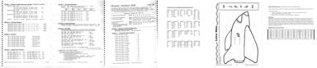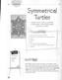

 | 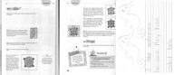
Day 9 | Lesson Design:  - Blending words in context  - Adding phonemes to make word changes  - Identifying final sounds  - Consonant riddle game  - Blending –ug word family  - S & L Workbook pgs. 138-139, identifying words  - Story crafting: by the sea  - Make a web about a starfish  - The Rainbow Fish by Marcus Pfister  Frontloading:  - Review the unit concept through pictures, hands on realia, discussion.  - Review and reteach vocabulary.  - Review webs and add to them, if possible.  Lesson Development:  - Look at “Show and Tell” items relating to the ocean. Introduce a starfish and pass it around for students to feel and look at in detail. Remind them about how fragile things from the ocean can be.  - Use guided practice for blending words in context, adding phonemes to make word changes, identifying final sounds, playing the consonant riddle game, and blending -ug word family on board. (See appendix G).  - Complete workbook pages 138-139 at desk in large group format. Teacher should model on the white board and circulate to ensure student understanding of assignment.  - Story crafting: Model how to use story starter ideas and create a story on the board. Remind students that stories must have a problem, an idea for solving the problem, and an ending that tells how the characters feel about the problem. Assign students to groups of three (use “advanced” students in each group to further their learning and teaching opportunities) and give them time to prepare their story and then to present it to the rest of the class. (See appendix H for story starter ideas).  - Create a web about a starfish in a group setting and post with other webs.  - Introduce new vocabulary and browse and activate prior knowledge for the new story. Continuing to use large group reading strategies, the teacher will read The Rainbow Fish by Marcus Pfister modeling fluency and extending information for the unit to aid in answering discussion questions after reading the story. Guide the students in using predicting and asking questions strategies during reading. Facilitate text-based discussions using thought-provoking questions and text illustrations to help with enduring understanding.  Building Knowledge:  - Continue to refer to the unit essential questions and check for enduring understanding. Facilitate text-based discussions using thought-provoking questions and text illustrations to

help with understanding.

Guided Practice:
- During workshop/intervention time period, have the students participate in differentiated centers to reinforce lesson topics and skills.
  - Play magic wand words in small groups. (Directions in appendix H).
  - Complete activities in Sounds and Letters for phoneme awareness practice in small group setting. Unit 16 activities in additional materials file (stages 1-7 daily).
  - Read leveled A-Z readers in small groups. Monitor partner reading, choral reading and repeated readings of text, following along in the text when teacher or other fluent reader is reading aloud. Reteach vocabulary during workshop intervention and preteach future vocabulary.
  - Complete the creating sight words sentences game (writing and spelling).
  - Letter slide –ug word family (cut and paste into comp book). (Please see additional materials file).

Independent Practice:
- Scientific Journal: What would a rainbow fish look like?
Remind students that the journal will be graded based on the rubric, so everyone should be working their best to complete it.

Additional Materials File/Appendix Thumbnails:
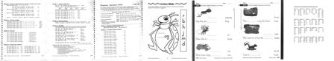
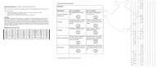
Day 10 | Lesson Design:  - Make a rhyme  - Blending words in context  - Adding phonemes to make word changes  - Blending –op word family  - Sight word practice  - Decodable book: A Ramp  - Willy the Wisher, “I Know All About Mr. Muddle”, pg. 95  - Vocabulary: ramp, unique, coral, spine, invisible, transparent, tentacles, enormous  - Windows on Nature: Animals of the Ocean Illustrated by Deborah Burr  - Make a web about a seahorse and post with others  - Sink or Float experiment (see Appendix I for supply list)  - Make a seahorse (art activity)

Frontloading:
- Review the unit concept through pictures, hands on realia, discussion.
- Review and reteach unit vocabulary.
- Review webs and add to them, if possible.

Lesson Development:
- Use guided practice for make a rhyme, blending words in context, adding phonemes to make word changes, sight word practice and review using Sight-Words Tales stories), and blending
-op word family on board. (See appendix G). Cultivate student interest and engagement in reading, writing, and speaking using all literacy activities.
- Using guided reading, group reading, choral reading, and partner reading, have students work their way through an Open Court decodable book, A Ramp. Monitor partner reading, choral reading and repeated readings of text, following along in the text when teacher or other fluent reader is reading aloud. Focus on explicitly building students’ academic and content vocabulary skills while instructing using correct syntax with the goal of constantly advancing students towards grade-level reading.
- Read Willy the Wisher, “I Know All About Mr. Muddle”, pg. 95 to build questioning and answering skills through visualization and critical thinking strategies. Facilitate text-based discussions using thought-provoking questions to help with understanding.
- Create a web about a starfish in a group setting and post with other webs.
- Introduce new vocabulary and browse and activate prior knowledge for the new story. Continuing to use large group reading strategies, the teacher will read Windows on Nature: Animals of the Ocean Illustrated by Deborah Burr modeling fluency and extending information for the unit and to aid in answering discussion questions after reading the story. Guide the students in using predicting and asking questions strategies during reading. Use illustrations to help with understanding the vocabulary. Ensure the usage of thought-provoking questions with the story and ensuing discussions.
- Sink or Float experiment materials: 2 jars, salt, water, hard-boiled egg. Assorted items that float to experiment with. Record steps in a list in the scientific journal (teacher modeled).

Building Knowledge:
- Continue to refer to the unit essential questions and check for enduring understanding. How does this story help answer our essential questions?
- How do humans connect with and interact with the ocean?
- Why is it so important that people take care of the ocean?
- Is the ocean important to people like you and me, who live far away from it?

Guided Practice:
- During workshop/intervention time period, have the students participate in differentiated centers to reinforce lesson topics and skills.
  - Play magic wand words in small groups. (Directions in appendix H).
  - Complete activities in Sounds and Letters for phoneme awareness practice in small group setting. Unit 16 activities in additional materials file (stages 1-7 daily).
  - Reread The Ramp in small group and with a partner practicing “mouth-to-ear, and knee-to-knee” strategies to contain noise levels. Monitor partner reading, choral reading and repeated readings of text, following along in the text when teacher or other fluent reader is reading aloud.
  - Read leveled A-Z readers in small groups. Monitor partner reading, choral reading and repeated readings of text, following along in the text when teacher or other fluent reader

is reading aloud. Reteach vocabulary during workshop intervention and preteach future vocabulary.
- Letter slide –op word family cut and paste into comp book. (Please see additional materials file).

Independent Practice:
- Scientific Journal: Record Sink or Float experiment in journal using illustrations and a list of materials (Appendix I). Record steps in a list in the scientific journal (teacher modeled).
- Paint a seahorse on a paper plate. When it is dry, brush it with watered down glue and then
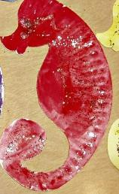
sprinkle it with glitter.
- Display on the By the Sea bulletin Board.
- Send Home Connection page 97 or page 98 home for parents to review.
Additional Materials File/Appendix Thumbnails:
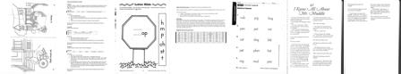

 | 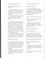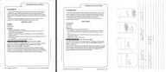
Week Three | Relating to ocean animals through attributes
Day 11 | Lesson Design:  - Making words  - Blending –ip word family  - Sentence extension  - Vocabulary: puffin, rafts, tasty, delicious  - There Once Was a Puffin  - Make a compare/contrast graphic organizer for tasty and yucky foods.  - Make a web about a puffin  Frontloading:  - Review the unit concept through pictures, hands on realia, discussion.  - Review and reteach unit vocabulary.  - Review webs and add to them, if possible.  Lesson Development:  - Use guided practice for making words using Word Family Short Vowels game, blending words in the –ip word family (See appendix G), extending sentences using same beginning sounds, introduce story vocabulary and read story.  Focus questions for Puffin (text-dependent):  Why was the Puffin lonely? How did the Puffin find friends?  - Using cooperative learning strategies, work as a class to make a graphic organizer listing foods suggested by students under “yummy” or “yucky”. Then compare to the food that the puffin ate? Same or different? Why?  - Create a web about a puffin in a group setting and post with other webs.  Building Knowledge:  - Continue to refer to the unit essential questions and check for enduring understanding. How does this story help answer our essential questions?  - How do humans connect with and interact with the ocean?  - Why is it so important that people take care of the ocean?  - Is the ocean important to people like you and me, who live far away from it?  - Help students to explore informational texts that deal with ocean animals. Learn how animals that live in and near the ocean can coexist peacefully.  Guided Practice:  - During workshop/intervention time period, have the students participate in differentiated centers to reinforce lesson topics and skills.  - Complete Open-ended learning games: Sentence Building (writing and spelling).  - Sight Words: Pop for Sight Words game.

- Complete activities in Sounds and Letters for phoneme awareness practice in small group setting. Unit 17 activities in additional materials file (stages 1-7 daily).
- Read leveled A-Z readers in small groups. Monitor partner reading, choral reading and repeated readings of text, following along in the text when teacher or other fluent reader is reading aloud. Reteach vocabulary during workshop intervention and preteach future vocabulary.
- Letter slide –ip word family (cut and paste into comp book). (Please see additional materials file).

Independent Practice:
- Scientific Journal: Help students draw a simple puffin picture in their scientific journals and complete the sentence starter: A puffin lives in the and eats . Remind students that their illustration should match their words and review the displayed rubric.

Additional Materials File/Appendix Thumbnails:
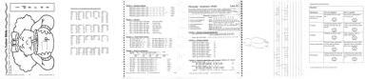
Day 12 | Lesson Design:  - Make a rhyme  - Same-sound word game  - Blending –an word family  - Sentence extension  - S & L Workbook pgs. 140-141, identifying words  - Vocabulary: muffin, lonely, playmates (from There Once Was a Puffin)  - Make a web about a seal  Frontloading:  - Review the unit concept through pictures, hands on realia, discussion.  - Review and reteach unit vocabulary.  - Review webs and add to them, if possible.  Lesson Development:  - Use guided practice for make a rhyme using Rhyming Sounds Play and Learn Phonics, same initial sound word game, blending words in the –an word family (See appendix G), and extending sentences using same beginning sounds.  - Complete workbook pages 140-141 at desk in large group format. Teacher should model on the white board and circulate to ensure student understanding of assignment.  - Identify fantasy and reality aspects of story.  - Create a web about a seal in a group setting and post with other webs.  Building Knowledge:  - Continue to refer to the unit essential questions and check for enduring understanding. Does this story help answer our essential questions?  - How do humans connect with and interact with the ocean?

- Why is it so important that people take care of the ocean?
- Is the ocean important to people like you and me, who live far away from it?
- Help students to explore informational texts that deal with ocean animals. Learn how animals that live in and near the ocean can coexist peacefully.

Guided Practice:
- During workshop/intervention time period, have the students participate in differentiated centers to reinforce lesson topics and skills.
  - Complete Open-ended learning games: Sentence Building (writing and spelling).
  - Sight Words: Pop for Sight Words game.
  - Complete activities in Sounds and Letters for phoneme awareness practice in small group setting. Unit 17 activities in additional materials file (stages 1-7 daily).
  - Read leveled A-Z readers in small groups. Monitor partner reading, choral reading and repeated readings of text, following along in the text when teacher or other fluent reader is reading aloud. Reteach vocabulary during workshop intervention and preteach future vocabulary.
  - Making sentences –an word family (cut and paste into comp book). (Please see additional materials file).

Independent Practice:
- Scientific Journal: Help students draw a seal in their scientific journals and complete the sentence starter: I like the seal because it is . {Persuasive writing.} Remind students that their illustration should match their words and review the displayed rubric.

Additional Materials File/Appendix Thumbnails:
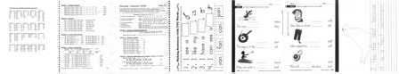
Day 13 | Lesson Design:  - Consonant riddle game  - Blending –ed word family  - Sentence extension  - Watch short video clips from “Dolphin Tales” (a true story)  - Make a web about a dolphin  Frontloading:  - Review the unit concept through pictures, hands on realia, discussion.  - Review and reteach unit vocabulary.  - Review stories we have read, videos we have seen, and artwork we have completed. How do

all of these things we’ve done relate to the importance the ocean plays in our world?
- Review webs and add to them, if possible.

Lesson Development:
- Use guided practice for the consonant riddle game, blending words in the –ed word family (See appendix G), and extending sentences using same beginning sounds.
- Show clips from the video “Dolphin Tales” using projector, computer and white board to introduce the idea that animals depend on humans sometimes (remind of Humphrey).
- Create a web about a dolphin in a group setting and post with other webs.

Building Knowledge:
- Continue to refer to the unit essential questions and check for enduring understanding. How does this story help answer our essential questions?
- How do humans connect with and interact with the ocean?
- Why is it so important that people take care of the ocean?
- Is the ocean important to people like you and me, who live far away from it?
- Help students to explore informational texts that deal with ocean animals. Learn how animals that live in and near the ocean can coexist peacefully.
- Watch additional selections of the video that show how the humans must work together to make a difference in the life of the dolphin.

Guided Practice:
- During workshop/intervention time period, have the students participate in differentiated centers to reinforce lesson topics and skills.
  - Complete Open-ended learning games: Sentence Building (writing and spelling).
  - Sight Words: Pop for Sight Words game.
  - Complete activities in Sounds and Letters for phoneme awareness) practice in small group setting. Unit 17 activities in additional materials file (stages 1-7 daily).
  - Read leveled A-Z readers in small groups. Reteach vocabulary during workshop intervention and preteach future vocabulary. Monitor partner reading, choral reading and repeated readings of text, following along in the text when teacher or other fluent reader is reading aloud.
  - Making sentences –ed word family (cut and paste into comp book). (Please see additional materials file).

Independent Practice:
- Scientific Journal: Ask students if they would like to swim with a dolphin? What else could they do with a dolphin? Where would they be if they had a dolphin to play with? Invite them to draw a picture of a dolphin in their journal and complete the sentence: I would like to with a dolphin. Remind them that their illustrations should match the text.

Additional Materials File/Appendix Thumbnails:
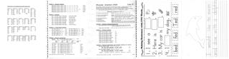

Day 14 | Lesson Design:  - What’s the sound? Game  - Same-sound word game  - Blending –un word family  - Sentence extension  - S & L Workbook pgs.142-143, identifying words  - Make a web about a stingray  - Read a story: Whales and Dolphins by Mark Oakley  - Art activity: how to draw a killer whale  Frontloading:  - Review the unit concept through pictures, hands on realia, discussion.  - Review and reteach unit vocabulary.  - Review stories we have read, videos we have seen, and artwork we have completed.  - How do all of these things we’ve done relate to the importance the ocean plays in our world?  - Review webs and add to them, if possible.  - Refer to http://seaworld.org website for marine animal information  Lesson Development:  - Use guided practice for the What’s the Sound? Game, the same-sound game using the Alphabet Mystery Box game, blending words in the –un word family (See appendix G), and extending sentences using same beginning sounds.  - Complete workbook pages 142-143 at desk in large group format. Teacher should model on the white board and circulate to ensure student understanding of assignment.  - Create a web about a stingray in a group setting and post with other webs.  - Read a story: Whales and Dolphins by Mark Oakley, pointing out the accurate pictures and information in the book. Involve the children in measuring out the length of a “killer” whale by counting out tiles in the hallway (about 30 feet long, male).  - Refer to the http://seaworld.org website for actual photographs, statistics, “ShamuTV”, etc. for many of the marine animals. The information about the orcas is well received and enjoyed by the children.  - Conduct a guided drawing lesson on how to draw a killer whale.  - Post completed drawings (after being colored and cut out) on By the Sea bulletin board.  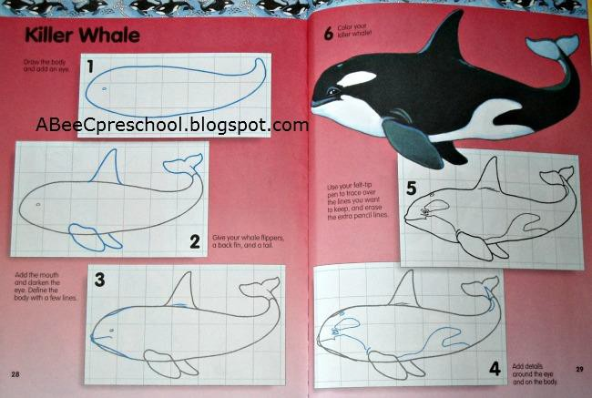

Building Knowledge:
- Continue to refer to the unit essential questions and check for enduring understanding. How does this story help answer our essential questions?
- How do humans connect with and interact with the ocean?
- Why is it so important that people take care of the ocean?
- Is the ocean important to people like you and me, who live far away from it?
- Help students to explore informational texts that deal with ocean animals. Learn how animals that live in and near the ocean can coexist peacefully.
- Watch additional selections of ShamuTV, if time allows.

Guided Practice:
- During workshop/intervention time period, have the students participate in differentiated centers to reinforce lesson topics and skills.
  - Complete Open-ended learning games: Sentence Building (writing and spelling).
  - Sight Words: Pop for Sight Words game.
  - Complete activities in Sounds and Letters for phoneme awareness practice in small group setting. Unit 17 activities in additional materials file (stages 1-7 daily).
  - Read leveled A-Z readers in small groups. Monitor partner reading, choral reading and repeated readings of text, following along in the text when teacher or other fluent reader is reading aloud. Reteach vocabulary during workshop intervention and preteach future vocabulary.
  - Making sentences –un word family (cut and paste into comp book). (Please see additional materials file).

Independent Practice:
- Scientific Journal: Ask students to describe and illustrate a killer whale (Orca) in their journals. Remind students to use the strategies of asking a neighbor, looking at resources in the room, and trying to do it by themselves. Remind students that the journal will be graded based on the rubric, so everyone should be working their best to complete it.
- IMPORTANT!!! Teacher should let students find the necessary information in the room (sight words, word chunk cards, letter-sound correspondence reminders, pictures, books, etc.) to complete journal pages without as much scaffolding.

Additional Materials File/Appendix Thumbnails:
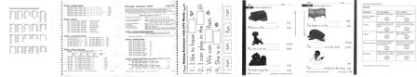

Day 15 | Lesson Design:  - Sound-change game  - Blending –it word family  - Sentence extension  - Decodable book: The Quilt  - Willy the Wisher, “The Lion Roared Like a Waterfall”, pg. 93  - Conduct a science experiment and record steps in journal.  Frontloading:  - Review the unit concept through pictures, hands on realia, discussion.  - Review and reteach unit vocabulary.  - Review stories we have read, videos we have seen, and artwork we have completed. How do all of these things we’ve done relate to the importance the ocean plays in our world?  - Review webs and add to them, if possible.  Lesson Development:  - Use guided practice for the sound-change game, blending words in the –it word family (See appendix G), and extending sentences using same beginning sounds using the Beginning Sounds Play and Learn Phonics game.  - Using guided reading, group reading, choral reading, and partner reading, have students work their way through an Open Court decodable book, The Quilt. Monitor partner reading, choral reading and repeated readings of text, following along in the text when teacher or other fluent reader is reading aloud. Focus on explicitly building students’ academic and content vocabulary skills while instructing using correct syntax with the goal of constantly advancing students towards grade-level reading.  - Read Willy the Wisher, “The Lion Roared Like a Waterfall”, pg. 93 to build questioning and answering skills through visualization and critical thinking strategies. Encourage clarification strategies during The Lion… story and identifying the fictitious attributes of the lion. Facilitate text-based discussions using thought-provoking questions to help with understanding.  - Explain that sometimes in stories animals may do things that they can’t do in real life. Use prior knowledge of There Once Was a Puffin and the Willy the Wisher story from Lesson 15 and make a list of attributes in each story that were fictitious.  - Conduct hands-on Science investigation (Appendix I):  - Materials: jar, salt, water, spoon, potato.  - Fill a jar 1/3 up with water. Add a large amount of salt, stirring until it is completely dissolved. Add another 1/3 fresh water into the jar; pour it gently over a spoon when adding so that it doesn’t mix with the salt water.  - The freshwater will form a layer over the salt water.  - Cut the fresh potato into the shape of a fish. Ask for predictions about what will happen to the fish when it is in the water. Place the fish in the water. (The fish will stay suspended in the middle of the jar.) Talk about why the fish doesn’t sink to the bottom or float on the top.  - What would happen if the salt weren’t mixed into the water?  Building Knowledge:  - Continue to refer to the unit essential questions and check for enduring understanding. How does this story help answer our essential questions?  - How do humans connect with and interact with the ocean?

- Why is it so important that people take care of the ocean?
- Is the ocean important to people like you and me, who live far away from it?
- Help students to explore informational texts that deal with ocean animals. Learn how animals that live in and near the ocean can coexist peacefully.

Guided Practice:
- During workshop/intervention time period, have the students participate in differentiated centers to reinforce lesson topics and skills.
  - Open Court decodable book, The Quilt; use again for fluency practice during workshop. Monitor partner reading, choral reading and repeated readings of text, and following along in the text when teacher or other fluent reader is reading aloud.
  - Sight Words: Pop for Sight Words game.
  - Complete activities in Sounds and Letters for phoneme awareness practice in small group setting. Unit 17 activities in additional materials file (stages 1-7 daily).
  - Read leveled A-Z readers in small groups. Monitor partner reading, choral reading and repeated readings of text, following along in the text when teacher or other fluent reader is reading aloud. Reteach vocabulary during workshop intervention and preteach future vocabulary.
  - Making sentences –it word family (cut and paste into comp book). (Please see additional materials file).

Independent Practice:
- Scientific Journal: Review steps and materials in scientific experiment and list on board. Ask students to make the list in their journals and to illustrate what happened in the experiment.
- Teacher should let students find the necessary information in the room (sight words, word chunk cards, letter-sound correspondence reminders, pictures, books, etc.) to complete journal pages without so much scaffolding.
- Send Home Connection page 99 or page 100 home for parents to review focusing on the puffin story.

Additional Materials File/Appendix Thumbnails:
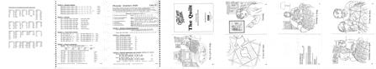
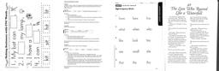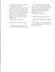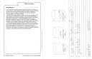

Week Four | Using our five senses helps us to identify with things in the ocean.
Day 16 | Lesson Design:  - Same-sound game  - Consonant riddle game  - Blending -ot  - Sentence extension  - Word-building game  - Vocabulary: sight, sound, smell, taste, feel, hue, chameleon  - Read Hello Ocean by Pam Muñoz Ryan  - Make a web about a jellyfish  - Complete a journal prompt  - Create covers for scientific journals  - Paint a jelly fish  Frontloading:  - Review the unit concept through pictures, hands on realia, discussion.  - Review and reteach unit vocabulary.  - Review stories we have read, videos we have seen, and artwork we have completed. How do all of these things we’ve done relate to the importance the ocean plays in our world?  - Review webs and add to them, if possible.  Lesson Development:  - Use guided practice for the same-sound game, consonant riddle game, blending words in the  –ot word family (See appendix G), and extending sentences using same beginning sounds. Initiate the end of the unit by explaining the end of unit wrap-up. Explain that all the hard work they have been doing in learning new vocabulary, new ways to write what they are thinking, and all the new information they have learned will be completed in their scientific journals and then they will be presenting portions of it to the class and their 4th grade buddies. Each student will have an opportunity to “show off” their knowledge by conducting scientific  experiments and explaining the results to the audience.  - Play the consonant riddle game by writing the word “seal” on the board. “What happens if you change the first sound to /d/? /m/? /r/? Look at the word “seal” again. “What happens if we take off the last sound? What if we added an /m/? How does that change the word?” (L.K.1f, 5a)  - Blending: pen, ten, den, hen, men, send, lend, Jen, Ben, ending, buzz, sand, sound, smell, taste, feel, sight. Talk about how the words are using the rules that they know and how some are not following the spelling rules. Ask if any of the words talk about the same things (5 senses). Create a class anchor chart using the sight words and tell the children that we will look at this chart again after we read our new story. (SL.K.1a, 1b)  - Use a word sort (with pictures) that show the different ways we use our five senses. Work together in small groups (no more than four students) to create words using the word-building supplies (plastic letters, word-building mat).  - Activate prior knowledge of the ocean, animals, and plants that we have learned. Today we are going to focus on experiencing the ocean using our five senses. Browse the book focusing on the illustrations and listening to comments about things that they find interesting. Read story: Hello Ocean by Pam Muñoz Ryan, modeling and using reading comprehension strategies of making connections and visualizing.  - Review the five senses listed on the anchor chart and ask students to tell what body part they

use with each sense. Read the story at least 2 times and have students answer questions about key details in text. (RI.K.1, 2, 3, 7, 10)
- Create writing prompt for scientific journal (work with class to come up with a short sentence that they can write and illustrate in their journal.) For example…I use my hand to touch the starfish. (W.K.1, 2, 3, 8) Remind students that they need to complete this sentence in their journal before they can illustrate the page.
- Paint on a coffee filter with watercolor paints. Allow paintings to dry and then hang simulating a jellyfish.

Building Knowledge:
- Continue to refer to the unit essential questions and check for enduring understanding. How does this story help answer our essential questions?
- How do humans connect with and interact with the ocean?
- Why is it so important that people take care of the ocean?
- Is the ocean important to people like you and me, who live far away from it?
- Help students to explore informational texts that deal with ocean animals. Help students to discover ways that they use their five senses.

Guided Practice:
- During workshop/intervention time period, have the students participate in differentiated centers to reinforce lesson topics and skills.
  - Practice phonics using Beginning Sounds Play and Learn phonics game.
  - Complete activities in Sounds and Letters for phoneme awareness practice in small group setting. Unit 18 activities in additional materials file (stages 1-7 daily).
  - Read leveled A-Z readers in small groups. Monitor partner reading, choral reading and repeated readings of text, following along in the text when teacher or other fluent reader is reading aloud. Reteach vocabulary during workshop intervention and preteach future vocabulary.
  - Making sentences –ot word family (cut and paste into comp book). (Please see additional materials file).
  - Create covers for and put together science journals.

Independent Practice:
- Scientific Journal: Work with class to come up with a short sentence that they can write and illustrate in their journal.) For example…I use my hand to touch the starfish. Remind students that they need to complete this sentence in their journal before they can illustrate the page.

Additional Materials File/Appendix Thumbnails:
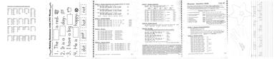
Day 17 | Lesson Design:  - Make a rhyme game  - Review high-frequency words  - Blending –sh word chunk

- Sentence extension
- Word-building game
- S & L Workbook pgs. 144-145, identifying words
- Vocabulary: bubbly, roar, shushing, clang, screak
- Reread Hello Ocean
- Make a web about a swordfish

Frontloading:
- Review the unit concept through pictures, hands on realia, discussion.
- Review and reteach unit vocabulary.
- Review stories we have read, videos we have seen, and artwork we have completed. How do all of these things we’ve done relate to the importance the ocean plays in our world?
- What are our five senses and how do they relate to what we are talking about?
- Review webs and add to them, if possible.

Lesson Development:
- Use guided practice for the make a rhyme game using Rhyming Sounds Play and Learn Phonics game, reviewing high-frequency words using Sight-Word Tales, blending words in the
–sh word chunk (See appendix G), and extending sentences using same beginning sounds. Work together to build words on word building mats and using letter cards in a pocket chart.
- Complete workbook pages 144-145 at desk in large group format. Teacher should model on the white board and circulate to ensure student understanding of assignment.
- Create a web about a stingray in a group setting and post with other webs.
- Reread story: Hello Ocean by Pam Muñoz Ryan, modeling and using reading comprehension strategies of making connections and visualizing.
- Employ Text-Dependent Questions:
  - General understanding:
What does the ocean taste like?
  - Key Details:
What tastes like the ocean?
  - Vocabulary and text structure:
Why is a “salty drink” best for fish and whales?
  - Author’s purpose:
Why does the little girl love the taste of the ocean?
  - Inference:
What type of drops are on the little girl’s face?
  - Opinions, arguments and inter-textual connections:
What might you taste if you went to the ocean?
- Create a web about a swordfish in a group setting and post with other webs.

Building Knowledge:
- Continue to refer to the unit essential questions and check for enduring understanding. How does this story help answer our essential questions?
- How do humans connect with and interact with the ocean?
- Why is it so important that people take care of the ocean?
- Is the ocean important to people like you and me, who live far away from it?
- Help students to explore informational texts that deal with ocean animals. Help students to discover ways that they use their five senses.

Guided Practice:
- During workshop/intervention time period, have the students participate in differentiated centers to reinforce lesson topics and skills.
  - Practice phonics using Beginning Sounds Play and Learn phonics game.
  - Complete activities in Sounds and Letters for phoneme awareness practice in small group setting. Unit 18 activities in additional materials file (stages 1-7 daily).
  - Read leveled A-Z readers in small groups. Monitor partner reading, choral reading and repeated readings of text, following along in the text when teacher or other fluent reader is reading aloud. Reteach vocabulary during workshop intervention and preteach future vocabulary.
  - Word mat –sh word chunk (cut and paste into comp book). (Please see additional materials file).
  - Choose experiment each child wants to “perform”.

Independent Practice:
- Scientific Journal: Work with class to come up with a short sentence that they can write and illustrate in their journal.) For example…Can you hear a swordfish? Remind students that they need to complete this sentence in their journal before they can illustrate the page.

Additional Materials File/Appendix Thumbnails:
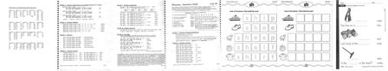
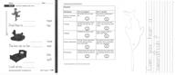

Day 18 | Lesson Design:  - What’s the Sound? Game  - Blending –ch word chunk  - Sentence extension  - Word-building game  - Vocabulary: refrain, tickle, squishy, soggy, fresh, reeky  - Make a web about the ocean  - Review science experiments  Frontloading:  - Review the unit concept through pictures, hands on realia, discussion.  - Review and reteach unit vocabulary.  - Review stories we have read, videos we have seen, and artwork we have completed. How do all of these things we’ve done relate to the importance the ocean plays in our world?  - Review webs and add to them, if possible.

Lesson Development:
- Use guided practice for the What’s the Sound? Game using the I Spy Aquarium game focusing on sounds rather than letter names, blending words in the –ch word chunk (See appendix G), and extending sentences using same beginning sounds.
- Work together to build words on word building mats and using letter cards in a pocket chart.
- Review vocabulary and find illustrations that match it to the text.
- Make a new web about the ocean—compare it to the original web and circle what they know now that is different.
- Review all science experiments in groups. Review presentation rules, safety precautions, and manners. Review science experiments and gather materials for each based on lists in journals.

Building Knowledge:
- Continue to refer to the unit essential questions and check for enduring understanding. How does this story help answer our essential questions?
- How do humans connect with and interact with the ocean?
- Why is it so important that people take care of the ocean?
- Is the ocean important to people like you and me, who live far away from it?
- Help students to explore informational texts that deal with ocean animals. Help students to discover ways that they use their five senses.

Guided Practice:
- During workshop/intervention time period, have the students participate in differentiated centers to reinforce lesson topics and skills.
  - Practice phonics using Beginning Sounds Play and Learn phonics game.
  - Complete activities in Sounds and Letters for phoneme awareness practice in small group setting. Unit 18 activities in additional materials file (stages 1-7 daily).
  - Read leveled A-Z readers in small groups. Monitor partner reading, choral reading and repeated readings of text, following along in the text when teacher or other fluent reader is reading aloud. Reteach vocabulary during workshop intervention and preteach future vocabulary.
  - Word mat –ch word chunk (cut and paste into comp book). (Please see additional materials file).
  - Gather materials for experiments that each child wants to “perform”.

Independent Practice:
- Scientific Journal: Write a final sentence and illustrate what they have learned about the importance of the ocean. Example: The ocean has many animals and helps me have food to eat.

Additional Materials File/Appendix Thumbnails:
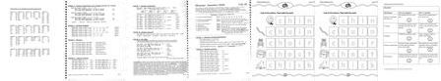

Day 19 | Lesson Design:  - Consonant riddle game  - Blending –ing word chunk  - Sentence extension  - Word-building game  - Humpback Goes North by Darice Bailer  - Review science experiments  - Cut and paste killer whale art activity  Frontloading:  - Review the unit concept through pictures, hands on realia, discussion.  - Review and reteach unit vocabulary.  - Review stories we have read, videos we have seen, and artwork we have completed.  - How do all of these things we’ve done relate to the importance the ocean plays in our world?  - Review webs and add to them, if possible.  Lesson Development:  - Use guided practice for the consonant riddle game, blending words in the –ing word chunk (See appendix G), and extending sentences using same beginning sounds.  - Work together to build words on word building mats and using letter cards in a pocket chart.  - Read Humpback Goes North by Darice Bailer. Review the other story we discussed about a humpback whale (Humphrey) and ask students to compare the same and different attributes about them.  - Review all science experiments in groups. Review presentation rules, safety precautions, and manners. Review science experiments and gather materials for each based on lists in journals.  - Create super easy killer whales from 1 piece of white and 1 piece of black construction paper and 2 wiggly eyes. Make the fins by cutting the edge off of the black circle and then cut that piece exactly in half.  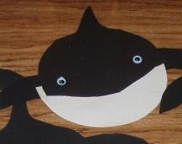  - Post completed whales on By the Sea bulletin board.

Building Knowledge:
- Continue to refer to the unit essential questions and check for enduring understanding. How does this story help answer our essential questions?
- How do humans connect with and interact with the ocean?
- Why is it so important that people take care of the ocean?
- Is the ocean important to people like you and me, who live far away from it?
- Help students to explore informational texts that deal with ocean animals. Help students to discover ways that they use their five senses.

Guided Practice:
- During workshop/intervention time period, have the students participate in differentiated centers to reinforce lesson topics and skills.
  - Practice phonics using Beginning Sounds Play and Learn phonics game.
  - Complete activities in Sounds and Letters practice in small group setting. Unit 18 activities in additional materials file (stages 1-7 daily).
  - Read leveled A-Z readers in small groups. Monitor partner reading, choral reading and repeated readings of text, following along in the text when teacher or other fluent reader is reading aloud. Reteach vocabulary during workshop intervention and preteach future vocabulary.
  - Word mat –ing word chunk (cut and paste into comp book). (Please see additional materials file).
  - Practice scientific experiments in small group setting. (Appendix G)

Independent Practice:
- Scientific Journal: Review experiment and make sure that all materials are collected.
- Send Home Connection page 101 or page 102 home for parents to review.

Additional Materials File/Appendix Thumbnails:
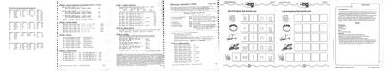
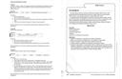
Day 20 | Lesson Design:  - Silly sentences  - Blending –ook word chunk  - Sentence extension  - Word-building game  - Decodable book: Puff  - Willy the Wisher, “Willy’s Lost Kitten”, pg. 98  - Read By the Sea Edited by: Michael W. Dempsey and Angela Sheehan

- Complete KWL chart (from lesson 1)
- Complete unit summative testing
- Perform science experiments for 4th grade buddies.

Frontloading:
- Review the unit concept through pictures, hands on realia, discussion.
- Review what we have learned about the sea.

Lesson Development:
- Use guided practice for the silly sentences game, blending words in the –ook word chunk (See appendix G), and extending sentences using same beginning sounds.
- Work together to build words on word building mats and using letter cards in a pocket chart.
- Using guided reading, group reading, choral reading, and partner reading, have students work their way through an Open Court decodable book, Puff. Monitor partner reading, choral reading and repeated readings of text, following along in the text when teacher or other fluent reader is reading aloud. Focus on explicitly building students’ academic and content vocabulary skills while instructing using correct syntax with the goal of constantly advancing students towards grade-level reading.
- Read Willy the Wisher, “Willy’s Lost Kitten”, pg. 98 to build questioning and answering skills through visualization and critical thinking strategies.
- Read By the Sea Edited by: Michael W. Dempsey and Angela Sheehan
- Complete KWL chart begun in lesson 1
- Review presentation rules, safety precautions, and manners. Make sure that all materials are ready and that students are confident in their abilities.

Building Knowledge:
- Refer to the unit essential questions and check for enduring understanding. Have we answered our unit essential questions? Do we have more questions and things that we want to know about?
- How do humans connect with and interact with the ocean?
- Why is it so important that people take care of the ocean?
- Is the ocean important to people like you and me, who live far away from it?

Guided Practice:
- During workshop/intervention time period, have the students participate in differentiated centers to reinforce lesson topics and skills.
  - Present experiments.

Independent Practice:
- Scientific Journal: Turn in completed journal for summative evaluation based on the rubric.
- Send Home Connection page 101 or page 102 for parents to review.

Additional Materials File/Appendix Thumbnails:
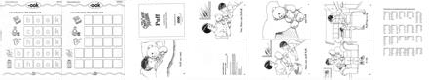

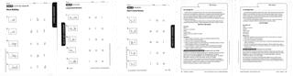

Table of Contents for APPENDICES A-N:

- Student Friendly Rubric  - Teacher Grading Rubric  - Scientific Journal Checklist  - Formative and Summative Assessments  - Scaffolds and Extension Ideas  - List of Additional Texts and Videos  - List of Word Families (by lesson)  - Magic Wand Word game list of supplies  - Science experiments (by lesson)  - Story Starter Prompts  - Fish Pattern for Sight Words, etc.  - Symmetrical Turtle Directions  - Glossary of Terms and Definitions  - Additional File Materials List | - A  - B  - C  - D  - E  - F  - G  - H  - I  - J  - K  - L  - M  - N

APPENDIX A
Kindergarten By the Sea Student Rubric

Student:
Elements | Yes (2 points) | No (1 point)
Pictures of animals from the sea | My animals all live in the sea. | Some of my animals don’t live in the sea.
Coloring | I colored my pictures nicely and they look like the real animal. | I didn’t color my best and some of my animals are silly colors.
Labeling | I labeled my pictures right. | Oops, I forget to label or didn’t label right.
Science experiments | I put the science experiment in order and my pictures show what I did. | My pictures are not in order and don’t show everything I did in my experiment.
Presentation | I followed all of the rules for speaking and did a good job. | I followed some of the rules for speaking and did an okay job.

APPENDIX B
Teacher Grading Rubric for By the Sea Scientific Journal

Student: Date:
Elements | Yes (2 points) | No (1 point)
Pictures of animals from the sea | Journal has lots of animal pictures that live in the sea. | Journal has pictures of animals but many don’t live in the sea.
Coloring | Pictures are colored neatly and true to life. | Pictures are scribbled on or have made up colors.
Labeling | Pictures of animals are labeled correctly. | Pictures of animals are not labeled or labeled wrong.
Science experiments | Process and results of experiments are correctly depicted with words and pictures. | Process and results of experiment are not in correct order or confusing. Words/pictures are hard to read or follow.
Presentation | The student followed all of the rules for speaking and did a good job with the presentation. | The student followed some of the rules for speaking and did an okay job with the presentation.
Comments:

APPENDIX C
Scientific Journal Checklist for By the Sea

Lessons  Numbers | Unit Investigations  (Teacher and students) | Supporting Student Investigations  (Teacher assisted)
Lesson 1 | *Build background for the study of oceans and animals.  *Generate questions about the unit theme. | *Introduce the unit concept through pictures, hands on realia, discussion.  *Begin the concept/question board including student questions and knowledge of the ocean.
Lessons 2-5 | *Draw pictures of animals that live in the ocean in personal science journal.  *Label the pictures using sound/spelling knowledge and the words on the  concept/question board. | *Introduce the science journals and show an example of what they might look like when they are finished. Point out that they will look different, but that they will all contain some of the same things.  *Assist students in labeling their pictures, where necessary.  Remind them to use the strategies of asking a neighbor, looking at resources in the room, and trying to do it by themselves.
Lessons 6-10 | *Observe and participate in experiments to learn the difference between fresh and salt water.  *Write notes about experiments in science journal (include words and pictures). | *Help students conduct scientific experiments to learn about the properties of fresh and salt water.  *Help students write notes and label pictures in scientific journal.
Lessons 11-15 | *Learn how animals that live in and near the ocean can coexist peacefully.  *Draw a picture in scientific journal of animals that live in the ocean peacefully and label appropriately. | *Help students to explore informational texts that deal with ocean animals.  *Help students decide what animals they wish to depict living peacefully and help them to be labeled appropriately.
Lessons 16-20 | *Create covers for and put together science journals.  *Present science experiments to audiences using speaking and listening goals and following class rules. | *Help students to put together journals and write their title on the front cover.  *Arrange for student to repeat the science experiments in groups for their peers. Remind them of the criteria that will be used to evaluate their presentations.

APPENDIX D
Formative and Summative Assessments for By the Sea

Assessments
Formative
- KWL Chart – at least 3 in each column
- Open Court Kindergarten (2005) Sounds and Letters workbook pages 132-145.
- Unit assessments pages 76 (words in context), 77 (high-frequency words), and 78 (word building).
- LANGUAGE! Sounds and Letters (phoneme awareness drills) units 16-18, stages 1-7.

Summative
- Students will recognize different sea animals and confirm their understanding through peer group discussions. (SL.K.1) (Group and peer discussions)
- Students will identify the main idea in an ocean text. (RL.K.1, RL.K3) (Group and peer discussions)
- Students will cite evidence and develop an argument for a favorite sea creature. (W.K.1) (Scientific journal)
- Students will distinguish relevant information about salt water and fresh water plants and animals from illustrations and text. (RL.K.7) (Reading, writing journal, speaking and listening)
- Students will apply simple sentence structure when writing using correct English conventions and appropriate letters. (L.K.1, 1a, 1f) (Scientific journal)
- Students will interpret information obtained through texts, illustrations and activities and will participate in collaborative discussions using class rules. (SL.K.1a) (Scientific journal, group and individual experiments, presentations to peers and buddies)
- Student will complete end of unit assessments pages 80 and 81 (long vowel review and short vowel review).

APPENDIX E
Scaffolding and Extension Ideas

All  Lessons | Scaffolds and Extensions
 | Universal Designs for Learning http://www.udlcenter.org/aboutudl/whatisudl/3principles
 | I. Provide Multiple Means of Representation: the “what” of learning.
- Provide options for perception: make information equally perceptible to all learners through different modalities and adjustable formats.
  - Customize the information: watch the size and color of text, rate and volume of speech, and the font used for printed materials.
  - Offer alternatives for auditory information: provide visual diagrams, charts, music, or tactile equivalents (sounds and letters plus kinesthetic actions for each).
  - Offer alternatives for visual information: describe visuals, images, graphics, use kinesthetic movements to enhance, explore using physical objects, be aware of seating in room.
- Provide options for language, mathematical expressions, and symbols: make connections within subjects through support of preteaching, reteaching, and guided practice within large groups, small groups, and individual instruction.
  - Clarify vocabulary
  - Clarify structure (activate prior knowledge
  - Provide support using explicit instruction
  - Provide instruction in 1st language, when possible; use a variety of visual and non-linguistic supports.
  - Illustrate concepts through a variety of media approaches; link information to illustrations, charts, diagrams, etc.
- Provide options for comprehension: teach learners how to transform information into useable knowledge.
  - Activate or supply background knowledge. (preteach, KWL charts, etc.)
  - Highlight patterns, big ideas, and relationships. (Examples and non examples, outlines, lists, graphic organizers.)
  - Guide information processing, visualization, and manipulation: model, scaffold, and give consistent feedback. (Be explicit in steps, chunk information, remove unnecessary distractions to the instructional goal.
  - Maximize transfer and generalization: don’t teach isolated facts, make sure that instruction includes multiple opportunities to explore and generalize new information, access prior knowledge to scaffold new information.

II. Provide Multiple Means of Action and Expression: the “how” of learning.
- Provide options for physical action.
  - Vary the methods of response required (have the children show how a crab would walk rather than draw a picture of a crab.)
  - Use technology to enhance lessons (PowerPoint, videos, computer programs, iPad applications, etc.)
- Provide options for expression and communication.
  - Use multiple options of media for communication (charts, graphs, visuals, videos, etc.)
  - Use a variety of tools for construction and composition: drawing, writing, talking, acting,

computers, iPads, stories, and experiments.
5.3 Build fluency levels through graduated support: guided reading, guided writing, guided spelling, etc.
- Provide options for executive functions.
  - Help students set appropriate goals.
  - Assist during planning and strategy sessions for reaching goals.
  - Facilitate managing information and resources. (Experiments, journals)
  - Enhance mentoring progress (assign peer groups, cross peer groups, mentor with 4th grade buddies).

III. Provide Multiple Means of Engagement: the “why” of learning.
- Provide options for interest.
  - Provide opportunities for individual choice in exploring the unit concept. This is mostly accomplished during workshop/intervention times when content is more individualized.
  - Make sure that knowledge is relevant, of value and authentic to learners.
  - Minimize distractions to learning.
- Provide options for sustaining effort and persistence.
  - Increase goals and objectives, when necessary. (Advanced students, students who have already reached original goals, etc.)
  - Provide opportunities to vary the demands and resources and optimize challenges in reaching objectives. (Guided learning, peer groups, individualized plans)
  - Foster communication and community through shared learning, group work, peer groups, partner work, and buddies.
  - Increase mastery-oriented feedback. Be involved with students during discussion, reading, and writing opportunities to provide direct feedback that relates to objectives of task.
- Provide options for self-regulation.
  - Promote expectations and beliefs that optimize motivation. (Review rules and expectations of task, make it interesting to students and teacher, and make it fun!)
  - Teach coping skills and strategies so that students are responsible for behaviors. (Love & Logic strategies)
  - Develop self-assessment and reflection. (Perhaps a mini-rubric that asks things in pictures…is this my best, almost my best, not my best work? Student can self-assess through the circling of pictures on the rubric.

Support for students who are ELL, have disabilities or read well below grade level text band:
It is imperative that ELL students or students who have disabilities receive intensive support and instruction both in whole class time and individually throughout the entire day. These intense supports will generally extend beyond ELA requirements and cross into all curriculum areas.

This support must include accessing or building a knowledge base, scaffolding upon prior knowledge, providing multiple opportunities to use different learning modalities, and acknowledging that these students may have a more difficult time in reaching the standards, but accepting the fact that they can reach them with structured, sequential, and systematic lessons.

Using more effective teaching practices include standards-focused lessons, exemplary vocabulary and comprehension instruction, and individualized instruction including small group and one-on-one with the teacher. Active participation in group work will help to develop vocabulary, speaking and listening skills, and self-worth for all students.

All students will benefit from highly focused lesson plans that include student engagement, diverse forms of information presentation, and opportunities to display learning. Structured and focused ELL and disabled student instruction is good for other classroom students, too. This type of focused engagement also provides multiple opportunities to explore the same subject through different modalities. There is really nothing different in teaching a highly focused vocabulary lesson if the instructor focuses on approaching instruction using all language acquisition strategies. All class members will benefit from instruction directed at their level of language acquisition.

Kindergarten students are luckier than most grade levels because much of their instruction occurs in learning groups, activity-based introductions, and lots of hands-on opportunities to explore the subject.
Extensions for Advanced Students
It is more difficult to differentiate for advanced students at the kindergarten level because their knowledge levels still require a lot of hands-on assistance from the teacher for reading, writing, and math.

Most extensions involve additional reading with reading buddies, extra writing prompts, and helping peers in the class. Some students are able to create stories that they can act out for the rest of the class, but that really depends on the topic. Many of the advanced are inclined to do more detailed writing in their journals and many also are more inclined to do public speaking.

One area of extension occurs naturally when more advanced students “buddy” up with a less advanced student during activities. The peer teaching and learning that occurs is often more intense than what would occur between a student and the teacher. With the focus of creating more able students, the CCSS standards encourage more peer interaction and learning opportunities for students to explain their methods or strategies to others. Peer modeling and “teaching” helps to satisfy the need for extending advanced students and for creating peer level leaders.

APPENDIX F
Additional Texts, Videos, and iPad Applications

Texts

There was an old lady who swallowed the sea (illustrated by Pam Adams) Sharks (Anne Schreiber)
Shellfish Aren’t Fish (Allen Fowler) Tish the Fish (Karen Harrington)
Endangered Coral Reef (Toni Albert, M.Ed.) Micro-Facts Oceans (Michael Johnstone) Amazing Sharks! (Sarah L. Thomson)
Ocean Life from A to Z (published by Reader’s Digest Children’s Books) Big Al (Andrew Clements)
Tickly Octopus (Ruth Galloway) Smiley Shark (Ruth Galloway) Fidgety Fish (Ruth Galloway) Ten Little Fish (Audrey Wood)
The Bravest Fish (Matt Buckingham)
The Bravest Fish and the Cave Monster (Matt Buckingham) I Love Sharks (Steve Parker)
Shark in the Dark (Peter Bently)

Related Video Clips

Discovery Education:
- Ocean Habitats: Light and Dark Zones (19 minutes)
- Ocean Habitats: Shoreline and Reef (16 minutes)
- Oceans Alive: Intro to Ocean Life (5 minutes)
- Oceans Alive: Sand Country (5 minutes)
- Reading Rainbow “Humphrey the Lost Whale” (28 minutes)
- Where the Water Meets the Land: What Types of Animals Live in Tidepools? (3 minutes)
- The Magic School Bus Takes a Dive (29 minutes)
YouTube:
- The Amazing Water World of Marine Animals
Full-length videos:
- Finding Nemo
- The Little Mermaid
- Dolphin Tale

Related free iPad applications

- Ocean Animals Game (ages 2-5) includes sorting and counting
- ABC Ocean Games (spelling skills)
- Underwater Math Game (counting and calculating for numbers up to 20)
- Ocean Shapes and Color Free (learn about sea animals)

APPENDIX G
Word Family Lists for blending during guided reading lessons:

Lesson 1 –in spin thin  chin shin  win fin  bin din  kin pin  sin tin | Lesson 2 –ap chap cap  gap yap  lap map  nap rap  sap tap  happy | Lesson 3 –ut shut hut  cut but  gut jut  nut rut  button | Lesson 4 –og bog clog  dog fog  hog jog  log frog  toggle | Lesson 5 –s dogs cats  fins caps  cuts bugs  hens pets  mops ships  fans beds  buns pits  pots rings
Lesson 6 –en den fend  hen Ken  lend men  pen sent  ten vent  went yen | Lesson 7 –at bat cat  flat chat  hatch mat  pat rat  that sat  vat brat | Lesson 8 –et bet get  jet let  met net  pet set  vet yet | Lesson 9 –ug bug dug  hug jugs  lug mug  pug rug  tug shrug | Lesson 10 –op chop flop  shop hop  lop mop  pop top  stop
Lesson 11 –ip chip dip  ship hip  lip pip  quip rip  sip trip  whip yip zip | Lesson 12 –an ban can  Dan fan  hand man  pan ran  sand tan  van than | Lesson 13 –ed bed fled  red Ted  wed shed | Lesson 14 –un bunch fun  pun run  sun lunch | Lesson 15 –it bit fit  hit kit  lit pit  quit sit
Lesson 16 –ot cot got  hot jot  lot not  pot rot  tot shot | Lesson 17 –sh- wish dish  ship shine  fish shape  shade mash  she shot | Lesson 18 –ch chap ching  chip chop  chum champ  chest chat  chug chin | Lesson 19 –ing thing sing  fling king  rings bring  ping wing  zing sting | Lesson 20 -ook book cook  hook look  nook rook  took shook

APPENDIX H
Magic Wand Words Game for Guided Practice during workshop/intervention

This is a game that invites students to use phonemic awareness and word building skills to create a given word.

The materials include:
- a “magic” wand (magnetic wand found in fabric stores to pick up errant pins) per child
- at least 3 (preferably 4) magnetic discs per child
- Word List of CVC and Long-Vowel words that can be “sounded out”

Game Play:
Each student is given a magic wand and three or four magnets. The magnets are placed on the floor in front of each student. The teacher says the word and the students repeat it. They all use their hands to indicate how many sounds are in the word. Then they “push” the sounds using the magnets on the floor moving from left to right as they push the sounds up from them. When the teacher is satisfied that the word has been “sounded out” correctly using hands and pushing the magnets, the students then start (left to right) to magically lift the sounds off the floor (saying the sounds as they pick them up). When they have all three (or four) magnets on the magic wand, they can then say the word.

Suggested Word List for By the Sea:

get | match | dine | ate | house | meat | shell | whale
crab | my | fish | boat | sea | ocean  /o/sh/n/ | wave | hear
grass | fresh | salt | sight | soggy | mammal | touch | float
smell | water | roar | clang | hue | find | sink | earth
web | seal | chunk | rules | safe | puffin | turtle | open
squish | care | feel | sound | drop | taste | face | girl
yucky | yummy | lost | life | sand | tail | fin | blow
fish | ray | shark | play | reeky | learn | eel | fact
label | old | best | pick | join | help | sword | star

APPENDIX I
Science Experiments by Lesson:

Lesson 7:
Complete “science” project of comparing freshwater and saltwater by preparing a taste of both for each student. Invite all students to taste the water and talk about how they are different they are.

Materials:
2 glasses of water | salt | spoon | 2 bathroom sized Dixie cups per student

Procedure:
- Leave one glass alone.
- Stir some salt into the other glass.
- Have a taste from both glasses (teacher pours a little bit into bathroom sized Dixie cups).
- Vote on which is better for humans? Better for ocean creatures?

Record materials in a list in the scientific journal (teacher modeled) and provide an illustration.

Lesson10:
Sink or Float experiment.

Materials:
2 jars | salt | water | spoon
hard-boiled egg | assorted items that float to experiment with

Procedure:
- Fill water in both jars to about ½ way up.
- Mix salt into one jar using the spoon.
- Experiment using hard-boiled egg and assorted items to see what will float

Record materials in a list in the scientific journal (teacher modeled) and provide an illustration.

Lesson15:
Conduct hands-on Science Sink or Float investigation. Materials:
jar | salt | water | spoon | fresh potato | sharp knife

Procedure:
- Fill a jar 1/3 up with water.
- Add a large amount of salt, stirring until it is completely dissolved.
- Add another 1/3 fresh water into the jar; pour it gently over a spoon when adding so that it doesn’t mix with the salt water. The freshwater will form a layer over the salt water.
- Cut the fresh potato into the shape of a fish. Ask for predictions about what will happen to the fish when it is in the water. Place the fish in the water. (The fish will stay suspended in the middle of the jar.)
Talk about why the fish doesn’t sink to the bottom or float on the top. What would happen if the salt had not been mixed into the water?

Record materials in a list in the scientific journal (teacher modeled) and provide an illustration.

APPENDIX J
Story Starter Idea Prompts

- Have the students work in groups of three. Assign group numbers (i.e. 1-10, if there are 30 students).
- Tell each student that they are going to make up a story about a sea/ocean animal who has a problem and who is able to find a solution to the problem. They will need to work together to choose the animal, the problem, and the solution and must agree to work together to get the job done.
- Explain that each story must have a problem, an idea for solving the problem, and an ending that tells how the sea creature feels when the problem is solved.
- To ensure that all students have a chance to participate, assign each student a part of the story that they are responsible for (beginning, middle, ending).
- Invite the groups to share by pulling the previously assigned group numbers from a hat when it is time for the presentations. Remind students that they shoud be practicing using good listening and speaking skills as each group presents their story.
- Continue the activity until all groups have completed their story-telling sequence.

- Here is a sample of the type of stick figures you may want to include in the “story” telling sequence:

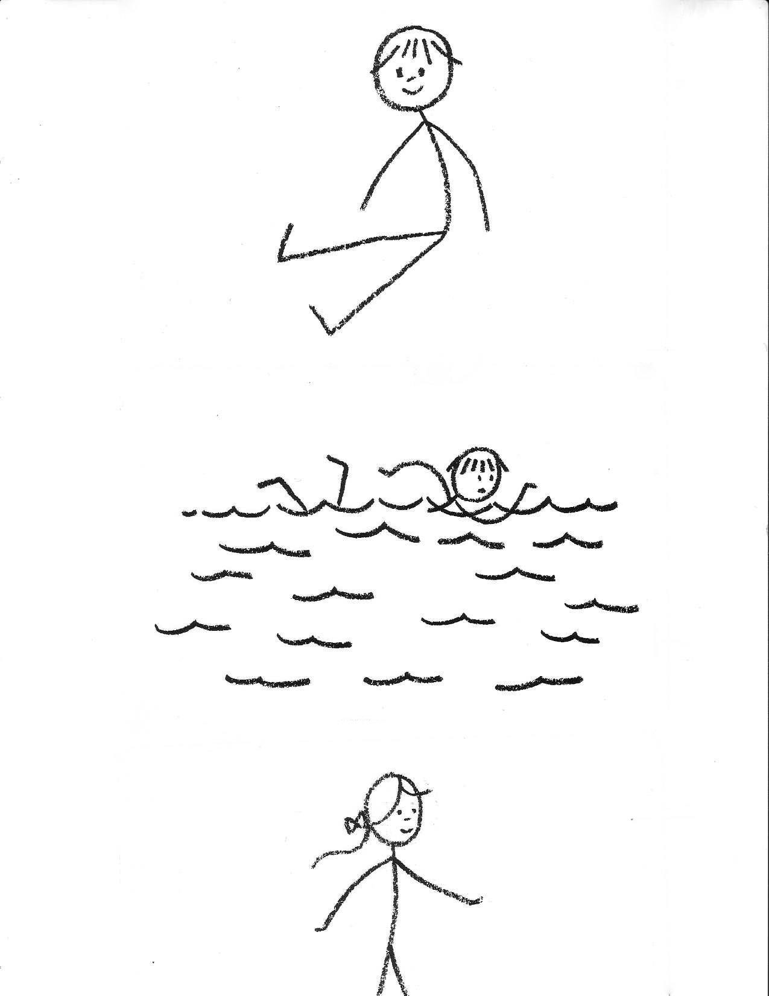

APPENDIX K
Fishing Pole Fish or Sight Word Fishing Pattern
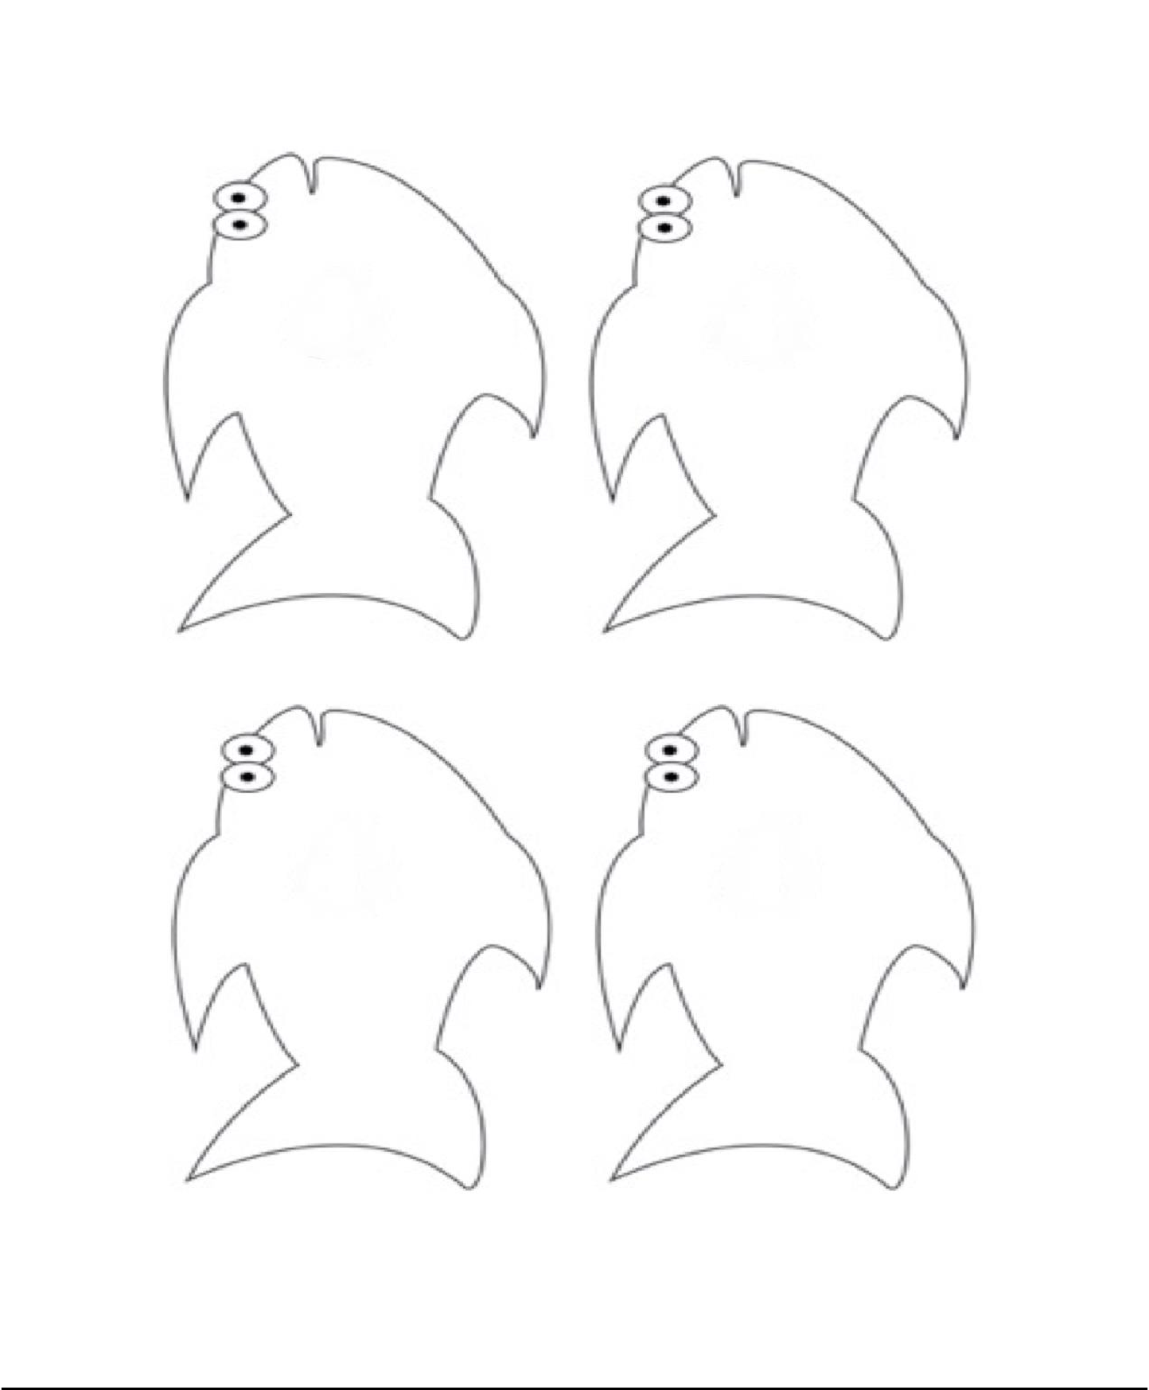

APPENDIX L
Directions for making a Symmetrical Turtle (lesson 8)
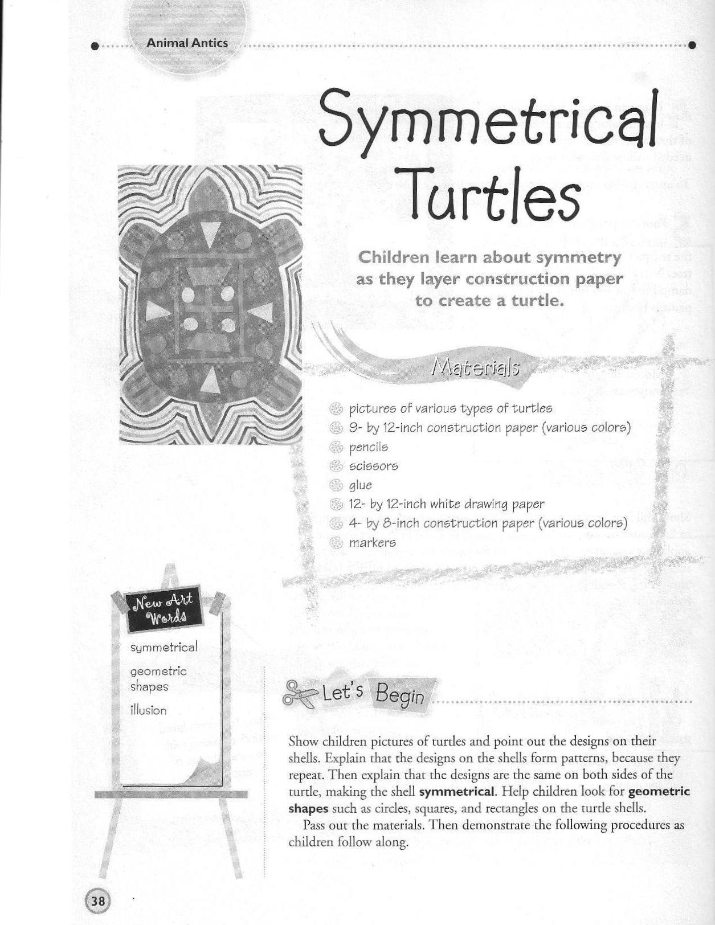

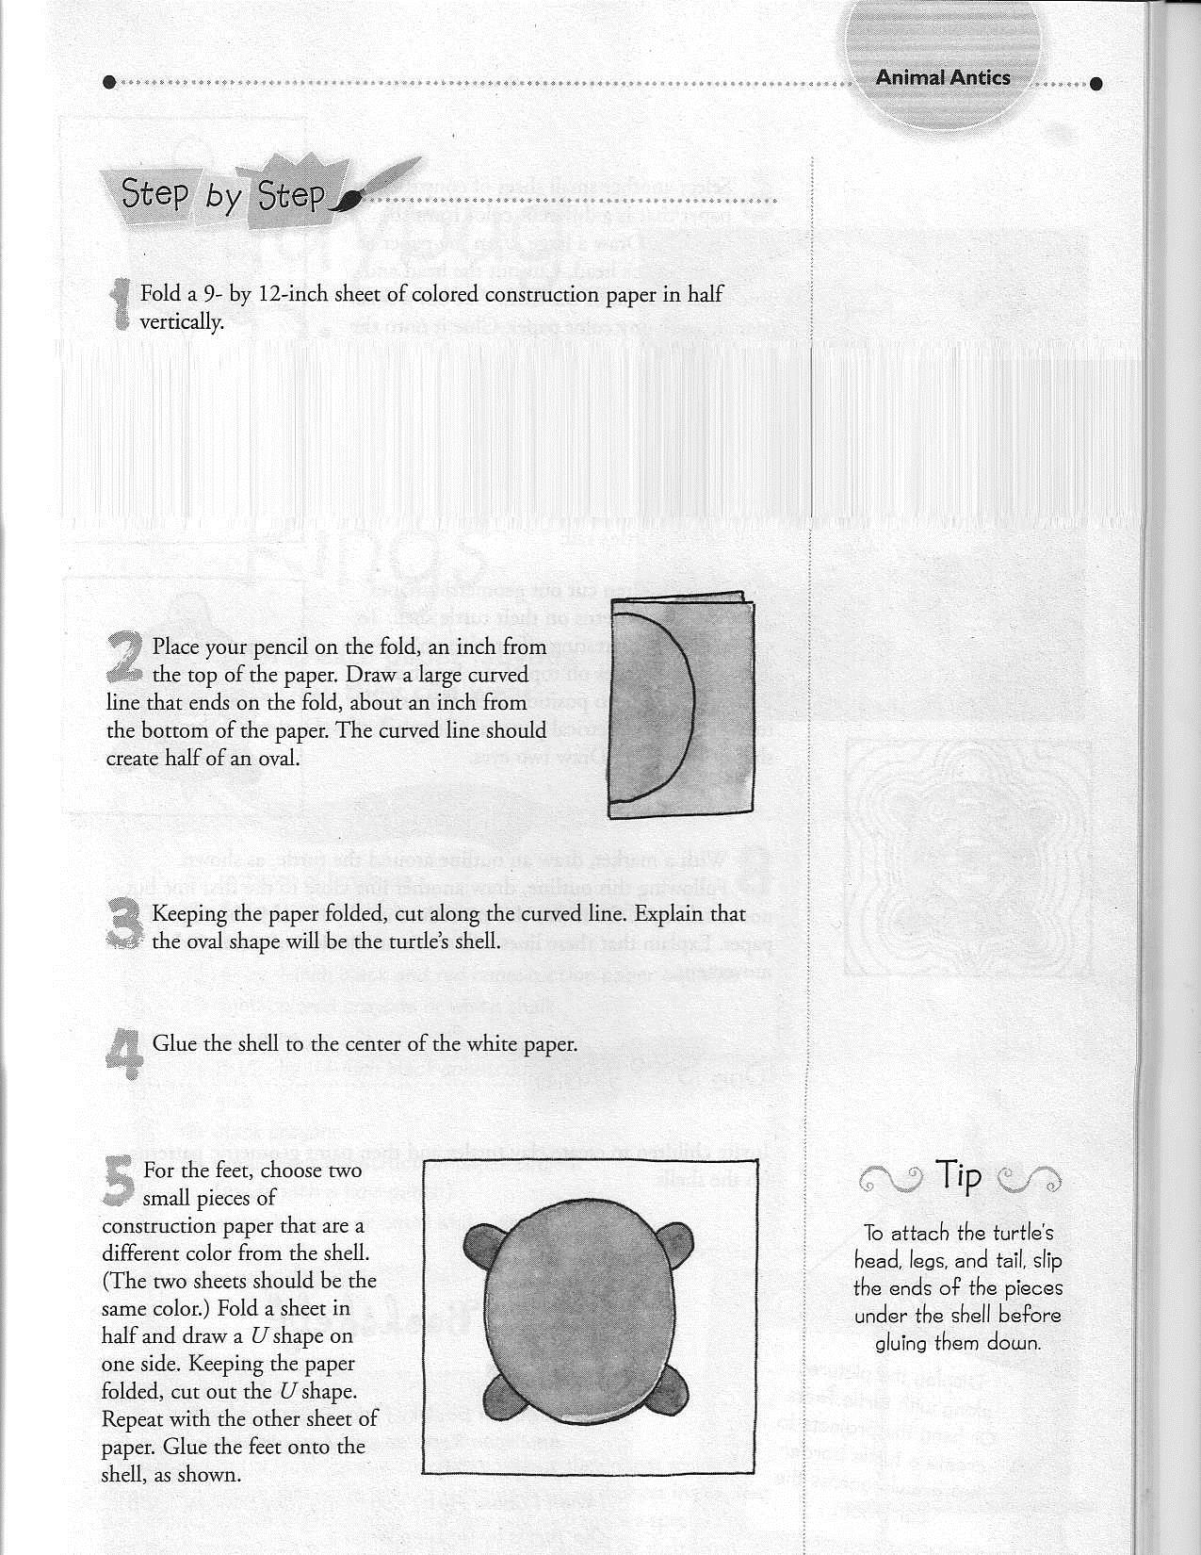

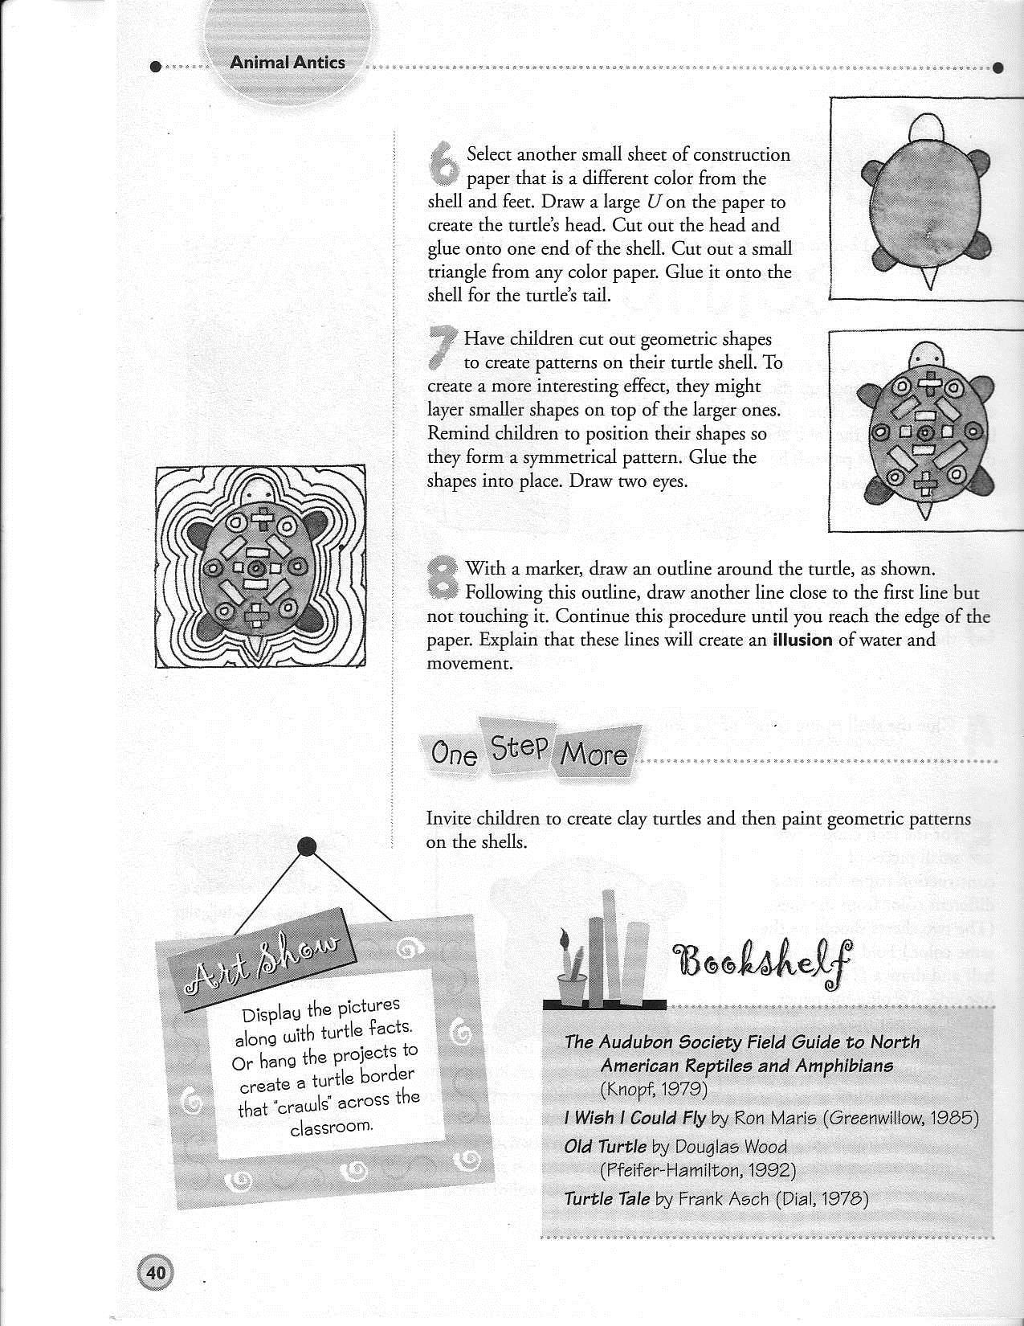

APPENDIX M
Glossary of Open Court Reading Routines

- Sound-by-Sound Blending
  - Write the spelling for the first sound.
  - Have students say the sound.
  - Write the spelling for the second sound.
  - Have students say the sound.
  - If the second sound is a vowel, blend through the vowel making a blending motion with your hand.
  - Write the spelling of the next sound.
  - Have studens say the sound.
  - If it is the last sound in the word, make the blending motion as students blend
and read through the word; if it is not the last sound, continue writing the spellings.
  - Students reread the word naturally as they would speak it.
  - Example:
Teacher (writes the letter on the board): c Students (say the sound the letter represents): /k/ Teacher (writes the letter on the board): a Students (say the sound the letter represents): /a/ BLEND (put sounds together) /k/ /a/= ka Teacher (writes the letter on the board): t Students (say the sound the letter represents): /t/
BLEND (put sounds together) /ka//t/= kat (sounds are belended into word) Repeat reading naturally “cat, cat, cat.”

- Reading Decodable Books
  - Review high-frequency words found in the story and new words by writing them on the white board and “sounding out” through the sound-by-sound blending process if applicable. Review the words multiple times before introducing the story to students.
    - Point out the words in context.
  - Pass out a book to each student.
  - Point out and read the name of the title pointing to each word.
  - Read the names of the author and illustrator and point them on the title page.
    - Remind students that an author writes the story and the illustrator draws the pictures.
  - Do a “picture walk” through the story having students browse, commenting on the illustrations and making predictions about what the story might be about.
  - Teacher reads the story completely through without stopping.
    - Move your hand beneath the words to show progression of print.
    - Answer any questions the students may have about the story.
  - Reread the book.
    - Have students point out high-frequency words they recognize.
    - Read the title aloud.
    - Read the title again and have students read it with you.
    - Make sure that students are following along with their “pointer fingers” as they read.
    - After you complete one page, have a student (pull sticks from a can, etc.) read it aloud; continue this way through each page of the book.

    - Pair up students (high with medium, medium with lower students)for partner reading of the book. Reinforce “knee-to-knee” and “mouth-to-ear” reading as you monitor reading throughout the room.
    - Change reading buddies and reread again. Practice again during workshop time. Students will be expected to read it individually to the teacher before “passing it off.”

- High-frequency words are not well defined in CCSS, but students are expected to learn a variety of highly used words in kindergarten. In our curriculum, Open Court 2005, our students are exposed to and are expected to learn 34 high-frequency words. We use these words consistently throughout the year in our reading, writing, and speaking opportunities. Students are assessed throughout all the units for mastery of learning. Additionally, each student is assessed on a monthly basis to determine their proficiency with the words. These are the words that we use:

a | an | and | are | at | big
can | do | down | go | he | here
has | have | I | in | is | it
like | my | no | not | on | see
she | small | the | this | too | up
we | what | who | you

We use these words on a daily basis: we review them on our word wall, write them in our writing journals, use them in workshop/intervention practice, apply them in our speaking, and read and identify them in our books. Additionally, we introduce color words, number words, and student names on our sight word wall.

- Concept/Question Board: for each unit we develop through the year, we create a concept (things we know) and question (things we want to know) board. We use this board to display our knowledge of a subject and to develop it further as we progress though our unit of learning. We add things to the board throughout the unit and use it to spark our show and tell activities.

- Guided practice: The teacher provides opportunities for students to learn and practice new concepts through constant guidance during the lessons and workshop/intervention times. The teacher uses as many different modalities as possible to reinforce the learning opportunities.

- Reading a story selection:
  - Before reading a story:
    - build background by activating prior knowledge and sharing relavant information.
    - browse the selection and set purposes for reading.
    - develop an understanding of selection vocabulary.
  - During reading:
    - have students stop periodically and check to see if the text is making sense to them. Use strategies like Clarifying and Predicting to support comprehension.
    - have students reread the text having students apply comprehension skills.
  - After reading:
    - have students make connections to other selectins in the unit as well as to selections in other units.
    - have students discuss what new information they have learned.

APPENDIX N
Additional Materials (Separate file)

Open Court Home Connections
- Lesson 1, pages 91, 92
- Lesson 4, pages 93, 94
- Lesson 5, pages 95, 96
- Lesson 10, pages 97, 98
- Lesson 15, pages 99, 100
- Lesson 20, pages 101, 102

LANGUAGE! Sounds and Letters (Phoneme Awareness Drills)
- Unit 16 pages 1, 2, and 3
- Unit 17 pages 1 and 2
- Unit 18 pages 1, 2, and 3

Open Court Unit 8 Lesson and End of Unit Assessments
- Lesson 10, page 76
- Lesson 15, page 77
- Lesson 20, page 78
- End of Unit, page 80
- End of Unit, page 81

Open Court Unit 8 Decodables
- A Bump (4 pages)
- A Ramp (4 pages)
- A Quilt (4 pages)
- Puff (4 pages)

- Open Court Unit 8 Sounds and Letters Worksheets

  - Lesson 1 pages 132 & 133
  - Lesson 4 pages 134 & 135
  - Lesson 7 pages 136 & 137
  - Lesson 9 pages 138 & 139
  - Lesson 12 pages 140 & 141
  - Lesson 14 pages 142 & 143
  - Lesson 17 pages 144 & 145

Scientific Journal Entries
  - Lesson 2 (ocean animals)
  - Lesson 3 (crab)
  - Lesson 4 (shark)
  - Lesson 5 (shells)

  - Lesson 6 (whale)
Scientific Journal Entries continued
  - Lesson 7 (experiment)
  - Lesson 8 (seahorses)
  - Lesson 9 (fish)
  - Lesson 10 (experiment)
  - Lesson 11 (puffin)
  - Lesson 12 (ocean animals)
  - Lesson 13 (dolphin)
  - Lesson 14 (killer whale {Orca})
  - Lesson 15 (experiment)
  - Lesson 16 (starfish)
  - Lesson 17 (swordfish)
  - Lesson 18 (ocean animals)

Willy the Wisher (thinking stories)
  - Lesson 5, pages 89-90 (“Mr. Muddle Tells About the Circus”)
  - Lesson 10, pages 95-97 (“I Know All About Mr. Muddle”)
  - Lesson 15, pages 93-94 (“The Lion Roared Like a Waterfall”)
  - Lesson 20, pages 98-99 (“Willy’s Lost Kitten”)

Workshop/Intervention Worksheets
  - Building Words
- Building Words –ap word family
- Building Words –en word family
- Building Words –it word family
- Building Words –og word family
- Building Words –ut word family

  - Letter Slides
- Letter Slide –at word family
- Letter Slide –et word family
- Letter Slide –ip word family
- Letter Slide –op word family
- Letter Slide –ug word family

  - Making Sentences
- Making Sentences –an word family
- Making Sentences –ed word family
- Making Sentences –it word family
- Making Sentences –ot word family
- Making Sentences –un word family

  - Workmats
- Workmat page 1 –ch Word Family
- Workmat page 2 –ch Word Family (just cut out the letters)
- Workmat page 1 –ing Word Family

- Workmat page 2 –ing Word Family (just cut out the letters)
Workshop/Intervention Worksheets continued
- Workmat page 1 –ook Word Family
- Workmat page 2 –ook Word Family (just cut out the letters)
- Workmat page 1 –sh Word Family
- Workmat page 2 –sh Word Family (just cut out the letters)

Works Cited

Adams, M. J. (2005). Sra open court reading: Pre-decodable and decodable takehome books. Columbus, OH: SRA.
Bereiter, C., & SRA/McGraw-Hill. (2002a). Sra open court reading: Level k home connection. Columbus, OH: SRA.
Bereiter, C., & SRA/McGraw-Hill. (2002b). Sra open court reading: Level k sounds and letters skills.

Columbus, OH: SRA.

Bereiter, C., & SRA/McGraw-Hill. (2002c). Sra open court reading: Level k units 1-8 assessment.

Columbus, OH: SRA.

Brockman, M. L., & Peteete, S. (2007). Mega-book of instant word-building mats. New York, NY: Scholastic.
Carney, E. (2006). Rhyming words puzzle cards. New York, NY: Scholastic.

Chavez-Rodriguez, F., Saenz-Ulloa, M., Mastromarco-Diaz, S., & Teacher Created Resources, Inc. (2008).

Word family activities: Short vowels : grades K-1. Westminster, CA: Teacher Created Resources.

Fleming, M., Phillips, M., Higgins, M., Chambliss, M., Wilhelm, H., Garfield, V., . . . Scholastic Inc. (2008a). AlphaTales: Learning the ABC's is easy and fun. New York, NY: Scholastic Professional Books.
Fleming, M., Wummer, A., Lyon, T., Girouard, P., Gordon, M., Quinn, J., . . . Franfou. (2008b). Sight word tales: 25 read-aloud storybooks that target & teach the top 100 sight words. New York, NY: Scholastic, Inc.
Greene, J. F. (1997). Sounds and letters for readers and spellers: Phonemic awareness drills for teachers and speech-language pathologists. Longmont, CO: Sopris West.
Key Education Publishing Company. (2007a). Textured touch and trace cards: First "30" words.

Minneapolis, MN: Carson-Dellosa Publishing Company.

Key Education Publishing Company. (2008b). I spy alphabet aquarium. Minneapolis, MN: Carson-Dellosa Publishing Company.
Key Education Publishing Company. (2008c). Open-ended learning games: Sentence building.

Minneapolis, MN: Carson-Dellosa Publishing Company. Lakeshore. (n.d.a). Alphabet mystery box. Carson, CA: Author.
Lakeshore. (n.d.b). Beginning sounds play and learn phonics game. Carson, CA: Author. Lakeshore. (n.d.c). Creating sight-word sentences center. Carson, CA: Author.
Lakeshore. (n.d.d). Rhyming sounds play and learn phonics game. Carson, CA: Author. Learning Resources. (n.d.). Pop for sight words. Vernon Hills, IL: Author.
Maio, B., & Williams, R. L. (2012). Cut & paste sight word sentences. Huntington Beach, CA: Creative Teaching Press.
Nayer, J., Charlesworth, L., Fleming, M., & Scholastic Inc. (2006). Phonics tales!: 25 read-aloud storybooks that teach key phonics skills. New York, NY: Scholastic.
SRA/McGraw-Hill. (2005). SRA open court reading: Level K - unit 8. Columbus, OH: Author.

