Unit Title: Writing an Informational Five Paragraph Paper 3rd Grade
Author: Tina Davis

Unit Rationale:
Third grade students need to understand and be able to produce a variety of writings. For the purpose to this unit, we will concentrate on Informative. The students in my school district greatly need to have more time spent with writing. The goal of this unit is to explicitly model the process of researching and writing an informational five paragraph paper. The emphasis is the structure of informational writing. Informative texts present facts, define terms, and provide examples to inform the reader. The writing can support research, observations, or experiences. Students will be using strategies to organize ideas for specific tasks and purposes. They will generate ideas through a variety of activities such as brainstorming, graphic organizing, drawing, and discussing. Students will be aware of the purpose of writing for the intended audience.
Focus Standards being Explicitly Taught and Assessed for Whole Unit
*R.I.3.2. Determine the main idea of a text; recount the key details and explain how they support the main idea.
*R.I.3.5. Use text features and search tools (e.g., key words, sidebars, hyperlinks) to locate information relevant to a given topic efficiently.
*W.3.2. Write informative/explanatory texts to examine a topic and convey ideas and information clearly.
*W.3.4. With guidance and support from adults, produce writing in which the development and organization are appropriate to task and purpose. (Grade-specific expectations for writing types are defined in standards 1-3).
*W.3.5. With guidance and support from peers and adults, develop and strengthen writing as needed by planning, revising, and editing.
*S.L.3.4. Report on a topic or text, tell a story, or recount an experience with appropriate facts and relevant, descriptive details, speaking clearly at an understandable pace.
*L.3.2. Demonstrate command of the conventions of standard English capitalization, punctuation, and spelling when writing.

Measurable Objectives for Whole Unit:
- Students will be able to brainstorm and choose a topic.
- Students will be able to read and respond to information paragraphs identifying topic, facts, and concluding statements to connect ideas within categories of information.
- Students will be able to examine information pertaining to topic using graphic organizers.

- Students will be able to determine main ideas, details, topic sentence, and concluding sentence for their topic.
- Students will be able to use various text features and search tools to locate key facts or information in a text.
- Students will be able to gather and organize details on note cards.
- Students will be able to write informative text that includes: a topic that groups related information together along with a concluding statement.
- Students will be able to plan, revise, edit, proofread, and rewrite paragraphs.
- Students will be able to receive and give responses to writing.
- Students will be able to report verbally using a logical, organizational format related to their topic utilizing descriptive details and clear speech at an understandable pace.

Unit Enduring Understandings Addressed:
- Students will use an expository organizational structure to write paragraphs that: uses factual information about a familiar topic, includes an introductory paragraph with an effective lead, develops a topic with supporting details, used transitions to link paragraphs, and ends with an effective conclusion.
- Students, with assistance from peers and teacher, will reread and revise writing for meaning, clarity, and sentence fluency by: combining and moving sentences/paragraphs to improve the focus and organization of ideas, using effective transitional phrases.
- Students will use editing checklist for grade level conventions.

Unit Essential Questions Addressed
*How does a good writer make information clear and interesting?
*How do writers develop a well written product?

Texts/Resources Recommended
Text and Level of Complexity
The Weddell Seals of Antarctica by: Sandy Riggs Type of text: Informational Nonfiction
Lexile: 670
Accelerated Reader: 3.4
This text being on grade level with short chapters should be an overall appropriate read for all students. It is full of information which includes diagrams that will challenge the students as well as hold their interest.
Working in small groups and with partners will assist those students who may struggle a bit with some of

the vocabulary and information.

Scaffolds/Supports for Texts:
Life in Antarctica by: Kenji Foster
This is a short three paragraph text that we will use for a partner and group close read learning to look for details and questions in our reading.
Penguin Chick by: Betty Tatham
This is the curriculum read for the week that the students will follow along with as they have it read to them on the smartboard as a whole class as an introduction.
Additional Materials Recommended
http://www.youtube.com/watch?v=BYRPsUuxknc 3 min.video put to music entitled:
Did you Know? Interesting Facts about Animals
Key Vocabulary Terms for Unit:
Explicitly Taught: main idea, details, conclusion, paragraph, sentence, brainstorm, topic sentence, proofread, revise, edit, draft, rubric, prewriting, publish, transition

Differentiation (based on principles of UDL): http://www.udlcenter.org/aboutudl/whatisudl/3principles
Multiple Modes of Representation:
I.3.3 Guide information processing, visualization and manipulation.

Multiple Modes of Expression
II.6.6 Support planning and strategy development.

Multiple Means of Engagement
III.8.3 Foster collaboration and communication.

Accommodations:
Below grade level students will be partnered with a higher level student making sure that they both contribute while supporting and assisting each other. This will also benefit the higher level students by placing them in a teaching and assisting role. I as the teacher will also meet with the below level students one on one or in small groups to review each step of the process and slowly move them along, giving them

small pieces at a time.

Above grade level students will be asked to type their final copy on the computer as well as have it handwritten, because a part of the rubric criteria is showing legible writing and neatness.
I will be using writer’s workshops with multiple lessons on the various skills associated with their writing of a paragraph; including main idea and details, editing, topic and concluding statements, rough drafts, and proofreading to help those who need additional help and support.

Procedures for Lesson One:
Title of Lesson Plan: Prewriting/Brainstorming, and Analyzing Informational Paragraph
Time Frame | Sequenced Activities, including evidence of text-dependent questioning
1  week | Today we are going to learn to plan an informational paper.  The purpose for writing is to summarize factual information from different sources. It is also to share what you have learned with your audience.  When we begin to write, we must remember the six stages of the writing process.  - Prewriting/Research  - Drafting  - Revising  - Proofreading/Editing  - Publishing  - Sharing  Prewriting Checklist:  - P= Pick a topic  - O= Outline your ideas; think about your audience and your purpose.  - I= Introduce the main idea in the topic sentence.  - N= Note the 3 supporting details.  - T= Tie it all together.  - S= Sum it up by restating the main idea in your conclusion.  Introduction: Students will follow along with the words on the smartboard as they listen to  “Penguin Chick” read to them which is the required text from our reading series. After listening to the story, as a whole group we will discuss the authors purpose for the story (to inform) and the details we learned about penguins.  Close Reading Activity:  * Teach students how to annotate by reading aloud to the class the first paragraph entitled “Plants” from Life in Antarctica. As I read I will demonstrate aloud the following process:  -Circle important parts or powerful words and phrases.  -Underline words or phrases that are confusing or they do not understand.  -Write important thoughts in the margins.  * Have half of the students read the second paragraph entitled, “Seabirds” from Life in

Antarctica, silently and annotate on their own. The other half will read the third paragraph entitled,
“Seals and Whales” from Life in Antarctica and also annotate on their own.
- With a partner, share what they circled, underlined, and write down what questions they have about the text.
- Next, students will get together in two small groups, one for the paragraph “seabirds” and the other for the paragraph “Seals and Whales”. They will share their questions and answer any of the questions for each other. (My job is to just facilitate the conversations.)
- I will now read the whole story again which will include the paragraphs the students just read from Life in Antarctica aloud to the class and ask them to continue to annotate by underlining any new ideas/points/questions as I read.
-Afterwards, I will give them a moment to write in the margin any new thoughts/comments if they haven’t done that while I was reading.
- Students share their new thoughts/ideas with partners and then to the group.
- I close by reviewing what we accomplished and the steps we went through. I will explain that it’s okay to have different things circled and underlined than each other because we are all different people and will see different things in the text. The purpose is to carefully and closely read to gather all the information and understanding that we can.

Anticipatory Set: Show video: “Did you Know? Interesting facts about animals.” http://www.youtube.com/watch?v=BYRPsUuxknc
Teacher Led: Teacher will pick a letter from a hat. (S) On a paper folded into 3-5 parts, brainstorm 3-5 possible animals for the letter choices. Write facts that I know about each. From that information, choose the one animal that interests me the most to be my topic. (Seal)
Using white board or chart paper, web details I know about the seal. (What looks like, where lives, what eats.)

Group Work: Divide students into 3 groups; each group assigned a chapter. Give assigned chapter copies of The Weddell Seals of Antarctica to students. Students read in their groups silently their assigned chapter using the close reading strategies we did previously using annotations.
Text-Dependent Questions:
- For their second read, after they have done a close read and annotated, they will work on these text-dependent questions finding answers and evidence.
  - (Questions about the overall meaning of the paragraph) What happened in the chapter? Use the words first, then, next, and finally to retell.
  - (Vocabulary questions) In chapter 1, the author used the word shuffles, chapter 2, the author used the word fierce, chapter 3, the author used the word prey. For the chapter that you read, what do you think that word means? Why do you think the author used that description in the chapter?
  - (Genre question) What genre is this story? What does that mean? How do you know?
  - (Inference question) Is the Weddell Seal considered a good hunter? Find parts in the story to help you decide.
  - (Opinion) What type of protection would you need to live in a cold, icy climate?
  - (Vocabulary and Opinion) Some people want to drill for oil in Antarctica. If this were allowed, how would it affect the Weddell Seals?

Now students will write additional facts they found from their reading about Seals on post-its

notes given them. Groups will then add their post-its to the web we started on the board.
Using the “Cluster Web” we created about seals, we will now organize that web into categories (example: diet, habitat, babies…) under these categories we can then move our post-its to the correct category. The final 3 categories will later become our paragraphs.

Independent Work: Students will now each choose their own letter from a hat which will be the starting letter of their animal to write about.
On a paper folded into 3-5 parts, brainstorm 3-5 possible animals for their letter chosen. Write facts that they know about each.

From that information, choose the one animal that interests them the most to be their topic.

Using the “Cluster of Ideas Web Handout” write their animal in the center. Write at least 3 things they know about their animal in circles around center. The other circles will be filled by research. They can draw more circles around if needed.

Hand out to each student a copy of the “Scoring for Information Paragraph Unit”, and “Informational Paragraph Rubric”. Explain them both to the students so that they are aware of what will be required of them throughout this process, and how their final paper will be scored.

Hand out “Planning An Animal Report Sheet.” Have students fill in their animal name, why they chose it, and questions that they have about their animal that they would like to find out.

Research: Students will find at least one book on their animal in the library. As they are looking for their book, they need to refer to their questions they wrote on their planning sheet along with their cluster sheet. This will help them focus their search for the information they want to find. They will also have to research their animal on the internet to find at least one site giving additional information. For this search I will suggest they google “interesting facts about….” From the research, they will be able to fill in the rest of their ‘Cluster Web” and complete their “Planning Sheet.”

Give each student a “Boxes and Bullets” sheet to organize their web into 3-5 of their favorite categories, eventually narrowing it down to their favorite 3 for their paragraphs. (example: habitat, birth, diet)
Success Criteria for Lesson:
*Students will fill out their own cluster map of ideas.
*Students will organize their cluster map information into bullets of topics from their research.
*Students will organize their thoughts on a planning sheet.

Assessments
Formative:

- Cluster Web
- Boxes and Bullets
- Planning Sheet

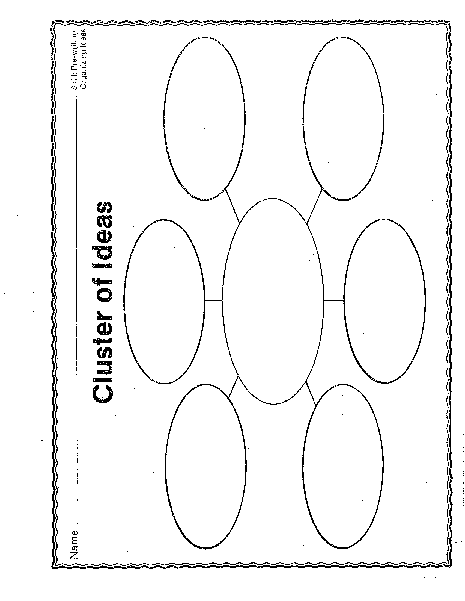

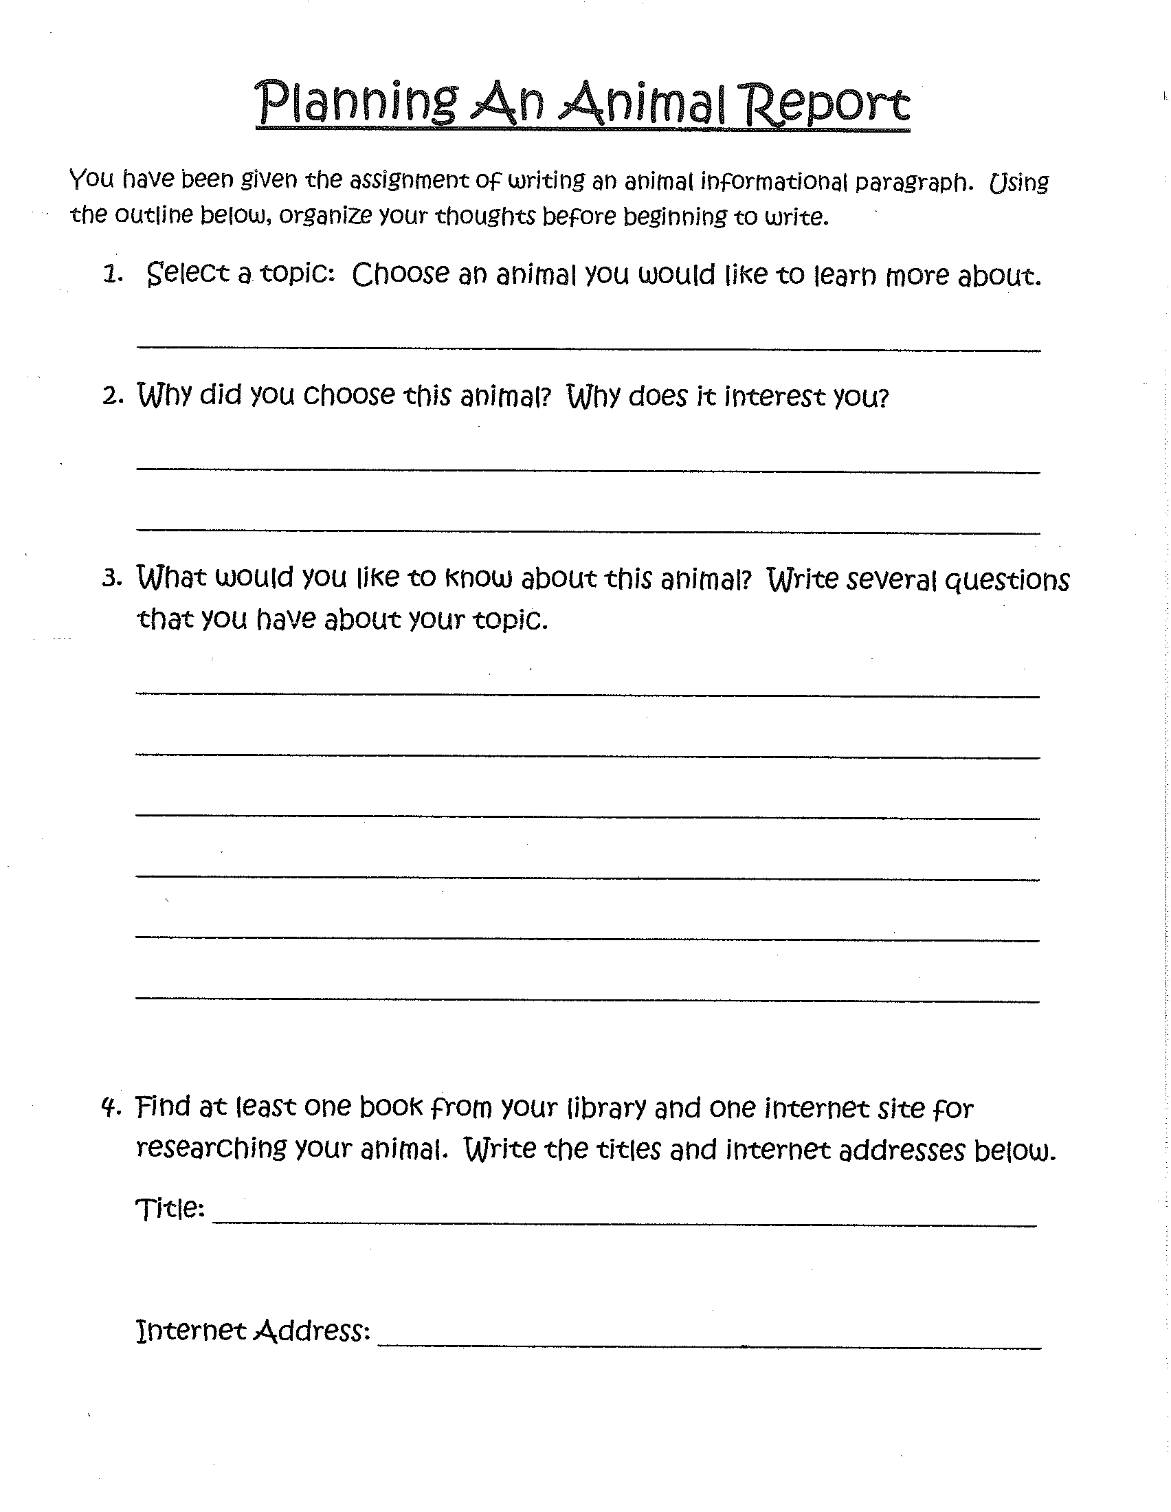

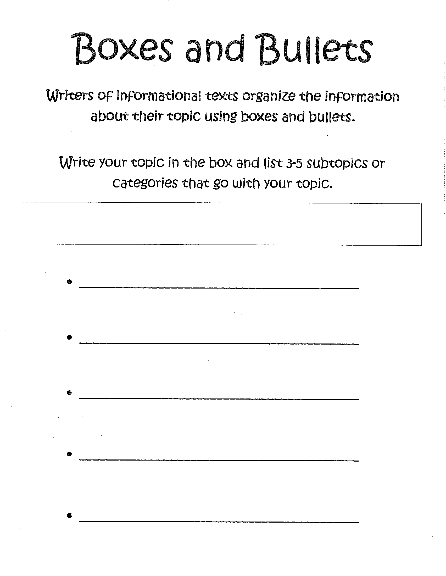

Procedures for Lesson Two:
Title of Lesson Plan: Connecting Main Idea and Details/Research and Note Taking
Time Frame | Sequenced Activities, including evidence of text-dependent questioning
1  week | A paragraph is a group of sentences that tells about one main idea. The first sentence is usually the topic sentence. It tells the main idea of the paragraph. Other sentences give details that tell more about the main idea in the topic sentence. The first word of a paragraph is indented, or moved in. This shows that a new paragraph is beginning. The detail sentences in an information paragraph tell facts about the main idea.  Topic: what a reading passage is all about. Ask yourself who or what the information is all about. Use just a few words.  Main idea: each paragraph has a main idea that tells more about the topic. Look for a sentence that tells the main idea in a paragraph. If no sentence tells about the main idea exactly, make up your own sentence to explain the main idea. This sentence is also known as the Topic Sentence.  Details: the details support or talk about the main idea in each paragraph. Look for details that support or tell more about each main idea.  Teacher Show: Put up picture of two monkeys talking on smartboard and ask: Which monkey is telling the most important thing about the picture? (main idea)  In paragraphs the main idea is the most important thing it tells too. It is what most of the sentences are about.  Partner Work: Have students work as partners to read the following paragraph and find the main idea or topic sentence.  The elephant finds its trunk useful in many ways. It is a wonderful nose because it can sniff high in the air or down along the ground. It also feeds the elephant by carrying food and water to its mouth. And last but not least, the useful trunk can give its owner a wonderful shower!  The main idea is often stated in the first sentence of a paragraph. But sometimes it is stated in another sentence. Now have them do the same with the following:  Most mammals have noses and lips, but the platypus has a bill like a duck. It has no teeth at all. And long webs of skin grow between its toes. The platypus is a most unusual-looking mammal.  Now in the following paragraphs, find the main idea or topic sentence in each and the sentence in each that does not explain the main idea. If you leave this sentence out, does the paragraph make better sense?

Leaping is the kangaroo’s way of getting from one place to another. At usual speed, the leaps of a large kangaroo are about one and a half meters long. Most kangaroos are found in Australia. When a kangaroo runs from danger, its leaps may be as long as seven and a half meters!

Every kind of animal has special ways to defend itself. Some animals hide when they are in danger. Some play dead. Many run from their enemies. Some animals are easily tamed. Others have built-in armor to protect them.

Group Work:
- Recognize main ideas: With your three groups from the previous lesson and the chapters you have, find the paragraphs from Weddell Seals that give information about each of the following main ideas.
  - Seal pups-Group 1
  - Life under ice-Group 2
  - Getting food- Group 3
Each group will do a close read of their chapter to find the main ideas (topic sentences) and if any information does not belong.

- Add details: Ask as a whole group: Whose paragraph would the following details belong? Explain your answer.
  - The seal stays underwater to eat.
  - Like all mammals, the pup drinks milk from its mother’s body.
  - Flippers help it swim swiftly and easily.

Independent work: Hand out “My Pet Peeves”
Step 1: Students use green pencil to underline the topic sentence or main idea. Step 2: Students use yellow pencil to underline details.
Step 3: Students use red pencil to underline conclusion sentence. Step 4: Students cross out the sentences that do not support the topic.

Research: When you write an informational paragraph, you need to do some research to gather information.
Refer to your “Planning an Animal Report.” Using your questions that you have about your topic and the book and internet site listed research for details.
Hand out 3x5 index cards to students for note taking. Write the Main idea on the top of each card. By researching list information on each card. Find at least three facts for each detail and card.

Success Criteria for Lesson:

*Students will work together to pick out main idea and details from “Find the Main Idea” chart.
*Students will independently underline correctly “My Pet Peeves” sheet.

*Students will gather details on note cards.

Assessments
Formative:

- Notecards
- Group and Partner Work

Summative:
- “My Pet Peeves” sheet

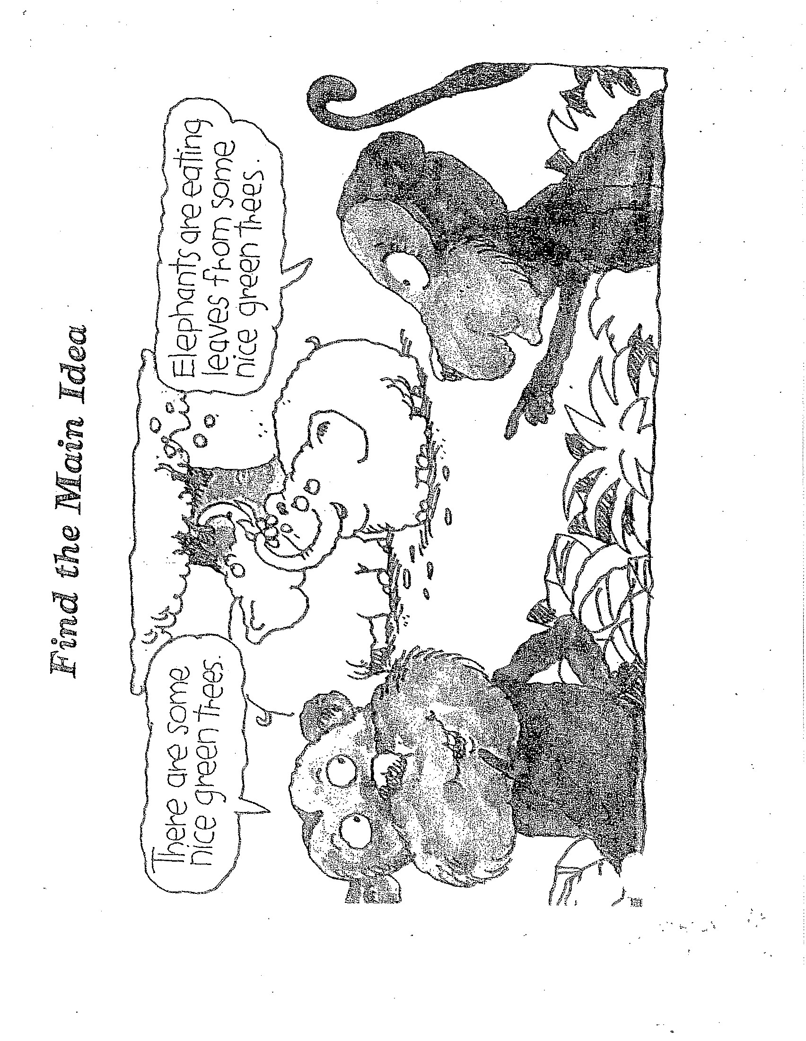

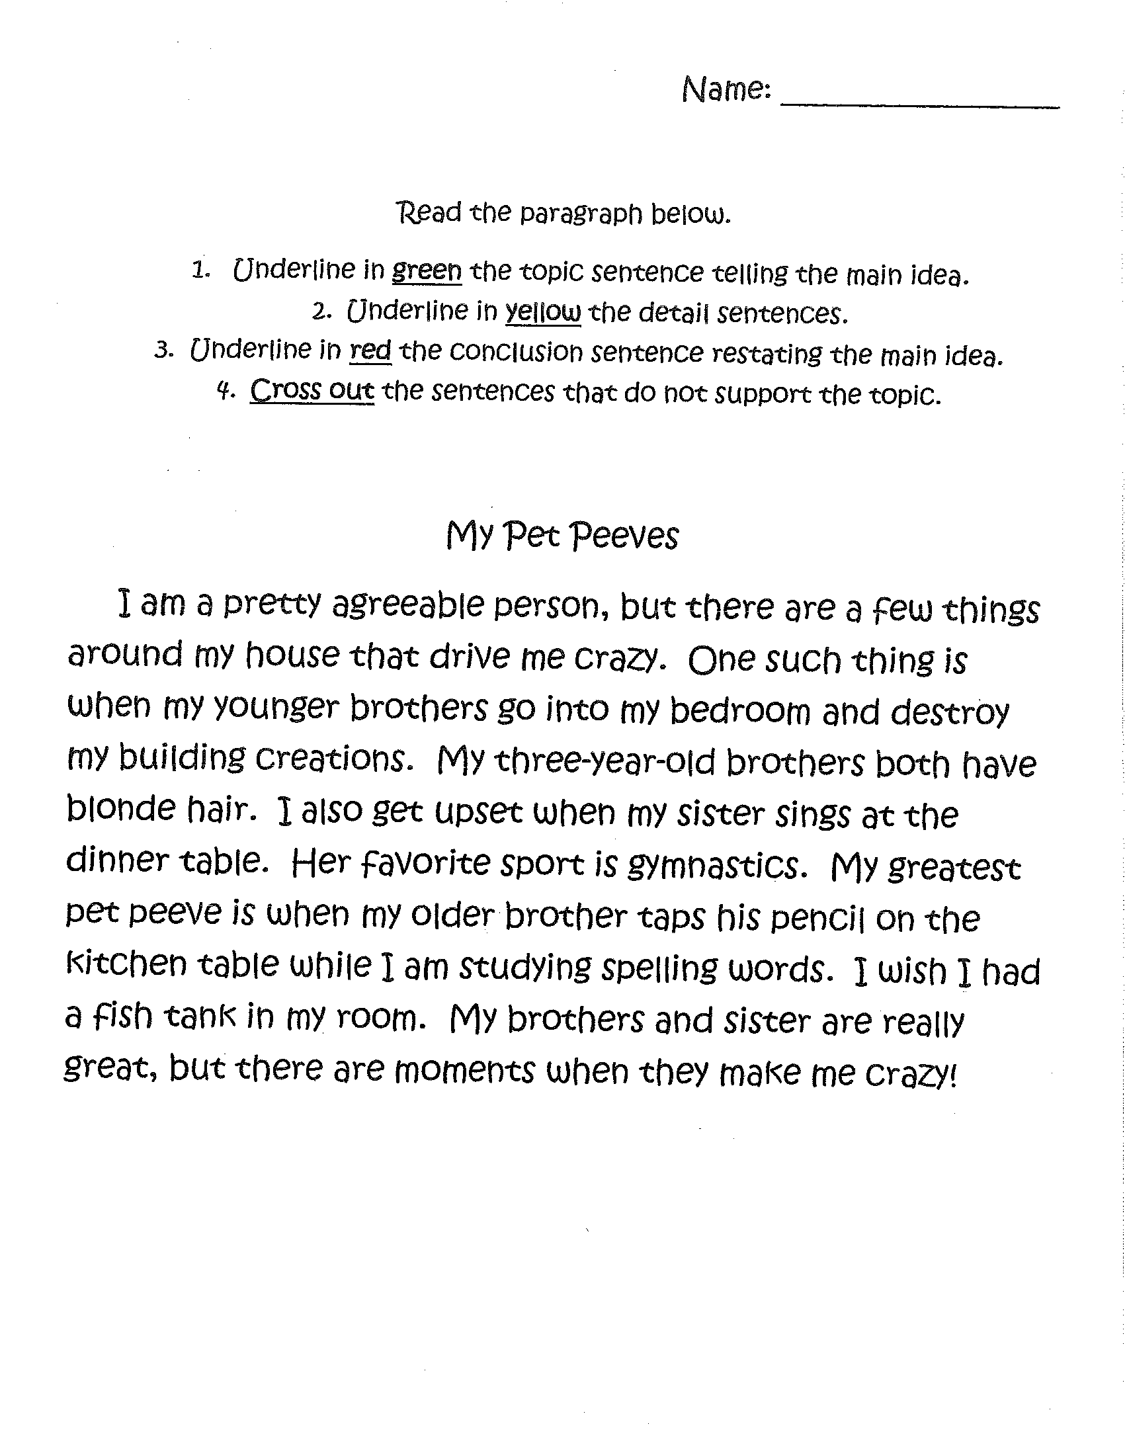

Procedures for Lesson Three:
Title of Lesson Plan: Drafting Information Paragraphs
Time Frame | Sequenced Activities, including evidence of text-dependent questioning
2  weeks | - Think about your main idea and details. Ask: Do all my details belong in a paragraph? Do I want to add or change any details?  - What? Think about your task: Remember that your task is to write an information paragraph.  Who? Think about who will read this information paragraph. Remember that your topic should interest your audience.  Why? Remember that your purpose is to share facts about your topic with your audience.  - Write your 1st draft. Write your topic sentence. Then write detail sentences that tell only about your main idea. Write quickly; not worrying about mistakes. You will have time later to make changes. Ask: Is this a complete sentence? Write 3 detail sentences with mistakes. Restate main idea to create conclusion. Draft quickly-mistakes.  - Repeat steps of paragraph. What comes 1st, 2nd, 3rd, 4th, and 5th? Which is most important? Are any more important?  - Begin rough draft- spelling and punctuation don’t matter.  Group Work: Using chapters from “Weddell Seals” list on board the three Main Ideas with three details under each one. Choose and write on the “Organizing Your Animal Report” sheet, shown on smartboard, three facts for each subtopic in complete sentences.  Independent Work: Have students take out note cards of facts researched previously. Read your notes about the animal you have selected. Choose and write on the “Organizing Your Animal Report” sheet three facts for each subtopic in complete sentences. Each student will have 3 sheets, one for each paragraph. From those three detail sentences, write a main idea sentence for each of the three sheets.  Create introduction: The introductory paragraph tells the reader about what is coming up in the whole paper.  The introduction is important for two reasons:  - It can encourage curiosity and interest in the topic and make your reader want to read the paper. This is called the lead.  - It lets the reader know what information will be covered in the paper. This is called the central claim.  Lead:  - Start with a question.  - Setting the scene (exclamation) gets the reader’s attention using emotion and senses (seeing, hearing, tasting, touching, or smelling).  - Amazing or unusual fact.  Central Claim: You will write a list of the main ideas. The statement should include the main ideas put together in one.  Next combine the lead with the central claim to write the complete introduction.

Group Work:
Example: Topic: Weddell Seals
Categories: 1. Weddell Seal Pups
- Life Under Ice
- Getting Food Introductory paragraph:
How much do you know about Weddell Seals? They are very interesting animals. This paper will tell you about the life of a Weddell Seal Pup. It will also tell about how Weddell Seals live under ice and interesting things about how they get their food.

Independent Work: Look at the categories that you have created. Think of an interesting main idea sentence and then write the introduction on “Organizing Introduction Paragraph” sheet by mentioning each category in the order it will appear in the paper.

Conclusion: The conclusion is a summary of what you have written about in your paper.

The purpose is for the author to once again, remind their readers of the important ideas or main ideas in their article and to keep the reader thinking. When we read a good conclusion paragraph, we should be able to tell what the whole article is about including the three main ideas. The conclusion should:
- Repeat the three main ideas.
- Have a transitional phrase at the beginning of the conclusion.
- Have an ending statement that is a question, which ends with a question mark, a wish or hope, which ends in a period, or a strong statement, which ends with an exclamation point.

Group Work:
Example: Topic: Weddell Seals
Categories: 1. Weddell Seal Pups
  - Life Under Ice
  - Getting Food
Conclusion Paragraph:
As you can see Weddell Seals are amazing animals. Now you know about the life of the seal pup, how seals can live under ice, and how they get their food. After doing this research, I hope to see a Weddell Seal someday.

Independent Work: Look at the categories and introductory paragraph that you have created. Follow the steps on “Organizing you Conclusion Paragraph” sheet and create your own paragraph.

Finally on “First draft” sheet copy put whole paper together, skipping lines to leave room for revisions to occur.

Success Criteria for Lesson:
*Students will fill out their “Organizing your animal report” for each paragraph.
*Students will fill out their “Organizing your Introduction Paragraph”.
*Students will fill out their “Organizing your Conclusion Paragraph”.
*Students will create their complete first draft.

Assessments
Formative:
- Organizing your animal report
- Organizing your Introduction Paragraph
- Organizing your Conclusion Paragraph

Summative:
- First Draft

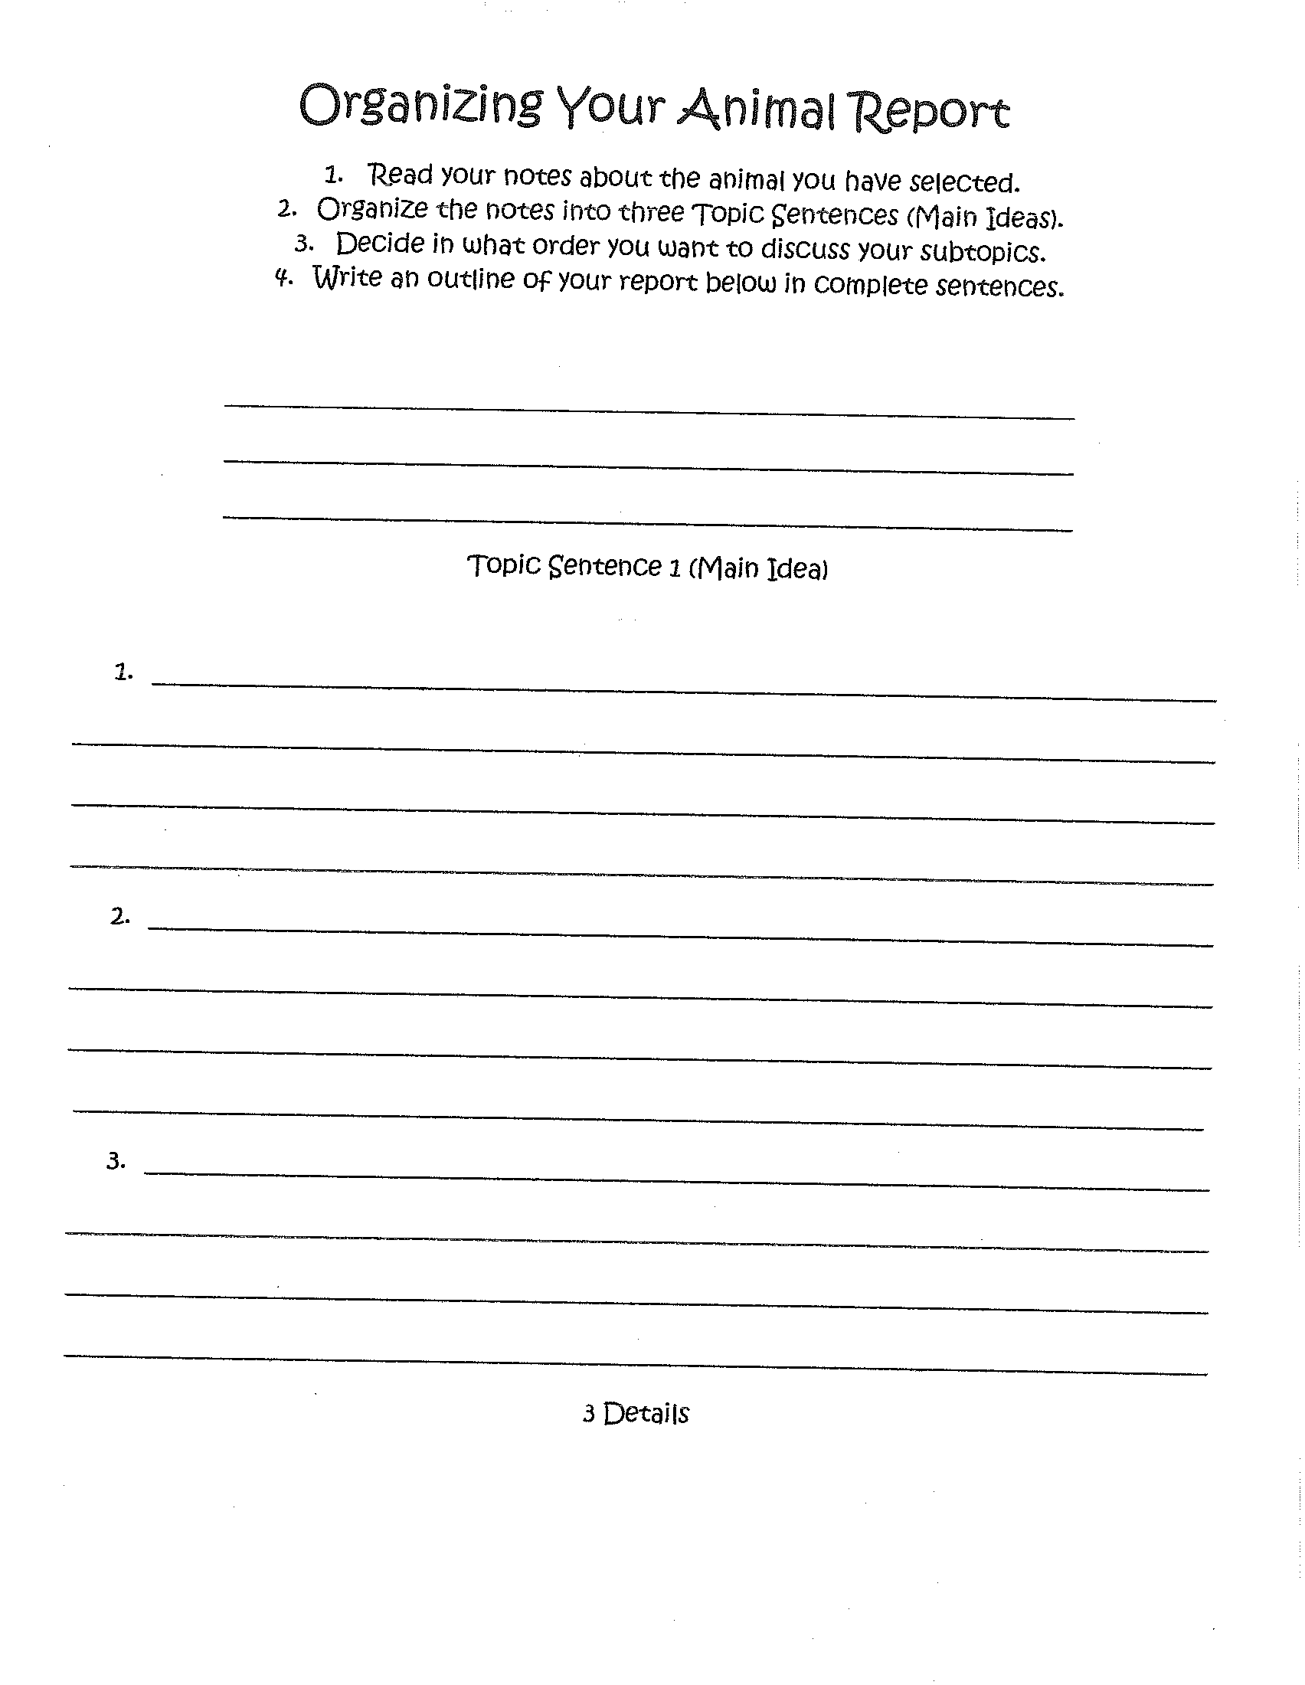

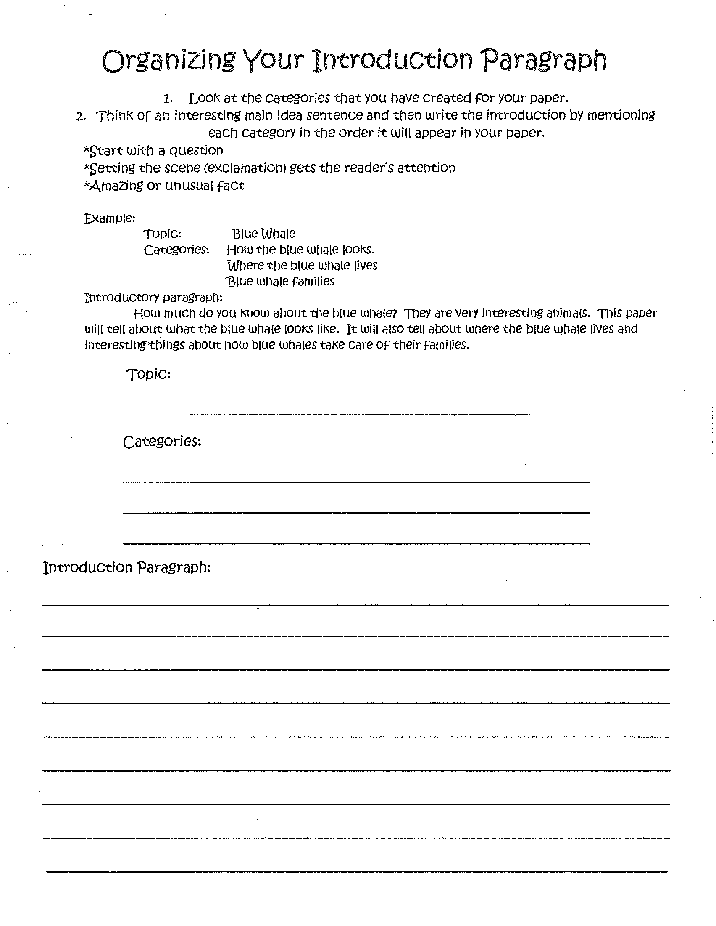

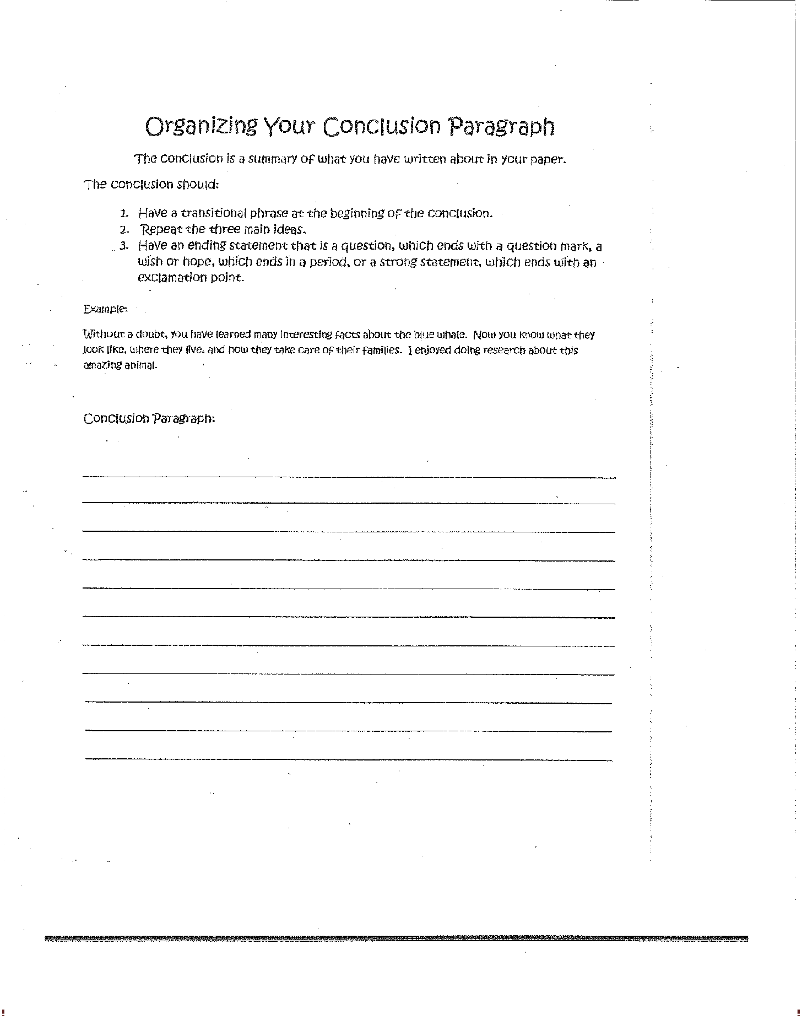

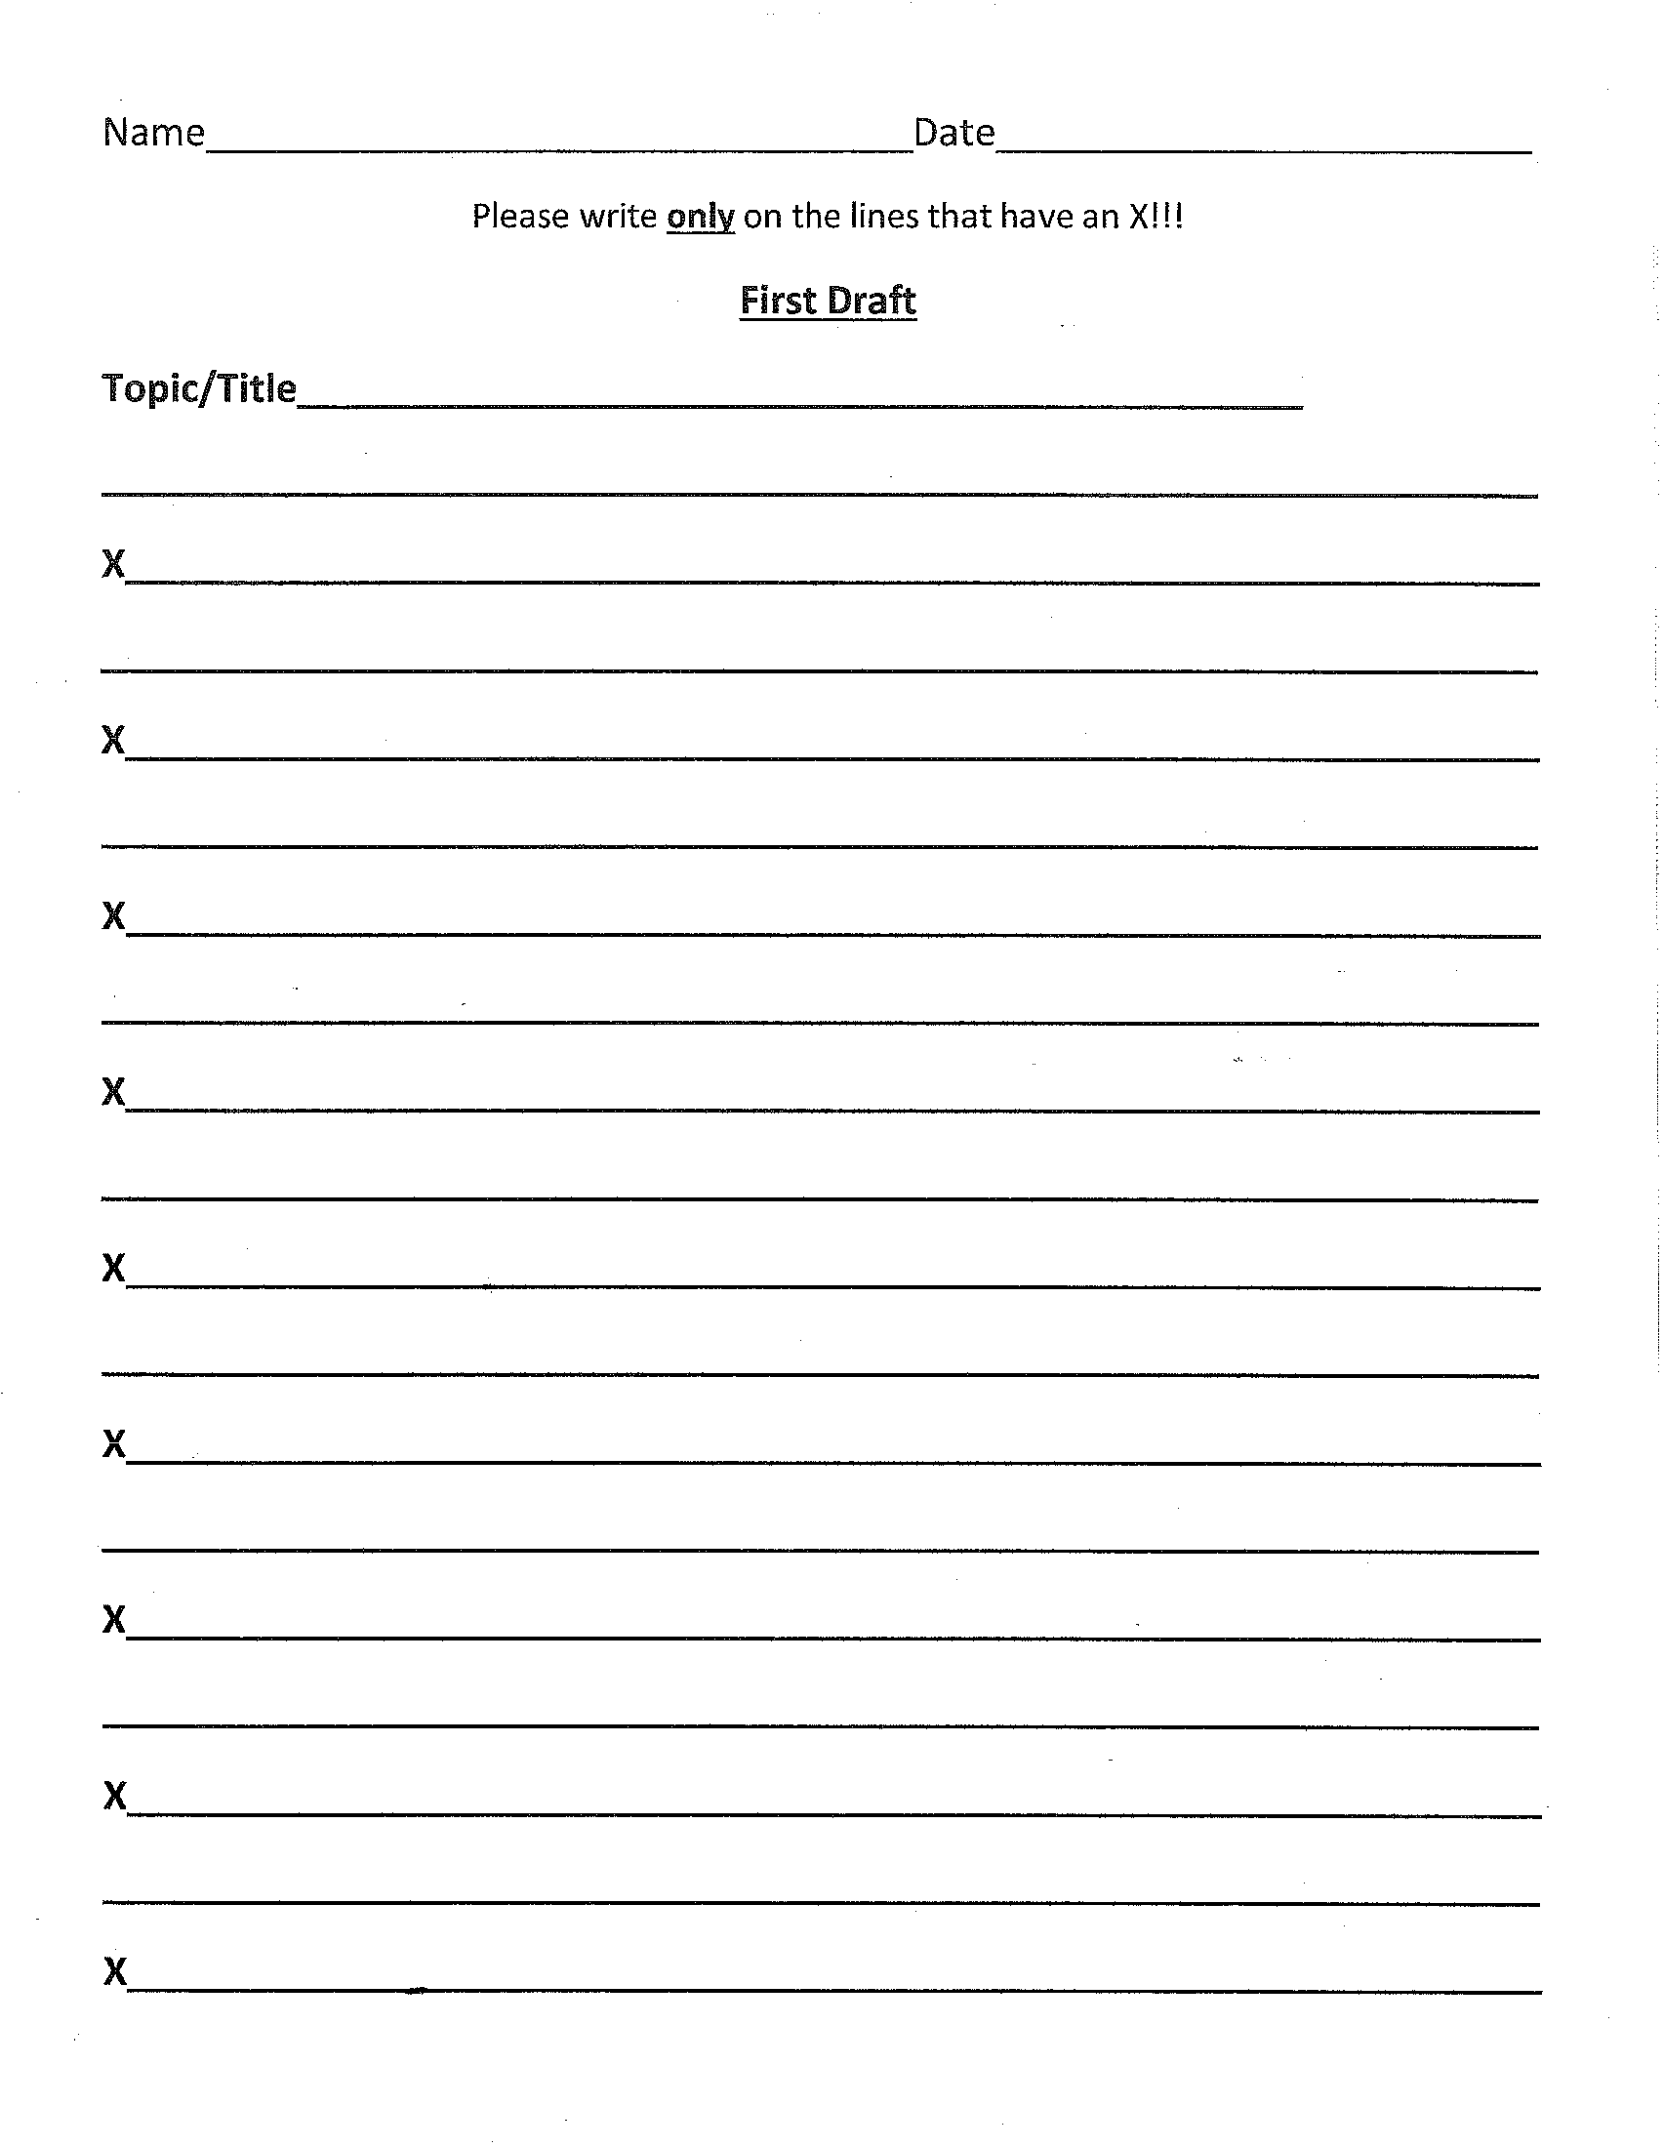

Procedures for Lesson Four:
Title of Lesson Plan: Revising/Proofreading/Editing
Time Frame | Sequenced Activities, including evidence of text-dependent questioning
2  weeks | Go over CUPS Editing Checklist with students: Use edit marks to make changes  Capitalization: use green colored pencil Understanding: use a purple colored pencil Punctuation: Use a red colored pencil Spelling: Use a blue colored pencil  - Did I use proper ending punctuation? (periods, question marks, and exclamation points)  - Did I use capitals at beginnings of sentences and with proper nouns?  - Did I indent at the beginning of the introduction, conclusion, and the 3 body paragraphs?  - Did I check the tenses for regular (live/lived) and irregular verbs (swim/swam)?  - Did I check for spelling? (Read your paper backwards and circle any words that “look  wrong”. Refer to a dictionary or get assistance.) Pay attention to the use of apostrophes. For example: Tom’s book or doesn’t  Go over Revision Checklist with students:  Did I write an introduction paragraph? Does it have an interesting lead? Does it have a clear focus statement that includes the 3 main ideas for the paragraphs?  - Did I have at least 3 paragraphs for the body of my paper? Does each paragraph have a clear main idea?  - Did I have enough supporting details to explain and describe?  - Did I write a conclusion paragraph? Does it start with a transitional phrase and restatement? Does it repeat the 3 main ideas? Does it end with a statement that is a question, wish or hope, or strong statement?  - Did I vary my sentence beginnings?  - Did I vary the length of my sentences?  Teacher Do: Demonstrate Editing Marks  Show 1st draft, skip lines to edit and revise. Use edit marks to show changes, edit with class.  Group Work: Hand out “Proofreading an Information Paragraph “and “Proofreading for  Punctuation and Capital Letters”. Practice independently, then exchange papers with a partner and check what was corrected or possibly missed.  Independent Work: Now students will edit and proofread their own paper Using the “Self-Edit and Peer-Edit” sheet. They will do their self-edit first, then exchange with a fellow student to do the peer-edits”.

The 1st draft will then go home for a parent check using “Parent Editing Checklist”. This will need to come back the next day along with 1st Draft.
Success Criteria for Lesson:
*Students will use revise, edit, and proofread checklists to complete self-edit and peer-edit using checklists.

*Students will take home 1st draft for parent edit using checklist.

Assessments
Formative:
- Checklists
- “Proofreading for Punctuation and Capital Letters”
- “Proofreading an Information Paragraph”

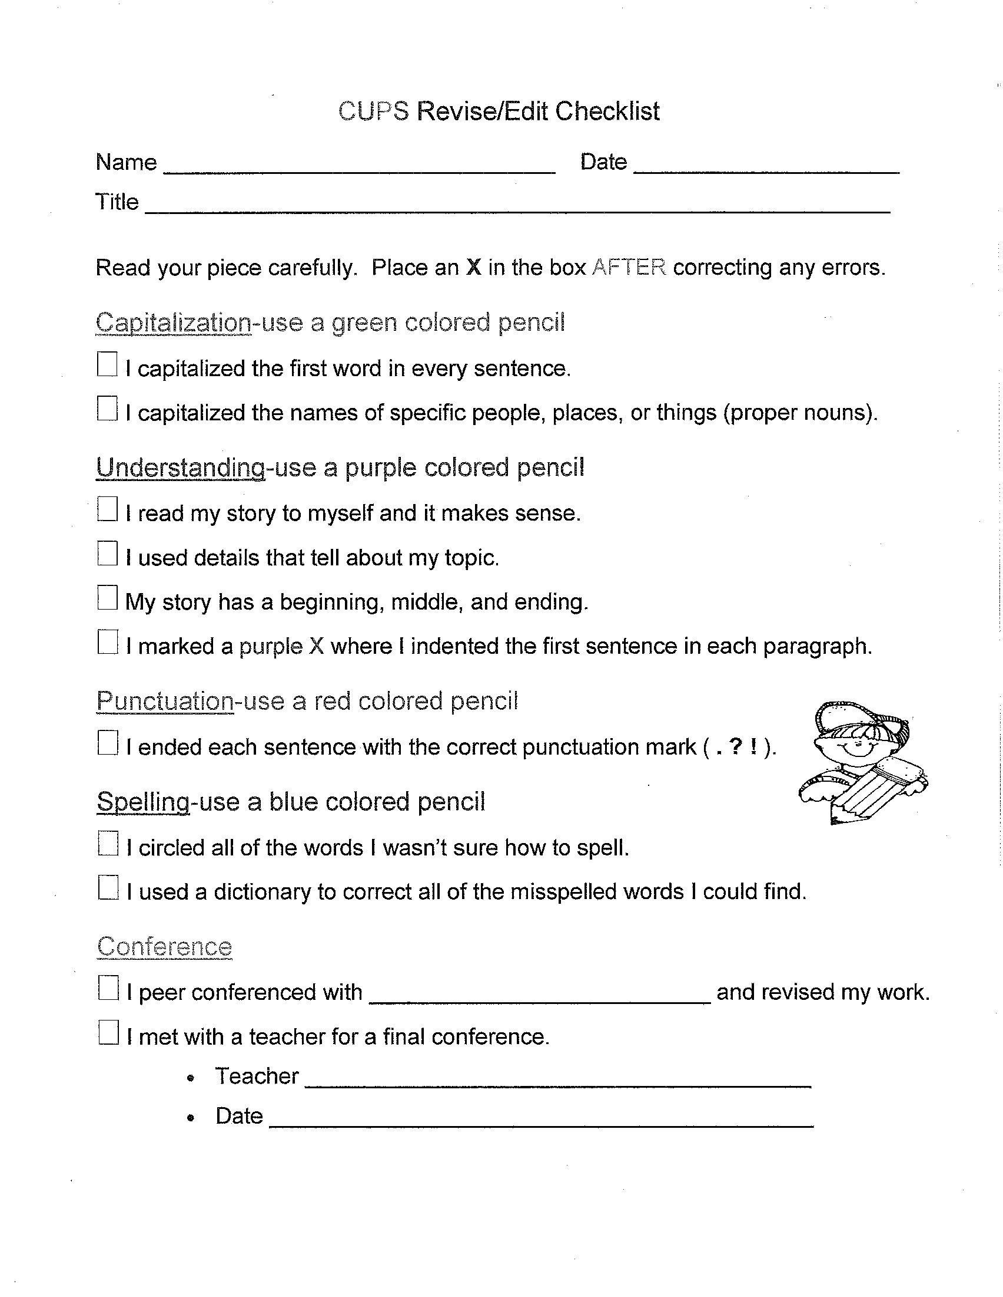

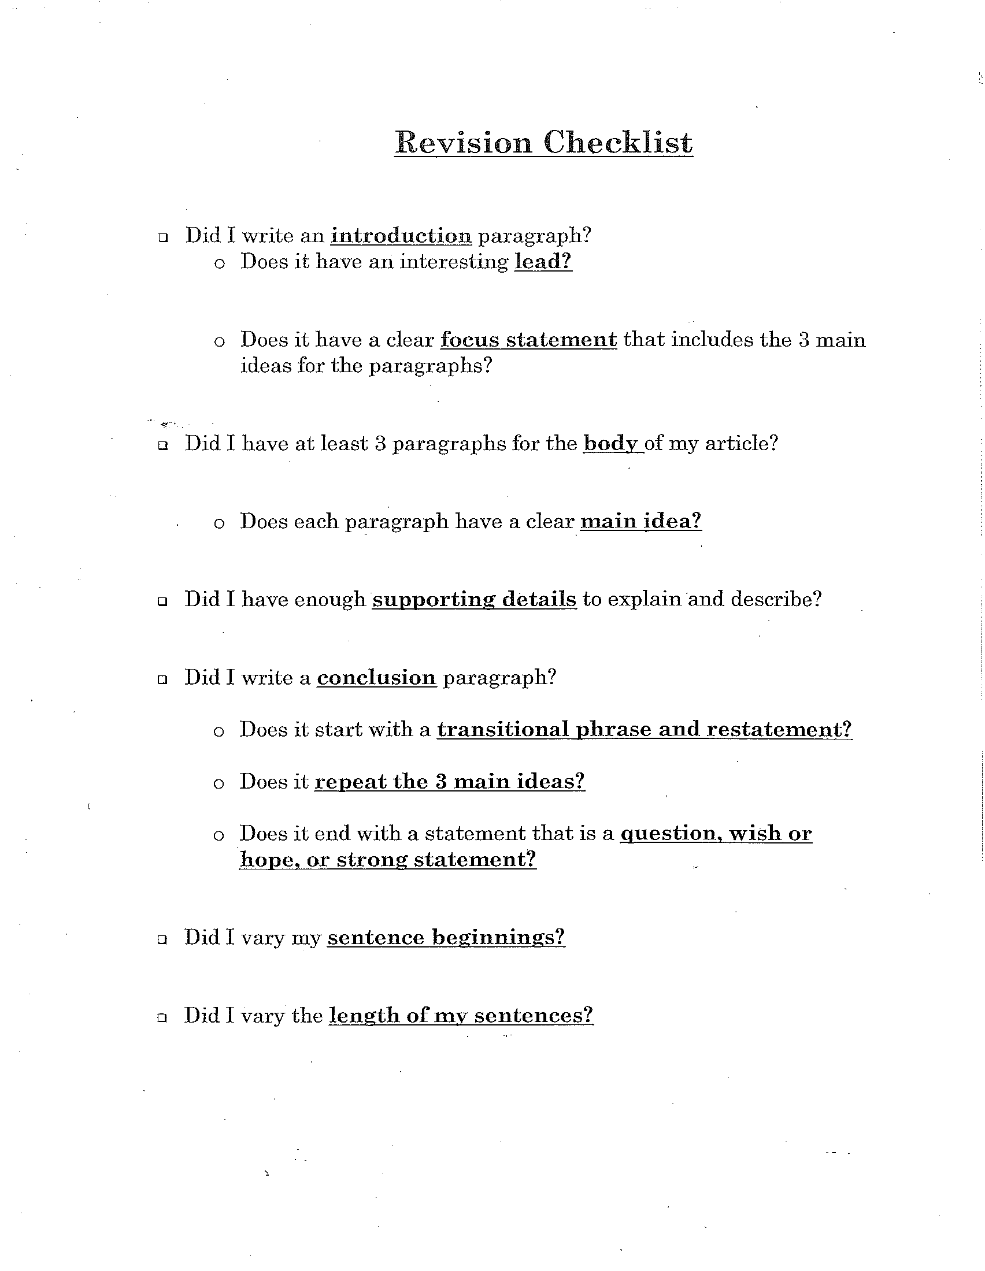

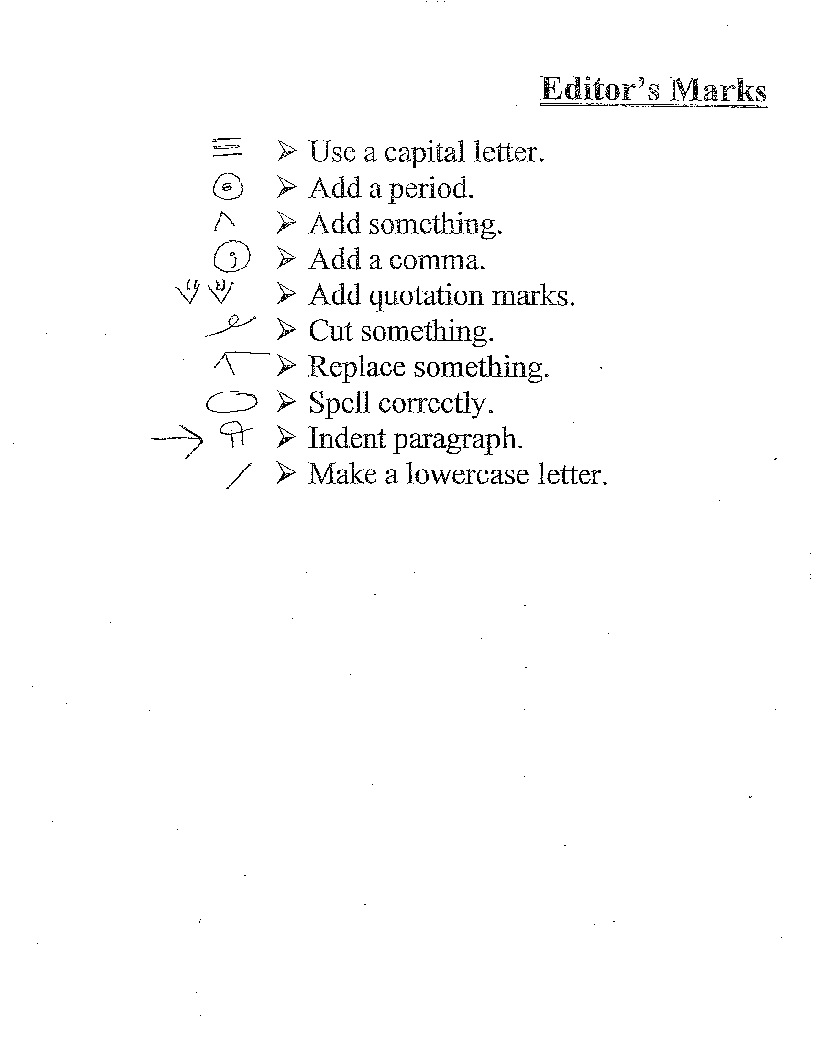

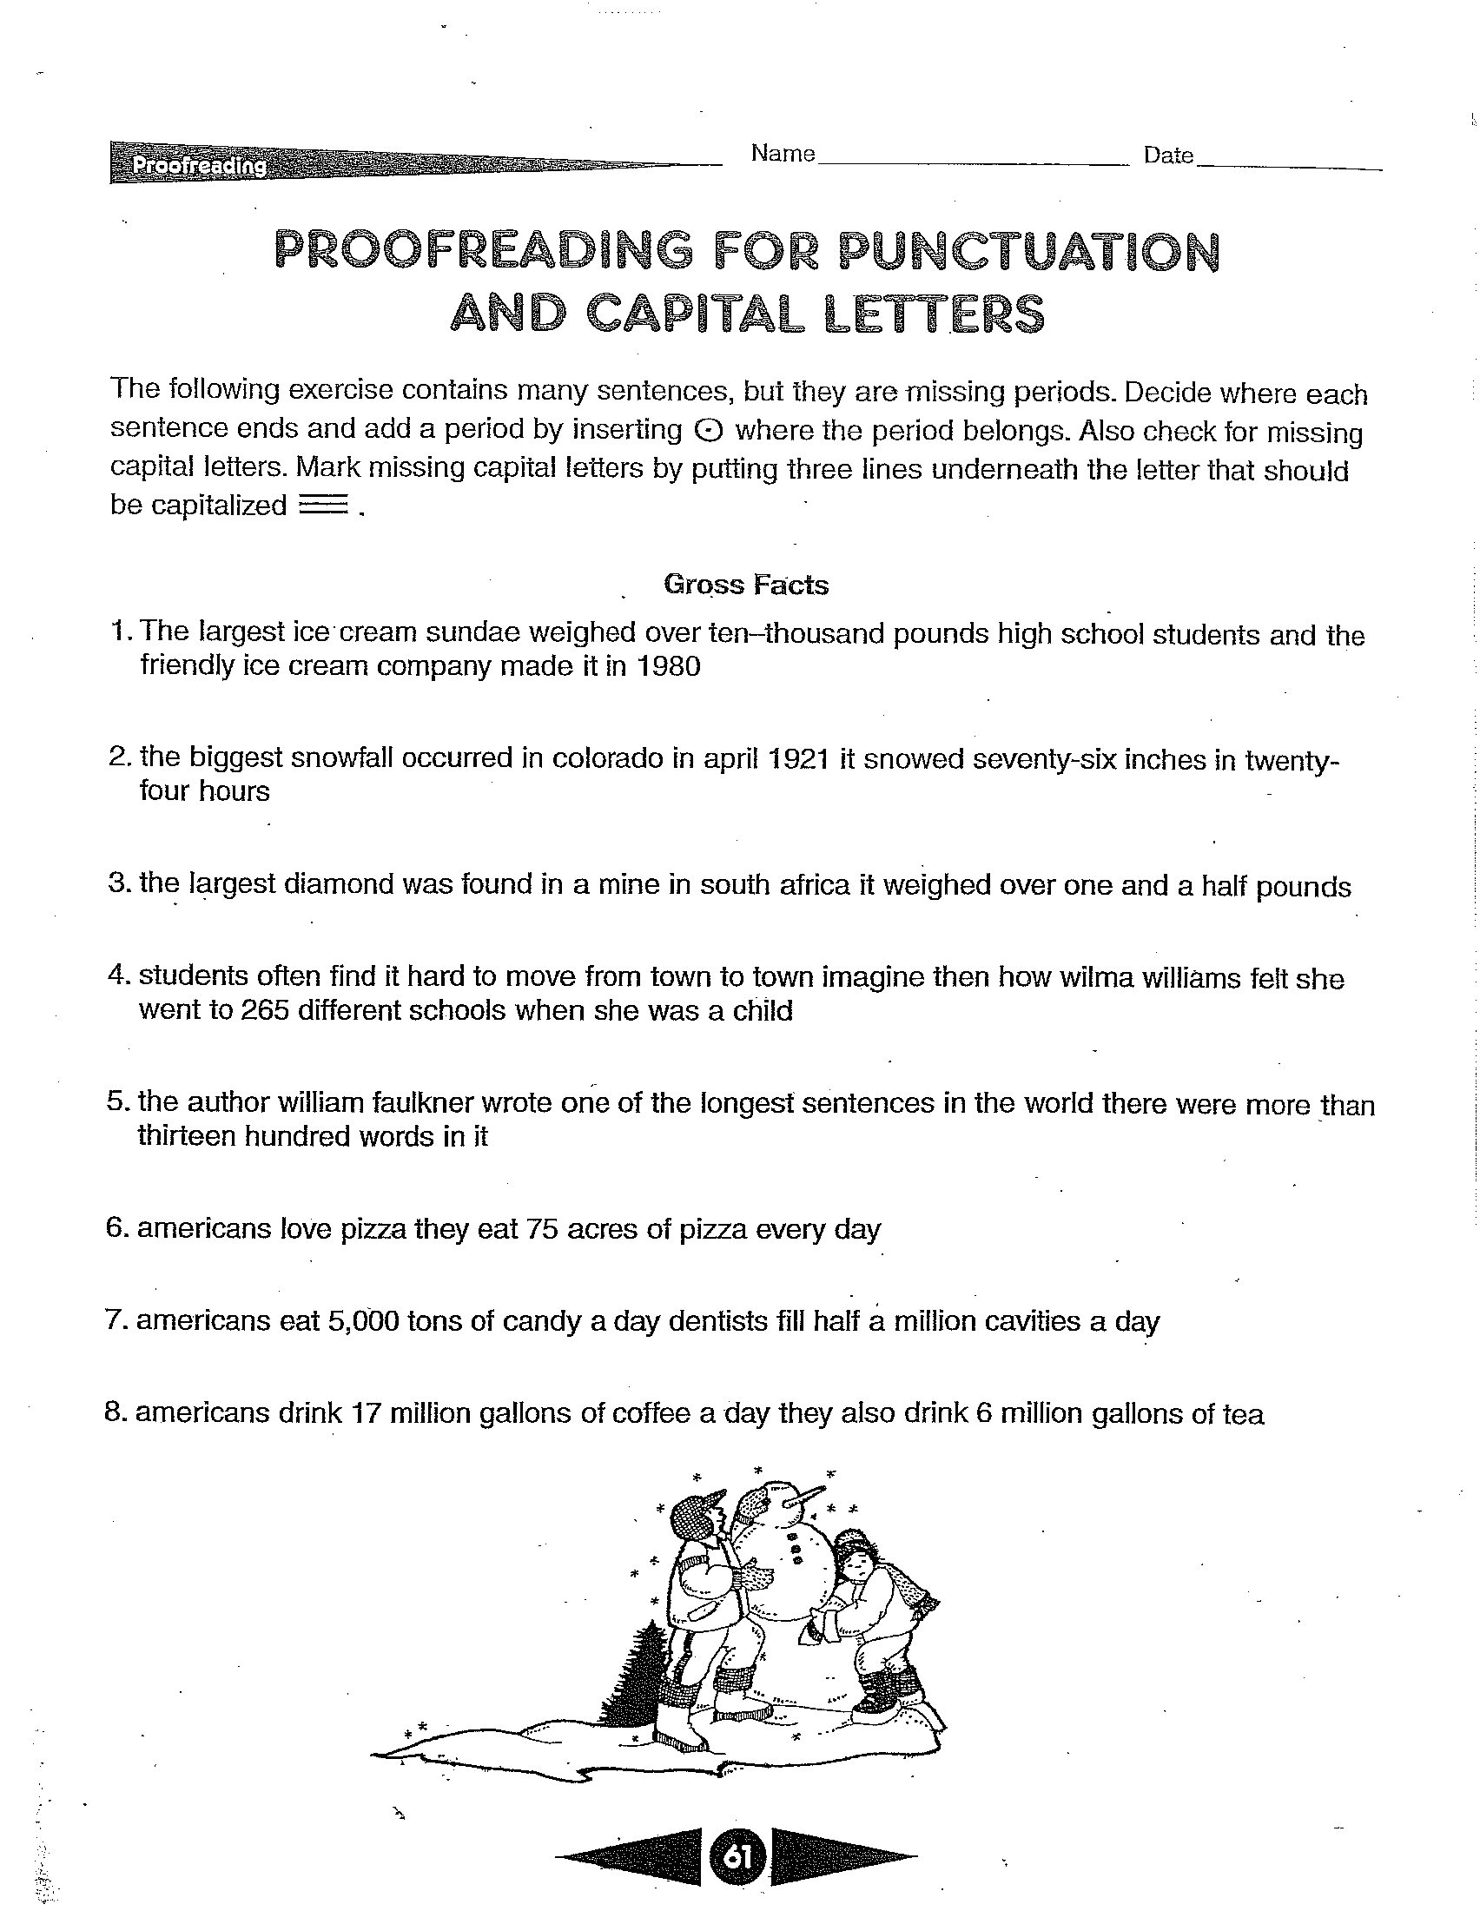

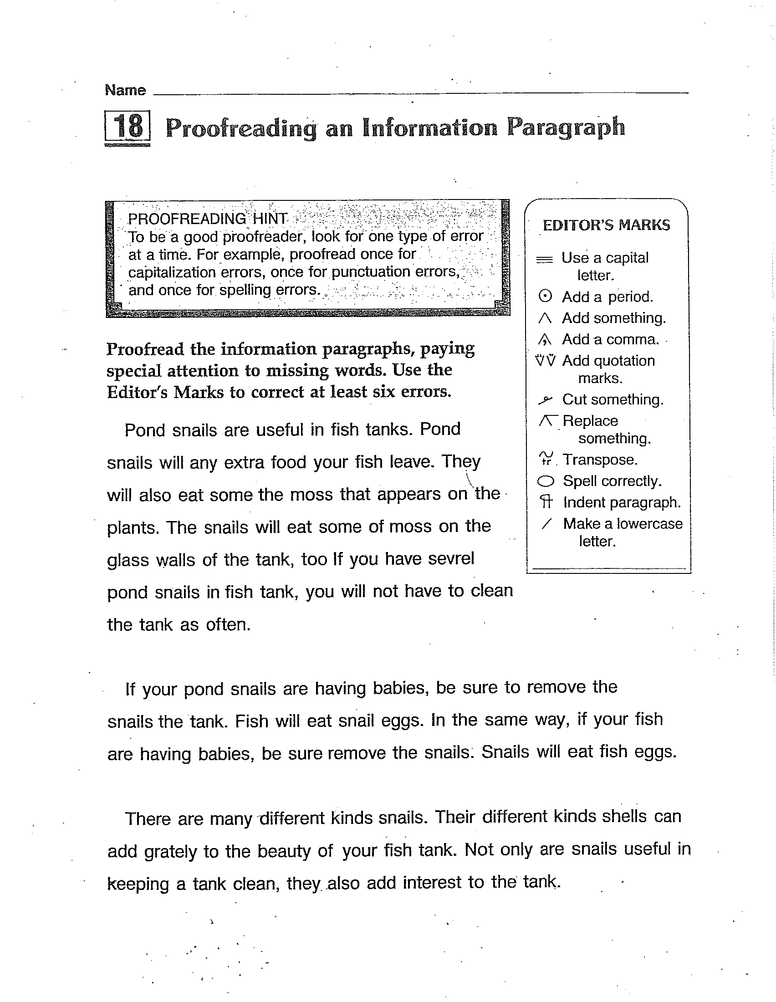

Procedures for Lesson Five:
Title of Lesson Plan: Publishing
Time Frame | Sequenced Activities, including evidence of text-dependent questioning
1  week | Publishing Checklist:  - Copy your paragraph neatly.  - Check to see that nothing has been left out.  - Be sure that there are no mistakes.  - Share your paragraph in an interesting way.  Students will write their final copy making all corrections and writing in their best writing.  They will also draw an illustration on “My Illustration paper”. Those above level students will be able to type their paper also.  Students will also be given the “Vocabulary review” to complete independently matching the words we have been talking about in this unit with their definitions.  Optional: When final paper and illustration is complete: Make an animural. Work with classmates on a large sheet of mural paper, draw pictures of the animals you wrote about. Draw your animals in their natural homes. Display the mural on a wall in the hallway for students to view.

Success Criteria for Lesson:
*Students will write their final copy along with Illustration.
*Students will create an animural.
*Vocabulary Review

Assessments
Summative:
- Final Paper
- Illustration
- Animural
- Vocabulary

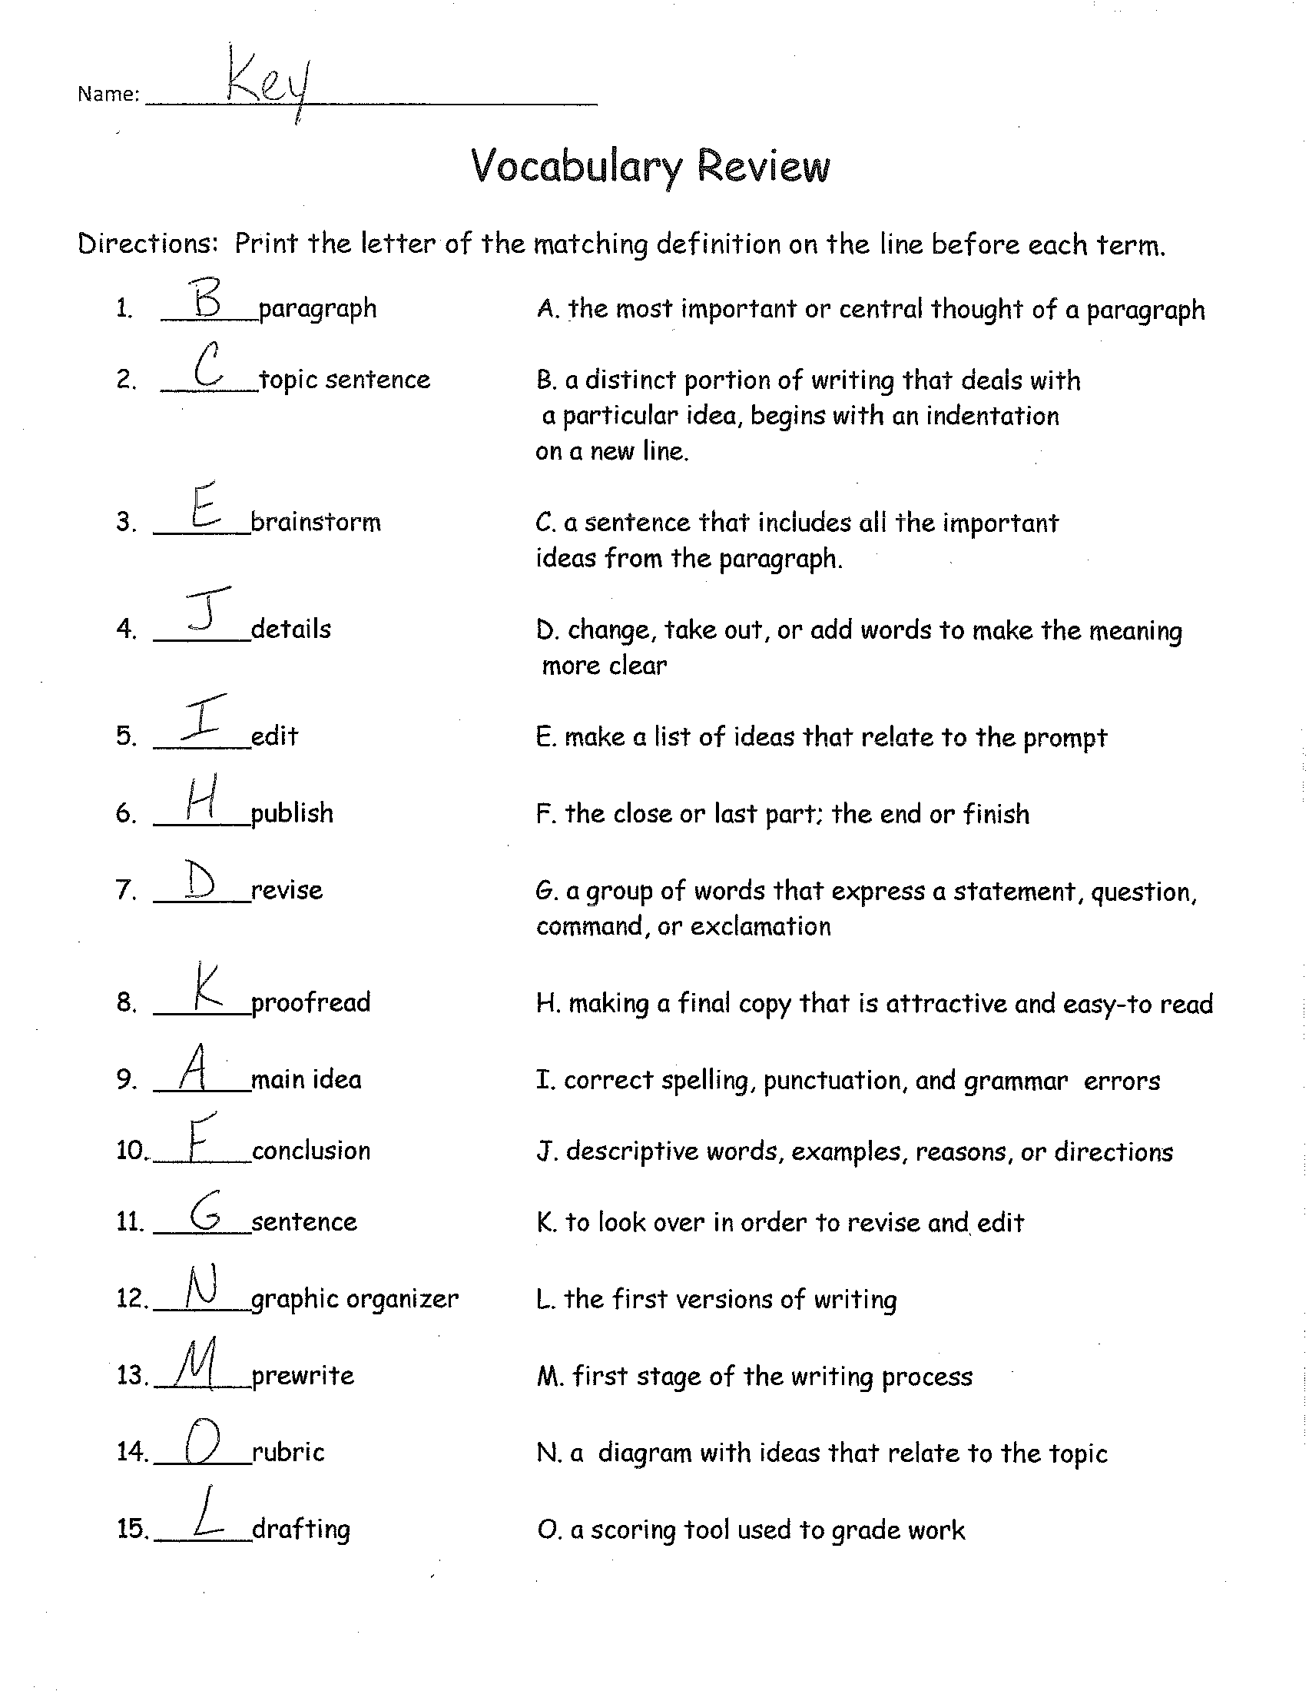

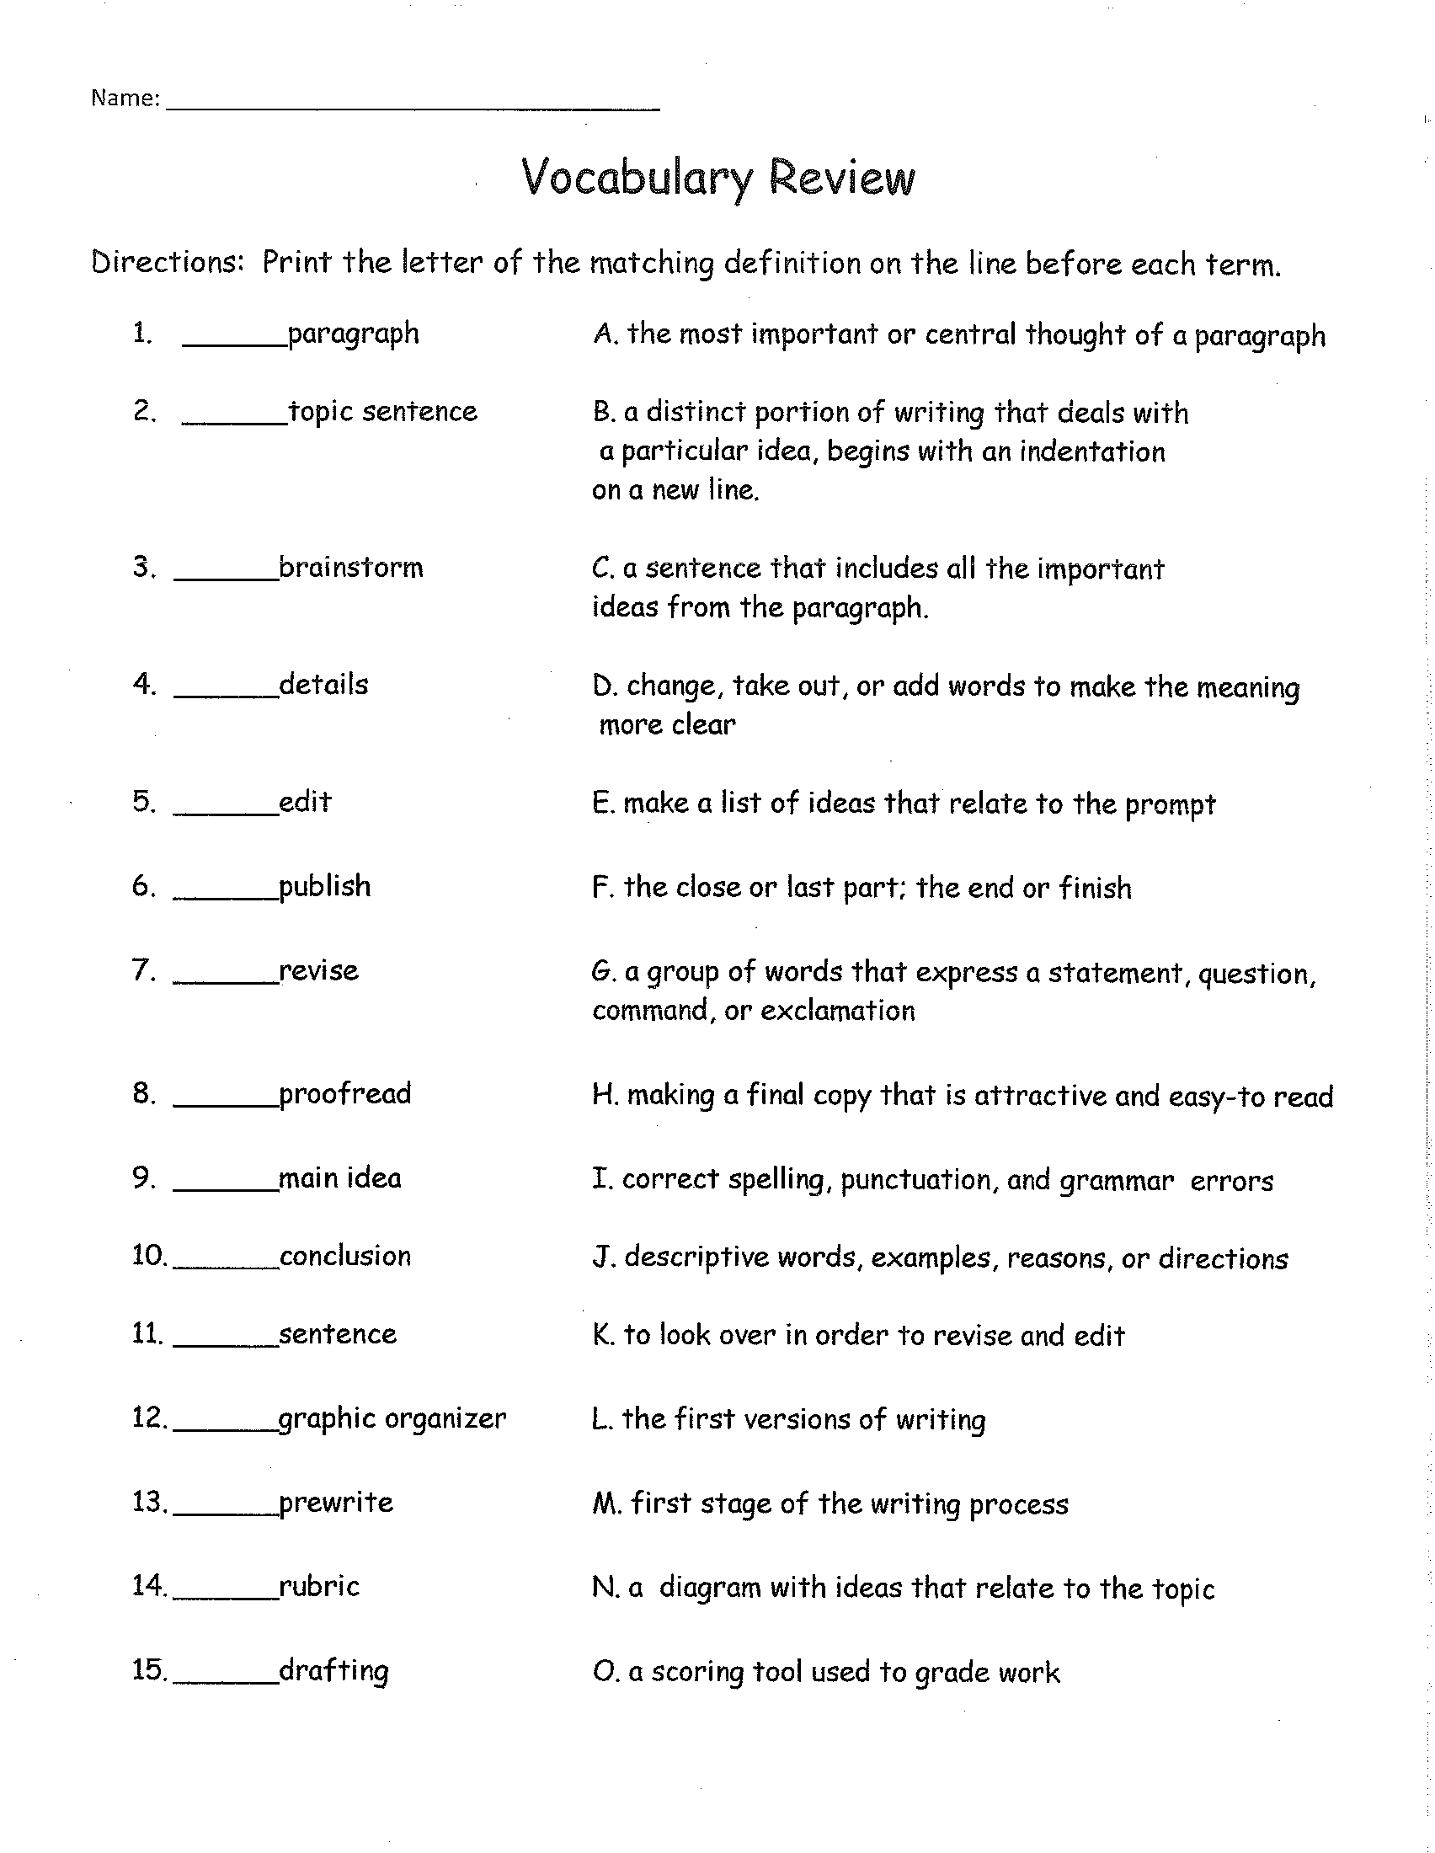

Procedures for Lesson Six:
Title of Lesson Plan: Oral Presentation
Time Frame | Sequenced Activities, including evidence of text-dependent questioning
1  week | Giving an oral presentation is a great way to share your research with several people at one time. This kind of presentation involves much more than just reading your report. Use this guide to plan an interesting presentation.  - Introduce yourself and your topic  - Tell about why you decided to research this topic.  - Read your paper clearly and loud enough for all to hear.  - Show and explain your illustration that goes along with your paper.  - Ask your audience if they have any question.
Success Criteria for Lesson:
*Students will give their oral presentation.

Assessments
Formative:

Summative:
- Oral Presentation

