  - COMPREHENSIVE Assessment Plan Template

LEA Comprehensive Assessment Plan

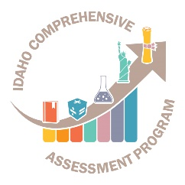
Idaho State Department of Education
Assessment & Accountability | Assessment monitoring

650 W State Street, 2nd Floor
Boise, IDaho 83702
208 332 6800 office
www.sde.idaho.gov

UPDATED 10/05/2018

TABLE OF CONTENTS
Instructions 3
[INSERT LEA Name] comprehensive assessment strategic plan [20__-20__] 4
Philosophy & Purpose of the State Comprehensive Assessment Program: 4
Assessment in Public Schools - Philosophy - Idaho Code §08.02.03.111.01 4
Assessment in Public Schools - Purpose -Idaho Code §08.02.03.111.02 4
LEA Assessment Philosophy/Vision 4
LEA Assessment Purpose/Mission 4
Assessments: 5
State and LEA Assessments 5
Testing Procedures 9
Table 3 – State Assessments 9
Table 4 – LEA Assessments 10
Assessment of Students with Disabilities and ELL students: 11
Table 5 – State Assessments 11
Table 6 - LEA Assessments 12
Professional Development: 14
Test Security: 14
Technology Support/ Data Quality: 14
Appendix A: Glossary 15
Appendix B: Idaho Comprehensive Assessment Program Inventory 17
Appendix C: Resources 21

Instructions
The comprehensive assessment plan is a living document. It will guide the work of Local Education Agencies (LEAs) while also developing an excellent training tool for staff. This document will inform stakeholders (e.g. parents, administrative staff, etc.) the purpose of assessment, when and which assessments are administered, how results are used to improve instruction, and demonstrate how assessments will improve student learning. This document not only meets accountability compliance with the State Department of Education, but it helps guide LEA’s comprehensive assessment systems along with illustrating their tremendous efforts already accomplished.

This document serves as a template for the LEA’s Comprehensive Assessment Plan. Each section within this template is required upon submission. There are brackets [ ] throughout the document where the local LEA will insert relevant information in in template (e.g. [Insert LEA Name]). Tables are throughout the document. Please complete each table with the requested information. Finally, there are sections requiring narratives that should be completed with as much detail as possible.

Districts that already have a Comprehensive Assessment Plan may submit their document for assessment monitoring so long as all components in the template are included in the submission.

To submit comprehensive assessment plan, please visit District Assessment Monitoring Google Form. Complete the entire Google Form. Within the form, LEAs will upload their comprehensive assessment plans. There will be a confirmation email sent when the comprehensive assessment plan has been submitted. If there are any questions or concerns the Assessment & Accountability Department will contact the District Test Coordinator. Each LEA will receive feedback on their comprehensive assessment plan from the Assessment & Accountability Department.

LEAs must submit their comprehensive assessment plan by April 30, 2019.

If you have any questions or concerns, please contact:

Danielle Taylor
Assessment Program Specialist
(208) 332-6903
dtaylor@sde.idaho.gov

[INSERT LEA Name] comprehensive assessment strategic plan [20__-20__]

The [insert LEA name]’s vision statement, mission statement, belief statements and learning goals provide the foundation for the Comprehensive Assessment System along with the District Strategic Plan and Idaho Content Standards.

Philosophy & Purpose of the State Comprehensive Assessment Program:

Assessment in Public Schools - Philosophy - Idaho Code §08.02.03.111.01
Acquiring the basic skills is essential to realization of full education, vocational and personal/social development. Since Idaho schools are responsible for instruction in the basic scholastic skills, the State Board of Education has a vested interest in regularly surveying student skill acquisition as an index of the effectiveness of the educational program. This information can best be secured through objective assessment of student growth. The State Board of Education will provide oversight for all components of the comprehensive assessment program.

Assessment in Public Schools - Purpose -Idaho Code §08.02.03.111.02
The purpose of assessment in the public schools is to:
- measure and improve student achievement;
- assist classroom teachers in designing lessons;
- identify areas needing intervention and remediation and acceleration;
- assist school districts in evaluating local curriculum and instructional practices in order to make needed curriculum adjustments;
- inform parents and guardians of their child’s progress;
- provide comparative local, state and national data regarding the achievement of students in essential skill areas;
- identify performance trends in student achievement across grade levels tested and student growth over time; and
- help determine technical assistance/consultation priorities for the State Department of Education.

LEA Assessment Philosophy/Vision
[Insert LEA philosophy/vision]

LEA Assessment Purpose/Mission
[Insert LEA purpose/mission]

Assessments:

State and LEA Assessments
Table 1 – State Assessments has been completed. Please complete Table 2 – LEA Assessments with the following information for locally administered assessments:

- Assessment
  - For the LEA Assessments Section, enter assessments required by the LEA.
- Grade Level
  - Specify grade level(s) for which the assessment is administered.
- Test Schedule
  - Provide the test window for the assessment.
- Purpose of Assessment
  - Describe the purpose of the assessment.
- Reporting
  - How are test results reported?
- Administration Mode
  - Specify medium through which the assessment is administered (computer, on-on-one, paper/pencil, etc.).
- Test Vendor
  - Name the test vendor, if any.

Note: Assessment types and definitions see Appendix A.

Table 1 – State Assessments
1. Assessment | 2. Grade Level | 3. Test Schedule | 4. Purpose of Assessment | 5. Reporting | 6. Administration Mode | 7. Test Vendor
Civics | Any time after grade 7 | Determined by LEA | Understand fundamentals of U.S. history & U.S. government | Transcript Required | District/School Decision | N/A
College Entrance Exam (PSAT)  *Optional* | Grade 10 | October 10, 2018 | Practice for SAT | Scores viewable off College Board Educator Portal | Paper/Pencil | The College Board
College Entrance Exam (SAT) | Grade 11 | April 9, 2019  *Make-Up Date April 23, 2019 | Graduation Requirement | Scores viewable off College Board Educator Portal | Paper/Pencil | The College Board
End-of-Course Science (Biology & Chemistry | Grades 10-12 | February 25-May 17, 2019 | Assessment Of Learning | Reports available in online reporting system (ORS) | Digitally Based Assessment | American Institutes for Research
Idaho Alternate Assessment | Grades 3-8 and 10 (9 & 11 optional) | March 18-May 17, 2019 | Assessment Of Learning | Reports available in online reporting system (ORS) | Digitally Based Assessment | American Institutes for Research
Idaho English Language Assessment (WIDA’s ACCESS 2.0) | Grades K-12 | January 28-March 8, 2019 | English language proficiency for program eligible English language learners | Score reports are in WIDA-AMS/DRC system | Digitally Based Assessment  *Paper/Pencil available | Data Recognition Corporation
Idaho Reading Indicator (IRI) | Grades K-3 | Fall: August 20- September 28, 2018  Spring: May 1-31, 2019 | Screener for early literacy skills | Reports available in Istation’s online reporting system | Digitally Based Assessment | Istation
Idaho Standards Achievement Test (ISAT) | Grades 3-8 and 10 (9 & 11 optional) | March 18-May 17, 2019 | Assessment of Learning –  Accountability  Student Growth | Reports available in online reporting system (ORS) | Digitally Based Assessment | American Institutes for Research
Interim Assessment  *Optional | Open to 2-11 | August 9, 2018-March 13, 2019  May 28-July 19, 2019 | Assessment for learning | Reports available in online reporting system (ORS) | Digitally Based Assessment | American Institutes for Research
The National Assessment of Educational Progress (NAEP) | Grades 4,8, & 12 | January 28-March 8, 2019 | National Trend | State reporting in odd years  National reporting in even years | Digitally Based Assessment | NCES

Table 2 – LEA Assessments
Please complete this table for locally administered assessments not included in the state comprehensive assessment system.
1. Assessment | 2. Grade Level | 3. Test Schedule | 4. Purpose of Assessment | 5. Reporting | 6. Administration Mode | 7. Test Vendor

Testing Procedures

Table 3 – State Assessments
In this table, identify the staff (by position) responsible and/or describe the processes for the following:
Assessment | Establishing test schedules | Ordering materials or uploading pre-identification file(s) | Identifies and trains proctors | Handling printed materials, including ordering, storing and returning.
Civics
College Entrance Exam (PSAT)
College Entrance Exam (SAT)
End-of-Course Science (Biology & Chemistry)
Idaho Alternate Assessment
Idaho English Language Assessment (WIDA’s ACCESS 2.0)
Idaho Reading Indicator (IRI)
Idaho Standards Achievement Test (ISAT)
Interim Assessment
The National Assessment of Educational Progress (NAEP)

Table 4 – LEA Assessments
In this table, identify the staff (by position) responsible and/or describe the processes for the following:
Assessment | Establishing test schedules | Ordering materials or uploading pre-identification file(s) | Identifies and trains proctors | Handling printed materials, including ordering, storing and returning.

Assessment of Students with Disabilities and ELL students:

Table 5 – State Assessments
Briefly describe each State assessment with the following information below:
Assessment | Procedures for the LEA has in place to ensure the inclusion of students with disabilities in the state assessment system | Procedures for the LEA has in place to ensure the inclusion of all English learners in the assessment system | The process for determining whether to  assess a student on the general assessment  without accommodation(s), the general  assessment with accommodation(s), or an alternate assessment | The process for ensuring the appropriate accommodations are available for Students with disabilities or English learners
Civics
College Entrance Exam (PSAT)
College Entrance Exam (SAT)
End-of-Course Science (Biology & Chemistry)
Idaho Alternate Assessment
Idaho English Language Assessment (WIDA’s ACCESS 2.0)
Idaho Reading Indicator (IRI)
Idaho Standards Achievement Test (ISAT)
Interim Assessment
The National Assessment of Educational Progress (NAEP)

Table 6 - LEA Assessments
Briefly describe each LEA assessment with the following information below:
Assessment | The LEA ensures the inclusion of students with disabilities in the LEA assessment system | Procedures for the LEA has in place to ensure the inclusion of all English Learners in LEA assessment system | The process for determining whether to  assess a student on the general assessment  without accommodation(s), the general  assessment with accommodation(s), or an alternate assessment | The process for ensuring the appropriate accommodations are available for Students with disabilities or English learners

Professional Development:
- Describe the process your district uses to train staff who interact with each of the State and LEA’s assessments. Provide as much detail as possible.
- Describe the process your district uses to train staff supporting students with disabilities and English learners on selection of and the appropriate use of accommodations and/or designated supports
- Describe how assessment results for each state and LEA assessment are used, including the audience for the results.
- Describe how testing schedules are developed, who is responsible for developing testing schedules, who is responsible for communicating the testing schedule to the district and school and parents.

Test Security:
- Explain process to ensure students do not have calculators, alphabet strips, recordings, books, walls are free from instructional materials, etc. during any state testing unless items are specifically approved as accommodations
- Describe the process used to ensure students are appropriately monitored when they are in the testing room, or leave the testing room for a break
- Explain the process for ensuring all paper assessments and other assessment materials are handled appropriately. Include how materials are transported, stored, returned, or destroyed.
- Provide any local policies established related to test security.

For additional information on test security, please review the Assessment Integrity Guide.

Technology Support/ Data Quality:
- Describe the responsibilities of District Technology Coordinators in supporting the state and LEA assessments.
- Describe how the LEA ensures that student information is accurate in ISEE reports.

Appendix A: Glossary
- Assessment – The process of quantifying, describing, or gathering information about skills, knowledge or performance.
- Benchmarks – Benchmarks describe the knowledge and skills that all students should know and be able to do, in selected content areas, by the time they reach certain grade levels. Benchmarks are yardsticks or targets, because they specify the knowledge and skills within a content area’s continuum that a student must possess to demonstrate a level of progress toward mastery or proficiency of a standard. States may refer to benchmarks as competencies, anchors, etc.
- Curriculum-Embedded Assessment – Curriculum-embedded assessments are those that have been deliberately incorporated in the instructional material being used by learners or in the instructional activities routinely taking place. Examples include: Quizzes, End of Chapter Tests, and Common Assessments.
- Decode – To analyze spoken or graphic symbols of a familiar language to ascertain their intended meaning and to change communication signals into messages, as to decode body language.
- Diagnostic Assessment – Pre-assessment that allows a teacher to determine students’ individual strengths, weaknesses, knowledge, and skills prior to instruction. It is primarily used to diagnose student difficulties and to guide lesson and curriculum.
- Formative Assessment – Refers to a process that includes the following attributes: Clarify Intended Learning, Elicit Evidence, Interpret Evidence, and Act on Evidence. The formative assessment process helps teachers identify where students are in their learning so that adjustments can be made to curriculum, instructional methods, and academic support. Formative assessment activities are not graded. These activities are integrated into daily instruction and are not quite teaching, but not traditionally what we call assessment. This evidence helps both learner and teacher decide what to do next.
- Growth Targets – A state or district level target, which is set to define progress and track change in individual student achievement scores over multiple years. Used for accountability purposes.
- Interim Assessment – Assessment that educators use to (1) periodically evaluate where students are in their learning progress and (2) determine whether they are on track to master standards within a given time period. Interim assessments are usually administered strategically during a course or school year (for example, every three to six weeks) and separately from the process of instructing students. They are not graded and not used for accountability purposes.
- Norm-Reference Assessment – Comparing a student’s performance or test result to performance of other similar groups of students; (e.g., he typed better than eighty percent (80%) of his classmates.
- On-Demand Assessment – Assessment that takes place at a predetermined time and place. Quizzes, state tests, SATs, and most final exams are examples of on-demand assessment.
- Performance Assessment – Direct observation of student performance or student work and professional judgment of the quality of that performance. Good quality performance assessment has pre-established performance criteria.
- Portfolio-Based Assessment – Collections of academic work that are compiled by students and assessed by teachers in a consistent ways. For example: assignments, lab results, writing samples, speeches, student-created films, or art projects.
- Proficiency – Having or demonstrating a high degree of knowledge or skill in a particular area to the extent that standards are met.
- Progress Monitoring – Progress monitoring probes are administered weekly or biweekly to gauge student growth toward mastery of a targeted skill.
- Screening – Assessment used to determine whether students may need specialized assistance or service, or whether they are ready to begin a course, grade level, or academic program. Screening assessments may take a wide variety of forms, they may be developmental, physical, cognitive or academic.
- Summative Assessment – Summative assessments provide information regarding the level of student, program, or school success at an endpoint in time. Results are used to evaluate student achievement toward grade level standards, determine program effectiveness, and meet accountability requirements. Examples include: End of Course Assessments, ISAT Assessment.
- Universal Screening – Universal Screeners are administered one to two times per year to identify learners who may be at risk of not meeting grade level standards. Examples include: Idaho Reading Indicator, CORE MAZE, CORE Vocabulary.

Appendix B: Idaho Comprehensive Assessment Program Inventory
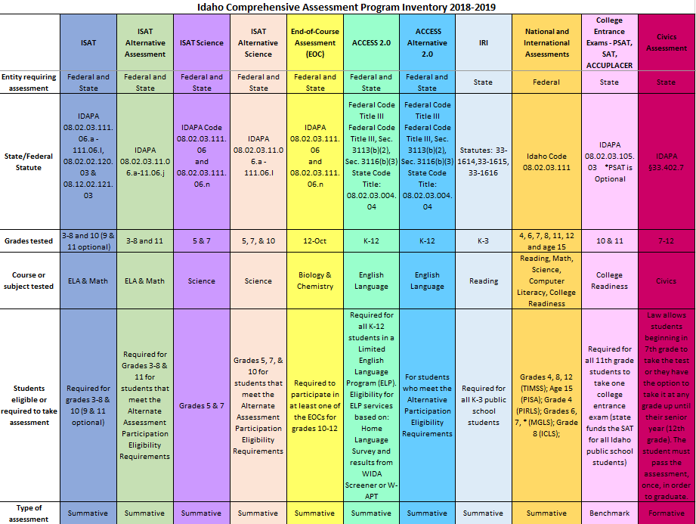

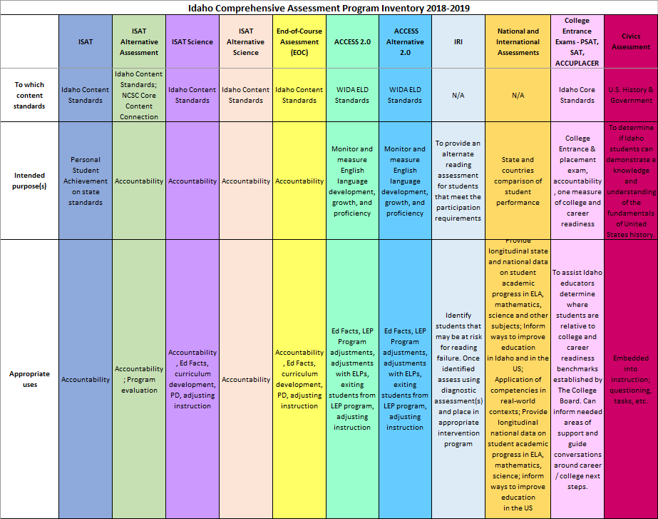

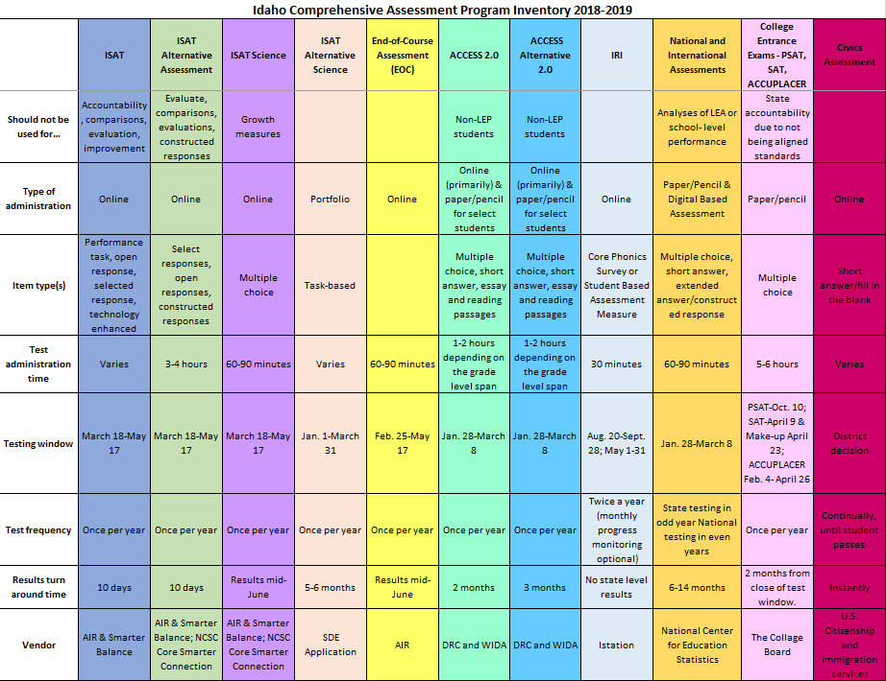

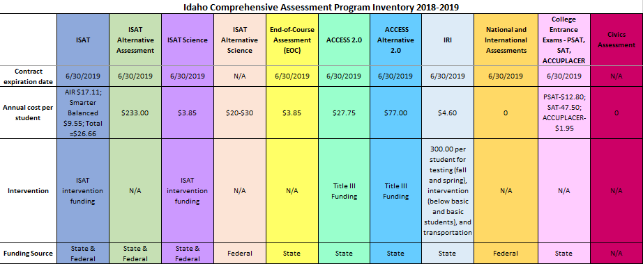

Appendix C: Resources
This list provides links to frequently accessed sites. Links to specific assessment portals or external websites are also included.
- Idaho State Department of Education Assessment and Accountability:
  - Assessment Main Page
    - Main page to navigate to each state assessment, calendar of events, resource center, and pending rule changes
  - Resource Center
    - Archived monthly webinars and newsletters; portals for ADEA, Assessment Monitoring, Incident Log, I-Pass, IRI, ISAT, Participation Appeals, WIDA AMS; resource files, FAQs, trainings and links for each of the portals
      - Edmodo
        - Annual Test Coordinators User Group - To subscribe, contact the Assessment and Accountability department for the current code
  - Pending Rule Changes
    - Keep up-to-date with any SDE pending rule changes
  - Civics Assessment
  - College Entrance Exams
    - College Board:
      - Main Webpage
      - SAT
      - PSAT
      - ACCUPLACER
      - ACCUPLACER Portal
  - English Language Proficiency Assessment
    - WIDA
      - WIDA Main Page
      - WIDA AMS
  - Idaho Reading Indicator
    - Istation Idaho Webpage
  - ISAT Comprehensive Assessment System
    - Digital Library
    - ISAT ELA
    - ISAT Math
  - Idaho System for Educational Excellence (ISEE)
  - National and International Assessments
    - National Assessment of Educational Progress (NAEP):
      - General Information
        - Previous reports, data tools, news releases, and sample questions
      - MyNAEP
  - Science
  - Special Education

