TIME AND EFFORT

Who must participate?

Is my employee required to participate in time and effort?
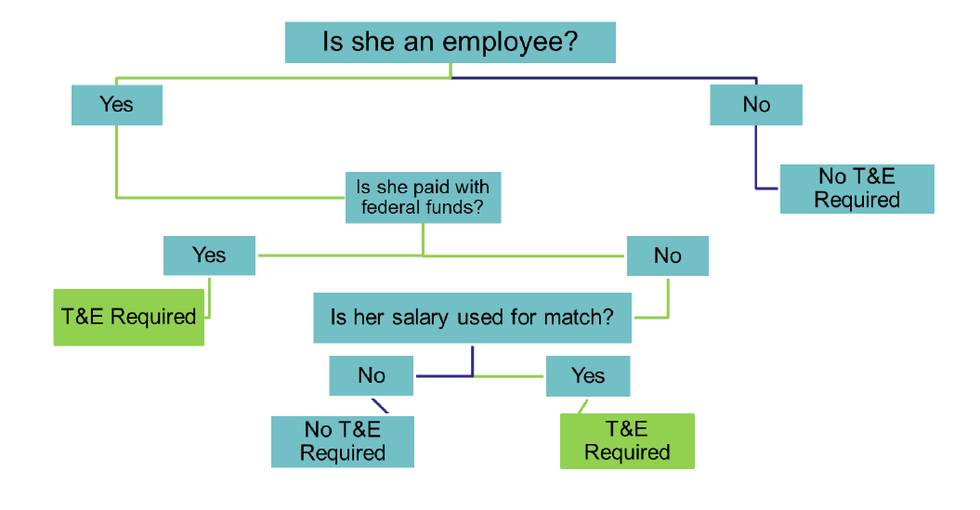

Description of the chart

Scenario 1

Question: Is she an employee?
Answer: No.
Final Determination: No Time and Effort is required.

Scenario 2
Question: Is she an employee?
Answer: Yes.
Question: Is she paid with Federal funds?
Answer: No.
Question: Is her salary used for a match?
Answer: No.
Final Determination: No Time and Effort is required.

Scenario 3
Question: Is she an employee?
Answer: Yes.
Question: Is she paid with Federal funds?
Answer: Yes.
Final Determination: Time and Effort is required.

