McKinney-Vento/Homeless Education
Mini-Manual

Idaho State Department of Education
Title IX-A Homeless Education Program

emily sommer
State Homeless Education Coordinator
esommer@sde.idaho.gov
208-332-6904

650 W State Street, 2nd Floor
Boise, IDaho 83702
208 332 6800 office
www.sde.idaho.gov

Updated 8/10/2023

McKinney-Vento/Homeless Education Mini-Manual
  - use The Mini-Manual in tandem with the Idaho State Title IX-A Homeless Education website @ https://sde.idaho.gov/federal-programs/homeless/
Table of Contents
Glossary of Acronyms & Abreviations 4
McKinney-Vento/Homeless Education Information 4
Purpose 4
Definition 5
Student Rights 6
STEP 1: Outreach & Identification 7
Strategies to Increase Identification 7
STEP 2: Verification & Eligibility 10
Verification/Confirming Eligibility - 10
Eligibility Notification - 11
Parent Communication - 13
STEP 3: Planning & Delivery of Services 15
Needs Assessment 15
STEP 4: Records & Reporting Processes 17
Data Collection & Reporting Tools 17
Coding in Student Management System 17
Student MV File & Permanent Records File 18
IDCI/Program Contact File 18
ISEE Uploads 19
Funding & Fiscal Responsibilities 20
Funding Options 20
Accounting processes 20
McKinney-Vento Liaison 21
District MV Policy 22
Program Evaluation & Monitoring 22
Annual Self-Assessment for Program Improvement 22
Monitoring by the Idaho State Department of Education 22

Glossary of Acronyms & Abreviations
Acronym | Program, etc.
MV | McKinney-Vento Act
EHCY | Education of Homeless Children and Youth
ESSA | Every Student Succeed Act – the 2018 reauthorization of the Elementary and Secondary Education Act of 1965
ESEA | Elementary and Secondary Education Act
LEA | Local Educational Agency (district or charter)
SDE | Idaho State Department of Education
ED | United States Department of Education
UHY | Unaccompanied Homeless Youth
ISEE | Idaho System for Educational Excellence
IDCI | Idaho District Contact Information (district program contacts directory)
IDEA | Individuals with Disabilities Education Act (Special Education)
FAFSA | Free Application for Federal Student Aid
PII | Personally Identifiable Information

McKinney-Vento/Homeless Education Information

Purpose
Subtitle VII-B of the McKinney-Vento Homeless Assistance Act authorized the federal Education for Homeless children and Youth (EHCY) program along with the Title IX-A section of Every Student Succeeds Act (ESSA) to provide students experiencing homeless with protections and services to ensure they enroll and attend school, complete their high school education and prepare for college or careers – their best hope of avoiding poverty and homelessness as adults.
It ensures students who lack a fixed and regular nighttime residence are provided equal access to a free appropriate public education-including public preschool, are able to stay in their school of origin, receive free school meals, and barriers are removed so they may fully participate in their education.
Local educational agencies (LEA) are instrumental in ensuring that the rights and services guaranteed in the McKinney-Vento Act are implemented throughout the district or charter.
All public-school LEAs must follow the requirements of the McKinney-Vento Act, whether or not they receive a McKinney-Vento supplemental subgrant or receive other federal funds.
Definition
Subtitle VII-B of the McKinney-Vento Homeless Assistance Act (per Title IX, Part A of the Elementary and Secondary Education Act, as amended by the Every Student Succeeds Act) defines homelessness and provides protections under the federal law, as follows:
The term "homeless children and youths":
(A) means individuals who lack a fixed, regular, and adequate nighttime residence; and
(B) includes:
(i) children and youths who are sharing the housing of other persons due to loss of housing, economic hardship, or a similar reason; are living in motels, hotels, trailer parks, or camping grounds due to the lack of alternative adequate accommodations; are living in emergency or transitional shelters; or are abandoned in hospitals;*
(ii) children and youths who have a primary nighttime residence that is a public or private place not designed for or ordinarily used as a regular sleeping accommodation for human beings;
(iii) children and youths who are living in cars, parks, public spaces, abandoned buildings, substandard housing**, bus or train stations, or similar settings; and
(iv) migratory children (as such term is defined in section 1309 of the Elementary and Secondary Education Act of 1965) who qualify as homeless for the purposes of this subtitle because the children are living in circumstances described in clauses (i) through (iii);(v) unaccompanied homeless youth (UHY) who meet the homeless living situations listed above AND are “not in the physical custody of parent or guardian”.
*Per Title IX, Part A of the Every Student Succeeds Act, "awaiting foster care placement" was removed from the definition of homeless on December 10, 2016.
**Per Title 24 – Housing and Urban Development – Federal Preference: Substandard Housing Section 5.425
A unit is substandard if it:
(1) Is dilapidated; (The unit does not provide safe and adequate shelter, and in its present condition endangers the health, safety, or well-being of a family; or the unit has one or more critical defects, or a combination of intermediate defects in sufficient number or extent to require considerable repair or rebuilding. The defects may involve original construction, or they may result from continued neglect or lack of repair or from serious damage to the structure.)
(2) Does not have operable indoor plumbing;
(3) Does not have a usable flush toilet inside the unit for the exclusive use of a family;
(4) Does not have a usable bathtub or shower inside the unit for the exclusive use of a family;
(5) Does not have electricity, or has inadequate or unsafe electrical service;
(6) Does not have a safe or adequate source of heat;
(7) Should, but does not, have a kitchen; or
(8) Has been declared unfit for habitation by an agency or unit of government.
See § 5.415(a)(2) and (c)(2)(ii)

Student Rights
All homeless students have the right to be free from segregation, isolation, and stigmatization. Homeless children and youth have access to the education and other services that ensure them the opportunity to meet the same challenging state student academic achievement standards to which all students are held.
McKinney-Vento eligible children have the right to:
- Receive a free, appropriate public education
- Enroll in school immediately, even if lacking documents normally required for enrollment
- Enroll in school and attend classes while the school gathers needed documents
- Enroll in the local school; or continue attending the school of origin (the school they attended when permanently housed or the school in which they were last enrolled), if that is their preference. *If the school district believes that the school you select is not in the best interest of the child, then the district must provide a written explanation of its position and inform parents and UHY of the right to appeal its decision
- Receive transportation to and from the school of origin, if requested
- Receive educational services comparable to those provided to other students, according to students’ needs.
- Children with special education needs between the ages of 3 and 21 are eligible to receive special needs services.

District Homeless Education Program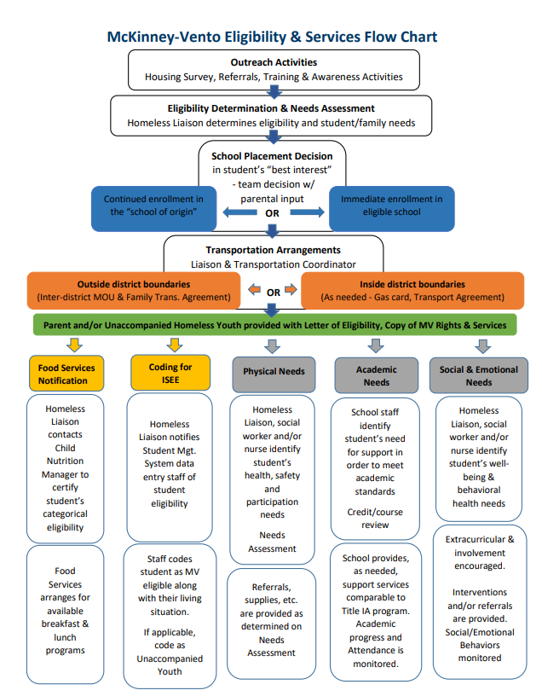
NOTE: See Idaho IX-A Homeless Education Website – PROG 8 for “MV Eligibility & Services Flowchart”

STEP 1: Outreach & Identification
Identifying all students experiencing homelessness is critical as it allows liaisons to help students and UHY who may have difficulty with enrollment, to connect students to educational support and community services, and to increase the likelihood that homeless students and UHY will overcome the extra educational challenges or barriers may they face.
While it is true that local liaisons themselves will and should identify many of the homeless students in a LEA, the actual charge in the law is for local liaisons to ensure that homeless students are identified “by school personnel through outreach and coordination activities with other entities and agencies” [42 U.S.C. § 11432(g)(6)(i)]. The language in the law means two important things. First, local liaisons are not expected to do the work alone and bear the sole responsibility for identifying students. Second, collaboration with other educational programs and even agencies outside the LEA is not only encouraged, but it is expected. The collaborations involved in ensuring students in homeless situations are identified may be very informal or be structured around formal activities and relationships.
School staff who may be particularly helpful in meeting the requirement to identify homeless students include
- school nurses;
- front office and registration staff;
- truancy and attendance officers;
- cafeteria staff;
- bus drivers;
- school social workers and counselors;
- classroom teachers and aides; and
- administrators, such as principals or directors of special education and Title IA.

Strategies to Increase Identification
Awareness Posters -
Notices regarding the rights of youths experiencing homelessness should be posted in places where parents and youth may see them and must be written in a user-friendly format.
NOTE: See Idaho IX-A Homeless Education Website for digital copies and how to order posters, flyers, and postcards in English and Spanish – PROG 3 Notification of Educational Rights
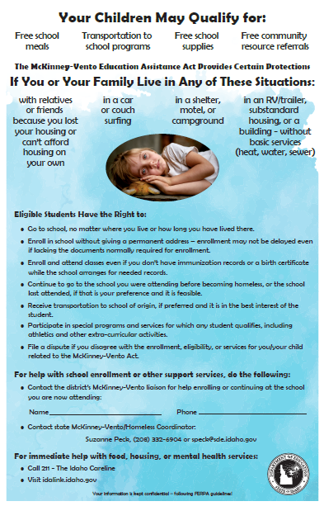

Home Survey
Including a housing questionnaire/survey with a simple statement of rights in the general enrollment and registration packet received by all students as they sign up for school is a good way to ensure the entire student population is informed. Avoid using the word “homeless,” as it may be off-putting. By providing the information in all the enrollment packets, no one feels singled out or stigmatized, but even those who are not homeless become more aware of things happening in the community.
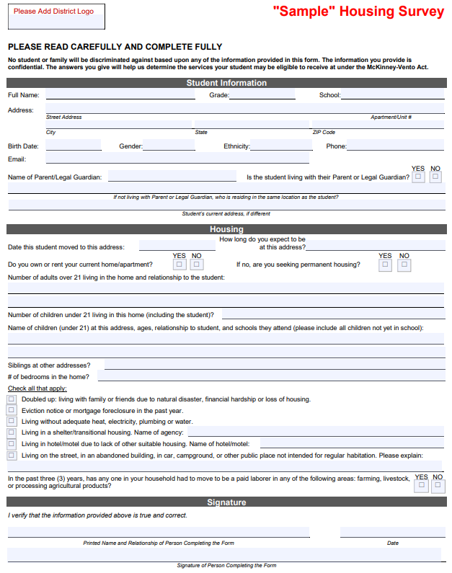
NOTE: See Idaho IX-A Homeless Education Website -SID 8 Homeless Educations Services & Identification for customizable forms in English and Spanish

Enrollment & Awareness Events
As required by statute, LEAs must enroll students seeking MV eligibility immediately, even if they are unable to provide paperwork normally required for enrollments. Efforts to confirm eligibility should take place once full enrollment has occurred.
Events like New Student Enrollment, Kindergarten Round-up or Head Start enrollment fairs can lead to more identified students. Many communities also host events which focus on connecting persons in need with agencies and organizations that can help them, including schools. Participating in community awareness events can help develop relationships with partners who can help assist the liaison with identification and in meeting the needs of families and students.

District Website or Newsletters
The LEA website should contain the student handbook and other important information targeted to students and their families. It can be a great tool for increasing awareness and disseminating information about the rights of homeless students as well as listing contact information for the liaison.

Mid-Year Outreach
Families may move from place to place and youth may become estranged from their families after enrolling in school; mid-year identification processes for families to update contact information, for staff to refer students or for youth to self-identify can help connect students to services who were not otherwise identified through beginning of the year enrollment/registration or home questionnaire/survey efforts.

STEP 2: Verification & Eligibility
To determine a student's McKinney-Vento eligibility, school districts must determine whether a student's living arrangement meets the McKinney-Vento definition of homeless. In this process, school districts will encounter instances where they will need to confirm information provided about a child's or youth's living arrangement.
Verification/Confirming Eligibility
Completed Housing Survey forms that indicate students are living in potentially “Homeless” qualifying situations will be reviewed in conjunction with the “Eligibility Determination Form” by the district McKinney-Vento liaison or school designee for verification of eligibility.
Efforts to confirm information about a child’s or youth’s living arrangement should be respectful, effective, discreet, and maintain LEA privacy guidelines. Conducting eligibility conversations should be conducted in a private space, in a respectful manner and with care and sensitivity as these conversations are very personal for the family or youth. The local liaison maintains the final authority for making determinations of eligibility. Avoid using the word “homeless” on school forms and in conversation with families or youth. Many families or youth would not want to be called “homeless” due to the stigma that may be associated with the term. Further, families or youth may not consider themselves homeless even though their living arrangement meets the definition.
Once a liaison sensitively and discreetly has explained the rights available under the McKinney-Vento Act, families or youth may choose not to take advantage of McKinney-Vento services at their discretion. The LEA should still count all children and youth who have been identified as homeless in their data collection, even if additional services are not provided.
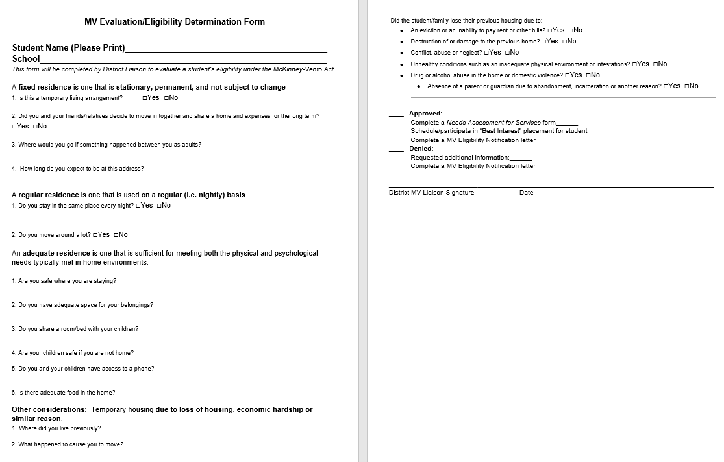
NOTE: See Idaho IX-A Homeless Education Website -SID 8 Homeless Educations Services & Identification for “MV Evaluation/Eligibility Determination Form”
Eligibility Notification
After students have been determined eligible, the liaison will contact the parents and/or students to provide them written confirmation of their eligibility or non-eligibility along with a copy of their educational rights under the McKinney-Vento Act.
All students who have been confirmed to be living in a McKinney-Vento situation are eligible for services/supports through the LEA MV/Homeless Education for the remainder of the year.
If, after investigating, a district concludes that a student is not MV eligible, the district must provide the parent/guardian or UHY the opportunity to appeal the district’s decision through the district MV dispute resolution process.
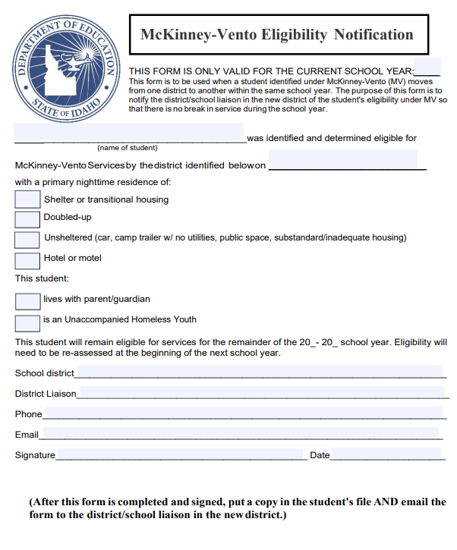
NOTE: See Idaho IX-A Homeless Education Website -SID 8 Homeless Educations Services & Identification for “Written Notification of Eligibility Simple Form”
Parent Communication
The McKinney-Vento Act accords parents and guardians experiencing homelessness the right to have their voices heard on what they believe is in the best interest of their children. The law requires local liaisons to provide parents and guardians information on the McKinney-Vento Act and on the process for disputing decisions of the local educational agency (LEA) when they disagree on enrollment and best interest determinations for their children.
Communication is critical for developing trust with parents. Good rapport enables local liaisons to establish a working relationship with parents that results in good educational decisions for children. The following tips will help you develop positive, productive relationships with parents.
- Keep impersonal communication, such as letters and emails, to a minimum; conduct face-to-face conversations whenever possible.
- Provide a welcoming environment.
- Conduct sensitive conversations in a private and comfortable place.
- Avoid using the word “homeless;” avoid charged and judgmental language.
- Talk to them about their living situation; be sensitive and discrete.
- Ask them about their needs. A good question to ask is, “How may we be of assistance to you and your family? What would be helpful for you now?”
- Assure them that their children are welcome in your school and that you have their best interest in mind.
- Empower and encourage parents; discuss solutions to challenges with them.
- Discuss things about which they feel positive.
- Listen! Listen! Listen!
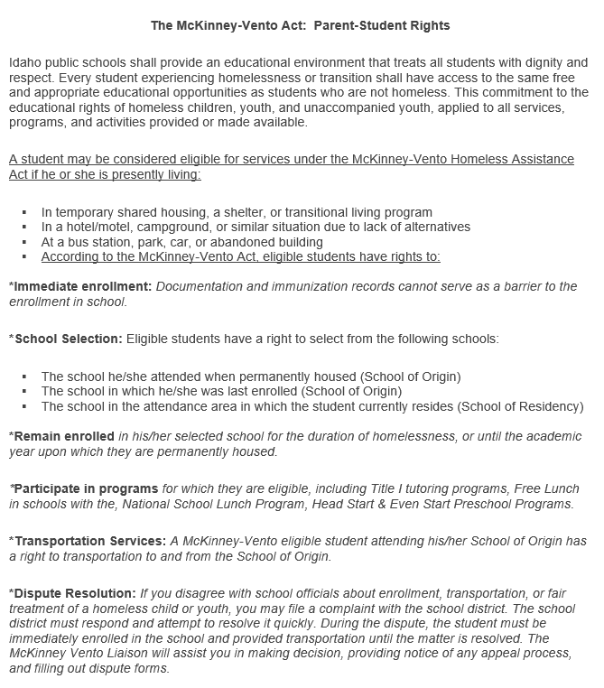
NOTE: See Idaho IX-A Homeless Education Website -PROG 33 Notice of Educational Rights for downloadable copies in English and Spanish

STEP 3: Planning & Delivery of Services
The absence of a stable living arrangement has a devastating impact on educational outcomes for youth. For many students who are homeless, not having the proper school records often leads to incorrect classroom placement. Medical records, immunization records, previous school transcripts, proof of residency, and for unaccompanied youth, parental permission slips, are some of the “paper” barriers to students being placed efficiently and appropriately within school districts.
When students change schools frequently, it is difficult for educators to correctly identify their needs and ensure proper placement. Parents may also have difficulty identifying the difference between academic or social difficulties that result from the stress of homelessness and mobility. Also, transportation is an obstacle that further prevents many homeless children and youth from obtaining education. Stigmas about homelessness combined with lack of support from the school district can often prevent homeless students from receiving the best education possible. All of these reasons prevent homeless youth from receiving education effectively and efficiently.
The services provided under McKinney-Vento provide families the opportunity to maintain education stability for their student, which is key to their educational trajectory and success.
One of the priorities of the act is the provision of transportation services to allow students experiencing homelessness to remain in their school of origin, which is defined as the school that the student attended when they first experienced homelessness.
Students who are identified by the MV liaison as meeting the homeless definition are categorically eligible to receive free meals through the Child Nutrition program. To expedite the delivery of nutritional benefits, school child nutrition staff may accept documentation that the children are homeless from the local McKinney-Vento liaison. Documentation to substantiate free meal eligibility must consist of the child’s name or a list of names, effective date(s), and the signature of the district McKinney-Vento liaison. This documentation is acceptable in lieu of a free and reduced-price meal application.

Needs Assessment
The McKinney-Vento liaison will meet with the parent and/or student to determine what services will be provided based on what is available within the district homeless education program. The district organizes supports based on the following types of services needed to remove barriers and to all students to fully participate in their education:
- Basic Needs & Supportive Services
  - Nutritional supports
  - Transportation
  - Social/Emotional counseling
  - Clothing & cold weather needs
  - Etc.
- Academic/Instructional Supports & Services
  - Enrollment assistance
  - School supplies
  - Referral and expedited evaluation for educational support programs
  - Extra-curricular activities
  - Credit recovery and/or Academic Intervention support
  - Graduation supports
  - College/Career counseling & FAFSA support
- Referral Services
  - Community partner resources
  - Medical, Dental & Vision services
  - Department of Health & Welfare navigation program
  - Housing referrals to regional coordinated entry service provider
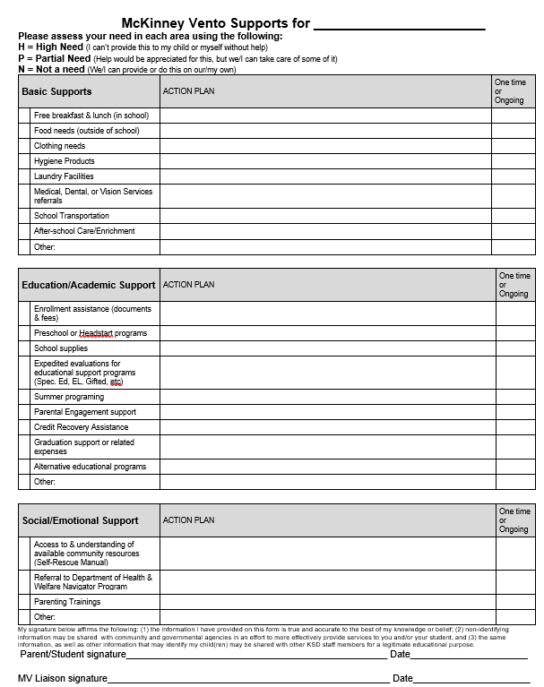
NOTE: See Idaho IX-A Homeless Education Website -SID 8 Homeless Education Services & Identification customizable form and templates to reflect community resources & partners.

STEP 4: Records & Reporting Processes
Data collection begins at the school and LEA level. The district MV liaison is responsible for working with the district/charter data staff and the State Coordinator to ensure accurate data is provided that meets the required elements.
In order to meet the data collection and dissemination requirements in federal law districts are required to collect and provide the identified data to the SDE on an annual basis; the SDE then submits the information to ED and uses the data for required elements of public reports like state report cards. Data is reported to the SDE through the Idaho System for Education Excellence (ISEE)
The essential pieces of data that must be submitted by districts annually include:
- the number of homeless students enrolled in each grade, including preschool;
- the primary nighttime residence of homeless students enrolled in school;
- the number of homeless students enrolled in school that are a part of particular subgroups, including English learners, unaccompanied homeless youth, students with disabilities, and migratory students;
- the number of homeless children and youth served by McKinney-Vento subgrants;
- the number of homeless students served by McKinney-Vento subgrants that were also part of the four subgroups;
- the participation and performance of homeless students on reading, math, and science assessments;
- the number of homeless students that dropout or graduate;
- the number of homeless students who are chronically absent;
- the number of homeless students who are served by Title I, Part A;
- the number of homeless students who meet other measures of academic achievement identified by the state – Idaho Standards Achievement Test (ISAT) and Idaho Reading Indicator (IRI)

Data Collection & Reporting Tools

Coding in Student Management System
Identified students should be coded in the district Student Management system as soon as they are identified to be included in district and state reporting.
Three pieces of information should be addressed in relation to coding students:
- MV status eligibility
- Primary Nighttime Residence/Living situation - Doubled up (D), Hotel/Motel (HM), Emergency Shelter (STH), Unsheltered/Substandard Housing (U)
- Unaccompanied Youth (UY) - experiencing homelessness without a parent/guardian

Student MV File & Permanent Records File
A student file should be created and maintained for students deemed eligible for MV supports and services. This record should be kept in a secure location. FERPA protects the privacy of educational records related to homelessness.
Any record ordinarily kept by the school, including immunization or medical records, academic records, birth certificates, guardianship records, and evaluations for special services or programs, regarding each homeless child or youth shall be maintained –
(i.) so that the records are available, in a timely fashion, when a child or youth enters a new school or school district; and
(ii.) in a manner consistent with section 444 of the General Education Provisions Act (20 U.S.C. 1232g).
The LEA treats information about a homeless child or youth’s living situation as a student education record, and shall not be deemed to be directory information. ESSA Section 722 (g)(D). Personally Identifiable Information (PII) regarding a student’s living situation should only be shared and/or transferred via a secure means.
Contents of the Student MV file should include:
  - Enrollment and living situation/eligibility documents
  - Copies of communication/notification with parents or UHY
  - Evidence of processes for data collection and monitoring student well-being, including: attendance, services/referrals provided, academic and/or behavioral supports and credit accrual/progress toward graduation.
  - Dispute documentation
IMPORTANT! A copy of the written “McKinney-Vento Eligibility Notification” should be filed in the student’s permanent record file for the current year of eligibility. This form must be included when information is sent to another school during a mid-year transfer.

IDCI/Program Contact File
The Idaho District Contact Information system is a district program contact directory used by the SDE look up district/charter school program personnel for communication. Program contact directory information displayed in the IDCI application is primarily updated from information/data reported through the ISEE Program Contact File submission. The Program Contacts File can be updated at any time with changes taking effect 1-2 business days after the upload.

It is the district responsibility to keep the Homeless Education Program related contacts up to date. To ensure that the correct information is published on the Homeless Education website, please contact the SDE Technology Support desk @ 208-332-6987 or support@sde.idaho.gov for assistance in updating roles.

Role Codes
McKinney-Vento Liaison (MVL) – Districts may only assign one individual the role of Title IX-A Homeless/McKinney-Vento Liaison. This individual is the one identified by the district to ensure that the requirements related to the McKinney-Vento Act and the 10 duties of the MV liaison are met. This individual's contact information will be published as the district contact on the Homeless Education webpage.

Homeless Education Contact (HED) Districts may have a number of individuals who are working in the Homeless Ed. program assigned the role of Title IX-A Homeless Contact (HED). These individuals will be provided Homeless Ed. Program updates BUT WILL NOT have their contact info listed on the website.

ISEE Uploads
The Idaho SDE has created the Idaho System for Educational Excellence, a K-12 Longitudinal Data System, which support the budgeting processes, data submission, and delivers information to educational stakeholders to create data-driven decisions. Data reporting is required from the LEA to the SDE through six (6) yearly data submissions. LEAs report data to the SDE for all programs and students.
For more information about dates for ISEE submissions or how to get access to the ISEE portal, please refer to the ISEE Technology Resource Webpage (http://www.sde.idaho.gov/tech-services/isee/)

Homelessness data reported at the district/charter level include:
• the number of students experiencing homelessness in each grade
• the type of primary nighttime residence the students had at the time they were identified as homeless
• the racial/ethnic background of homeless enrolled students
• the number of students in each subgroup of homeless students
• the type of primary nighttime residence unaccompanied homeless youth (UHY) had at the time they were identified as homeless
• the number of students served by McKinney-Vento subgrants
• the number of students served by Title I targeted assistance or schoolwide programs
• the number of homeless students who were chronically absent
• the Adjusted Cohort Graduation Rate of homeless students
• the number of homeless students who complete high school
• the number of homeless students who drop out of school
Data Submission Timeline & Verification Process
IMPORTANT: Local liaisons need to verify data with the district ISEE coordinator BEFORE data is uploaded via ISEE!

Funding & Fiscal Responsibilities
Funding Options may include:
- Title IA Homeless Set-Aside
- MV/Homeless Enhancement Subgrant
- Other State Programs
- District Funds
- “Angel Fund”
- Community Partners & Donations

(The following two sections should be personalized by each district/charter)

Funding Options
- Provide description of what funds are used to support students experiencing homelessness AND how the amount is determined

Accounting processes
- Provide description of how are funds accessed and accounted for
NOTE: See Idaho IX-A Homeless Education Website, FA 3-Allowable Use of Funds and FA12 - Homeless Education Program Funding for “Homeless Set-Aside & Program Development Needs Assessment”

McKinney-Vento Liaison
The local liaison is the key to ensuring homeless children and youths receive the services they need. Required in all LEAs regardless of subgrant status, the liaison is the primary contact between homeless families, school and LEA staff, shelter workers, and other service providers. The district McKinney-Vento liaison’s contact information is annually published on the SDE Homeless Education website.

The local liaison can fulfill many roles. In carrying out the responsibilities of the position, this person will act as an administrator, a professional development coordinator, a school social worker, and an outreach specialist. The LEA will shape the position based on its current needs in serving homeless children and youths. Therefore, the LEA will provide the liaison with sufficient time and capacity to carry out the required set of duties as described in 42 USC §11432(g)(6)(A).

McKinney-Vento liaisons must ensure that:
- homeless children and youth are identified by school personnel through outreach and coordination with other entities and agencies;
- homeless children and youth are enrolled, and have a full and equal opportunity to succeed, in school;
- homeless families, children and youth receive educational services for which they are eligible, including Head Start, early intervention services under Part C (Idaho Infant Toddler Program) of the Individuals with Disabilities Education Act (IDEA), and other preschool programs administered by the LEA;
- homeless families, children and youth receive referrals to health, dental, mental health, housing, substance abuse, and other appropriate services;
- parents or guardians are informed of the educational and related opportunities available to their children and are provided with meaningful opportunities to participate in the education of their children;
- public notice of homeless students’ rights is disseminated in locations frequented by parents, guardians and unaccompanied youth, including schools, shelters, libraries and soup kitchens, in an understandable manner and form;
- enrollment disputes are mediated according to 42 U.S.C. § 11432(g)(3)(E);
- parents, guardians and unaccompanied youth are informed of and assisted in accessing transportation services, including transportation to the school of origin;
- school personnel providing McKinney-Vento services receive professional development and other support; and
- unaccompanied youth are enrolled in school, have opportunities to meet the same challenging state academic standards as other children and youth, including through receiving partial credits, and are informed of their status as independent students for the Free Application for Federal Student Aid (FAFSA) and receive verification of that status.
NOTE: See Idaho IX-A Homeless Education Website – PROG 28 for a customizable annual MV Liaison Calendar

District MV Policy
The district/charter ensures that policies and procedures do not create barriers for the education of homeless children and youths. The board policy regarding the education of homeless students is regularly reviewed to ensure that the policy meets all of the necessary components.

(Please customize) District policy review process & timeline: _____________________________________

NOTE: See Idaho IX-A Homeless Education Website – PROG 31 for a District MV/Homeless Policy Checklist

Program Evaluation & Monitoring
Evaluation is a valuable and necessary addition to the provision of services. Built into regular programming, well-conducted evaluations assist providers in knowing if their services have a real impact on families’ lives.
Standards provide a common basis for establishing measurable goals and implementing a program.
The Idaho Federal Program Monitoring & Self-Monitoring Tool incorporates the MV related statute from the Every Student Succeeds Act (ESSA) and McKinney-Vento Homeless Assistance Act within the indicators to provide districts/charters a guide to developing the required elements to implement a quality McKinney-Vento - Homeless Education program. The indicators and State monitoring processes are designed to help improve local homeless education program performance and educational outcomes for students experiencing homelessness through a variety of means, including monitoring, technical assistance, and making LEA-level homeless student enrollment and school-level homeless student achievement data publicly available.

Annual Self-Assessment for Program Improvement
The district/charter reviews program requirements and needs annually in the Spring using the Needs Assessment tool.
Monitoring by the Idaho State Department of Education
The district/charter participates in the scheduled Idaho Department of Education – Federal Programs monitoring program. This process may include:
- Uploading evidence via a secure digital application using the Monitoring Upload Tool (MUT) or Idaho Monitoring Application Tool (IMAT)
- Participating in onsite or virtual interviews
- Creating an Action Plan based on the Federal Programs Final Report to address any findings
- Working with the State MV Coordinator to get approval of program modifications related to the findings in the final report
NOTE: See Idaho IX-A Homeless Education Website – Program Development & Monitoring for the current MV/Homeless related indicators

