Sample Parent Employment Survey Procedures – Region 5 & 6

Dear Secretary or registrar,

The most important step in identifying migrant students is the Parent Employment Survey filled out by parents or guardians at enrollment. Please use the following procedures to make sure that we are able to identify these students effectively and in a timely manner. Call the migrant family liaison if you have any questions. If indicated, in the chart below, the copy of the survey will go to your local contact who will mail them to the Regional ID&R Coordinator for your area. Thank you for your help in getting eligible students the services they need!

- Include the Parent Employment Survey in the registration packet for all new students.

- 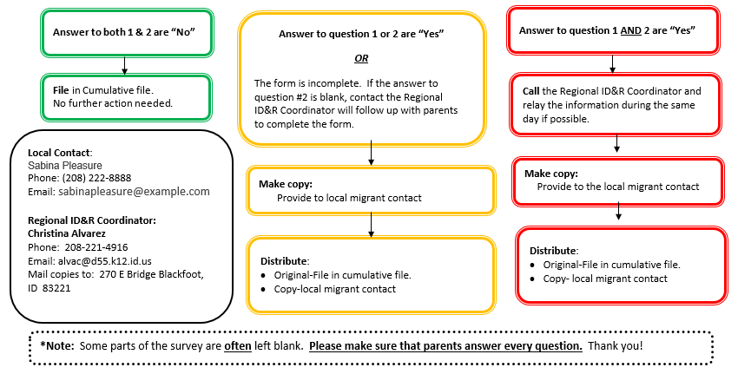Pre-screen and complete the surveys process as follows:

Parent Employment Survey Procedures – Region 5 & 6

Dear Secretary or registrar,

The most important step in identifying migrant students is the Parent Employment Survey filled out by parents or guardians at enrollment. Please use the following procedures to make sure that we are able to identify these students effectively and in a timely manner. Call the migrant family liaison if you have any questions. If indicated, in the chart below, the copy of the survey will go to your local contact who will mail them to the Regional ID&R Coordinator for your area. Thank you for your help in getting eligible students the services they need!

- Include the Parent Employment Survey in the registration packet for all new students.

- Pre-screen and complete the surveys process as follows:
Answer to both 1 & 2 are “No”
File in Cumulative file.
No further action needed.
Answer to question 1 AND 2 are “Yes”
Answer to question 1 or 2 are “Yes”

OR

The form is incomplete. If the answer to question #2 is blank, contact the Regional ID&R Coordinator will follow up with parents to complete the form.

Call the Regional ID&R Coordinator and relay the information during the same day if possible.
Make copy:
Provide to local migrant contact
Distribute:
- Original-File in cumulative file.
- Copy-local migrant contact
*Note: Some parts of the survey are often left blank. Please make sure that parents answer every question. Thank you!
Local Contact:
(Name)
Phone:
Email:

Regional ID&R Coordinator:
Christina Alvarez
Phone: 208-221-4916
Email: alvac@d55.k12.id.us
Mail copies to: 270 E Bridge Blackfoot, ID 83221

Distribute:
- Original-File in cumulative file.
- Copy- local migrant contact
Make copy:
Provide to the local migrant contact

