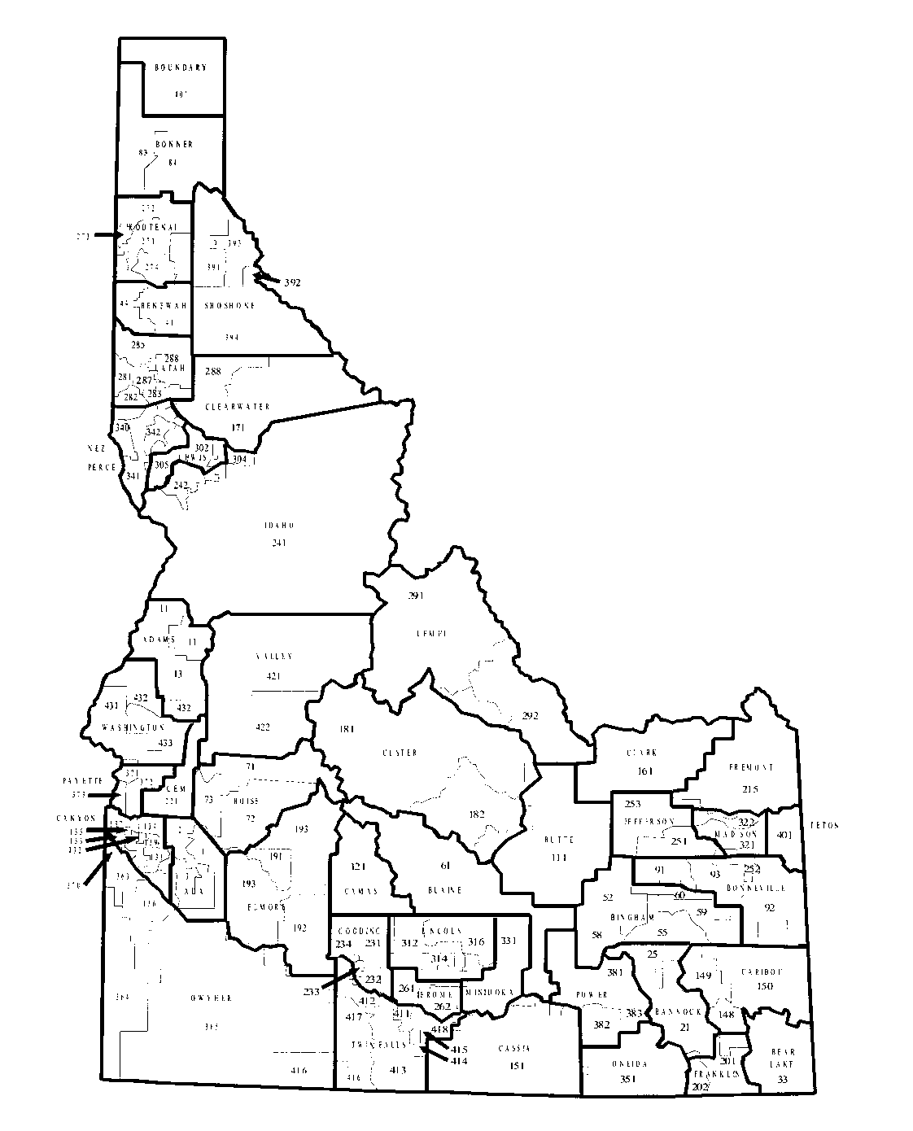

SCHOOL DISTRICT BUDGET
2021 – 2022

Name of School District/Charter School

Organization Number

County

Sherri Ybarra
STATE SUPERINTENDENT OF PUBLIC INSTRUCTION
DEPARTMENT OF EDUCATION
P.O. BOX 83720

BOISE, 83720-0027

